**RESEARCHER’S PROFILE**

**ARLENE GRACE CALING ALONZO**

 Purok #5 San Roque Arbol, Lubao, Pampanga

 [*agca.alonzo@gmail.com*](mailto:agca.alonzo@gmail.com)

 09773313402

**EDUCATION:**

|  |  |
| --- | --- |
| 2018 - Present | Bachelor of Science in Information Technology  Don Honorio Ventura State University |
| 2016 - 2018 | Senior High School - TVL Major  AMA Computer Learning Center |
| 2012 - 2016 | Junior High School  Sta. Cruz High Integrated School |
| 2011 - 2012 | San Roque Arbol Elementary School |

**WORK EXPERIENCE:**

|  |  |
| --- | --- |
| 2021 –Present | Junior Supervisor  EGM Land Titling Services |
| 2020 | Virtual Assistant  RCJ Enterprise |
| 2019 | Jilliane’s Catering Services |
| 2017 | On the Job Trainee (0JT) Information and Communications Technology Office |

**GRANTS, HONORS, SCHOLARSHIPS**

|  |  |
| --- | --- |
| 2021 | President’s Lister ( 2nd Sem S.Y. 2020 – 2021)  College of Computing Studies (CCS) |
| 2021 | Dean’s Lister ( 1st Sem S.Y. 2020 – 2021)  College of Computing Studies (CCS) |
| 2019 | Participant  Regional Assembly of Information Technology (RAITE 2019) |
| 2018 | President Lister (2nd Sem S.Y. 2018 – 2019)  College of Computing Studies (CCS) |
| 2018 | National Certificate (NCII) Information Communication Technology |
| 2018 | Senior High School – Graduated with Honors |

**SEMINAR ATTENDED:**

|  |  |
| --- | --- |
| 2018 | #SMLSEMINAR Social Media Literacy Seminar  Don Honorio Ventura State University |

**PROFESSIONAL AFFILIATIONS**

|  |  |
| --- | --- |
| 2020 - 2021 | **Associate Director**  Taguimpan Films |
| 2019 - 2020 | **Board Member on Records**  College of Computing Studies Student Council (CCSSC) |

**PERSONAL INFORMATION:**

|  |  |  |
| --- | --- | --- |
| Birthdate | : | January 18, 2000 |
| Birthplace | : | Tondo, Manila |
| Gender | : | Female |
| Height | : | 5’4 |
| Weight | : | 114 lbs. |
| Civil Status | : | Single |
| Nationality | : | Filipino |
| Religion | : | Born Again Christian |
| Languages | : | English, Tagalog |

**CHARACTER REFERENCE:**

**MS. ELVIRA G. MALIT**

*(EGM Land Titling Services)-* CEO

Lubao, Pampanga

**MR. MARTHY V. ZAPATA**

Information Technology Officer II (Officer-in-Charge)

City Government of San Fernando, Pampanga

**MR. LOWELL T. MANIQUIS**

Academic Head

*(AMA Computer Learning Center)*

Guagua Campus

**REV. RODOLFO F. GUINTU**

Head Principal

*(Shiloh Christian Academy)*

Tondo, Manila

***I hereby certify that the above information is true and correct to the best of my knowledge and belief.***



ARLENE GRACE C. ALONZO

4th Year Information Technology Student

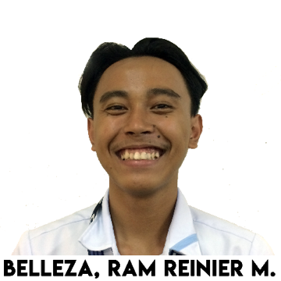**RAM RAINIER M. BELLEZA**

 020 Sitio Centro Santa Lucia Lubao Pampanga

 [bramrainier@gmail.com](mailto:bramrainier@gmail.com)

 +63-991-390-0007

**EDUCATION:**

|  |  |
| --- | --- |
| 2018 - Present | Bachelor of Science in Information Technology  Don Honorio Ventura State University |
| 2016 - 2018 | Senior High School  Lubao National High School |
| 2012 - 2016 | Junior High School  Lubao National High School |
| 2011 - 2012 | Lubao Central Elementary School |

**WORK EXPERIENCE:**

|  |  |
| --- | --- |
| 2017 | Computer Shop Operator  Respect Computer Shop |

**SEMINAR ATTENDED:**

|  |  |
| --- | --- |
| 2018 | #SMLSEMINAR Social Media Literacy Seminar  Don Honorio Ventura State University |

**PERSONAL INFORMATION:**

|  |  |  |
| --- | --- | --- |
| Birthdate | : | October 30, 1999 |
| Birthplace | : | Lubao, Pampanga |
| Gender | : | Male |
| Civil Status | : | Single |
| Nationality | : | Filipino |
| Religion | : | Roman Catholic |
| Languages | : | English, Tagalog, Pampango |

**CHARACTER REFERENCE:**

**Mrs. Josefina Balatbat**

School Teacher

Lubao Central Elementary School

Brgy. San Nicolas Lubao Pampanga

0912-980-9897

**Mrs. Lidia Hererra**

School Principal

Lubao National High School

Brgy. Remedios Lubao Pampanga

0998-950-3534

**Mr. Carlo Pamintuan**

School Teacher

Don Honorio Ventura State University

Brgy. San Fernando Pampanga

0912-345-6789

 ***I hereby certify that the above information is true and correct to the best of my knowledge and belief.***

RAM RAINIER M. BELLEZA

4th Year Information Technology Student

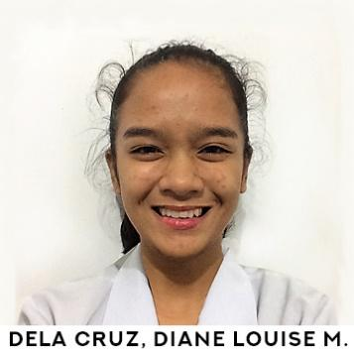**DIANE LOUISE M. DELA CRUZ**

#497 Zone 3 San Isidro, Sta. Rita, Pampanga

 [dlm_delacruz@ymail.com](mailto:dlm_delacruz@ymail.com)

 09773564413

**EDUCATION:**

|  |  |
| --- | --- |
| 2018 - Present | Bachelor of Science in Information Technology  Don Honorio Ventura State University |
| 2016 - 2018 | Senior High School – Science, Technology and Mathematics (STEM)  Pampanga High School |
| 2012 - 2016 | Junior High School – Special Science Class (SSC)  Pampanga High School |
| 2008 - 2012 | SPED Section  Sindalan Elementary School Elementary School |
| 2004 - 2008 | Jesus Is Lord Christian School |

**WORK EXPERIENCE:**

|  |  |
| --- | --- |
| 2020 | Graphic Designer  RCJ Enterprise |
| 2019 | Special Program for Employment of Students (SPES)  Department of Education |

**GRANTS, HONORS, SCHOLARSHIPS**

|  |  |
| --- | --- |
| 2018 - Present | Department of Science and Technology (Scholarship) |
| 2021 | President’s Lister (2nd Sem S.Y. 2020 – 2021)  College of Computing Studies (CCS) |
| 2021 | President’s Lister (1st Sem S.Y. 2020 – 2021)  College of Computing Studies (CCS) |
| 2019 | President’s Lister (1st Sem S.Y. 2019 – 2020)  College of Computing Studies (CCS) |
| 2018 | President Lister (2nd Sem S.Y. 2018 – 2019)  College of Computing Studies (CCS) |
| 2018 | President Lister (1st Sem S.Y. 2018 – 2019)  College of Computing Studies (CCS) |
| 2018 | Senior High School – Graduated with Honors |
| 2016 | Special Science Class (SSC) Survivorship Award |

**SEMINAR ATTENDED:**

|  |  |
| --- | --- |
| 2019 | Regional Assembly on Information Technology Education (RAITE) |
| 2019 | Disaster Risk Reduction and Management |
| 2018 | #SMLSEMINAR Social Media Literacy Seminar  Don Honorio Ventura State University |

**PROFESSIONAL AFFILIATIONS**

|  |  |
| --- | --- |
| 2020 - 2021 | **Vice President**  Society of Information Technologists |
| 2019 - 2020 | **Secretary**  Society of Information Technologists |

**PUBLICATION AND PAPER PRESENTATION:**

|  |  |
| --- | --- |
| 2015 | Paper Presenter  Division Science Congress and Research Exhibit |

**PERSONAL INFORMATION:**

|  |  |  |
| --- | --- | --- |
| Birthdate | : | January 11, 2000 |
| Birthplace | : | Manila |
| Gender | : | Female |
| Height | : | 5’2 |
| Weight | : | 95 lbs. |
| Civil Status | : | Single |
| Nationality | : | Filipino |
| Religion | : | Born Again Christian |
| Languages | : | English, Tagalog |

**CHARACTER REFERENCES:**

**Mrs. Raquel T. De Castro**

Master Teacher II

Pampanga High School

09065802665

**Mrs. Abegail Cortez - Roque**

Teacher III

Pampanga High School

09065340507

**Mr. Christoper O. Lumba**

Master Teacher II

Pampanga High School

09178903870

***I hereby certify that the above information is true and correct to the best of my knowledge and belief.***

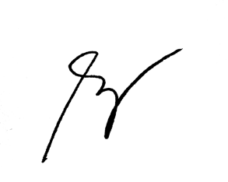

DIANE LOUISE M. DELA CRUZ

4th Year Information Student

**MHARCK STEPHEN P. MAGAT**

 488. Cuyugan Street Del Pilar City of San Fernando, Pampanga

 mharckmagat06@gmail.com

 09063738539

**EDUCATION:**

|  |  |
| --- | --- |
| 2018 - Present | Bachelor of Science in Information Technology  Don Honorio Ventura State University |
| 2016 - 2018 | Senior High School  Our Lady of Fatima University |
| 2012 - 2016 | Junior High School  Pampanga High School |
| 2008 - 2012 | San Fernando Elementary School Elementary School |

**WORK EXPERIENCE:**

|  |  |
| --- | --- |
| 2020 | Virtual Assistant  RCJ Enterprise |
| 2019 | Special Program for Employment of Students (SPES) |
| 2017 | Encoder  Triple K Printing Service |

**GRANTS, HONORS, SCHOLARSHIPS**

|  |  |
| --- | --- |
| 2017 | Subject Excellence Awardee in Statistic and Probability |
| 2017 | Subject Excellence in Research Project |
| 2018 | SHS – ICT Microsoft Office Proficiency Exam passer |

**SEMINAR ATTENDED:**

|  |  |
| --- | --- |
| 2018 | #SMLSEMINAR Social Media Literacy Seminar  Don Honorio Ventura State University |

**PROFESSIONAL AFFILIATIONS**

|  |  |
| --- | --- |
| 2020 - 2021 | **Secretary**  Society of Information Technologists |
| 2019 - 2020 | **Auditor**  Society of Information Technologists |

**PERSONAL INFORMATION:**

|  |  |  |
| --- | --- | --- |
| Birthdate | : | December 06, 1999 |
| Birthplace | : | Pampanga |
| Gender | : | Male |
| Height | : | 5’7 |
| Weight | : | 154 lbs. |
| Civil Status | : | Single |
| Nationality | : | Filipino |
| Religion | : | Roman Catholic |
| Languages | : | English, Tagalog, Pampango |

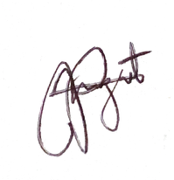***I hereby certify that the above information is true and correct to the best of my knowledge and belief.***

MHARCK STEPHEN P. MAGAT

4th Year Information Technology Student

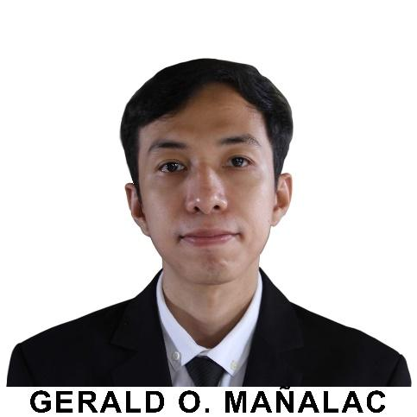**GERALD O. MAÑALAC**

 432 Zone 6 San Matias, Santa Rita, Pampanga

geraldolayresmanalac@gmail.com

 +63905-1757-955

**EDUCATION:**

|  |  |
| --- | --- |
| 2018 - Present | Bachelor of Science in Information Technology  Don Honorio Ventura State University |
| 2003 – 2007 | Becuran High School |
| 1997 - 2003 | San Matias Elementary School Elementary School |

**WORK EXPERIENCE:**

|  |  |
| --- | --- |
| 2019 | Special Program for Employment of Students (SPES)  Municipality of Sta. Rita |

**GRANTS, HONORS, SCHOLARSHIPS**

|  |  |
| --- | --- |
| 2021 | President’s Lister ( 2nd Sem S.Y. 2020 – 2021)  College of Computing Studies (CCS) |
| 2021 | President’s Lister ( 1st Sem S.Y. 2020 – 2021)  College of Computing Studies (CCS) |
| 2019 | President’s Lister ( 1st Sem S.Y. 2019 – 2020)  College of Computing Studies (CCS) |
| 2018 | Dean’s Lister (2nd Sem S.Y. 2018 – 2019)  College of Computing Studies (CCS) |
| 2018 | President Lister (1st Sem S.Y. 2018 – 2019)  College of Computing Studies (CCS) |

**SEMINAR ATTENDED:**

|  |  |
| --- | --- |
| 2018 | #SMLSEMINAR Social Media Literacy Seminar  Don Honorio Ventura State University |

**PERSONAL INFORMATION:**

|  |  |  |
| --- | --- | --- |
| Birthdate | : | October 31, 1990 |
| Birthplace | : | Guagua, Pampanga |
| Gender | : | Male |
| Height | : | 5’4 |
| Weight | : | 90 lbs. |
| Civil Status | : | Single |
| Nationality | : | Filipino |
| Religion | : | Roman Catholic |
| Languages | : | English, Tagalog, Pampango |

**CHARACTER REFERENCE:**

**Mrs. Nelda D. Salvador**

Office of the Municipal Assessor

Municipality of Santa Rita, Santa Rita, Pampanga

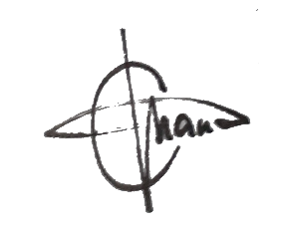***I hereby certify that the above information is true and correct to the best of my knowledge and belief.***

GERALD O. MAÑALAC

4th Year Information Technology Student

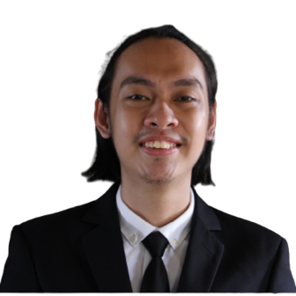**JOHN CARLO C. PINEDA**

 668 Sn. Marcos St., Sepung Bulaun, Porac, Pampanga

 johncarlocpineda@gmail.com

 +63966-182-3841

**EDUCATION:**

|  |  |
| --- | --- |
| 2018 - Present | Bachelor of Science in Information Technology  Don Honorio Ventura State University |
| 2012 - 2018 | Saint Catherine’s Academy |
| 2006 - 2012 | Sepung Bulaun Elementary School |

**WORK EXPERIENCE:**

|  |  |
| --- | --- |
| 2020 | Junior Wordpress Developer  WP Dragons |

**GRANTS, HONORS, SCHOLARSHIPS**

|  |  |
| --- | --- |
| 2021 | Dean’s Lister (2nd Sem S.Y. 2020 – 2021)  College of Computing Studies (CCS) |
| 2021 | President’s Lister (1st Sem S.Y. 2020 – 2021)  College of Computing Studies (CCS) |

**SEMINAR ATTENDED:**

|  |  |
| --- | --- |
| 2018 | #SMLSEMINAR Social Media Literacy Seminar  Don Honorio Ventura State University |

**PERSONAL INFORMATION:**

|  |  |  |
| --- | --- | --- |
| Birthdate | : | July 14, 2000 |
| Birthplace | : | Guagua, Pampanga |
| Gender | : | Male |
| Height | : | 5’6 |
| Weight | : | 65kg |
| Civil Status | : | Single |
| Nationality | : | Filipino |
| Religion | : | Roman Catholic |
| Languages | : | English, Tagalog |

**CHARACTER REFERENCE:**

**Mr. Clyde Ariola**

Chief Executive Officer

WP Dragons

Municipality of Porac

Porac, Pampanga

***I hereby certify that the above information is true and correct to the best of my knowledge and belief.***



**JOHN CARLO C. PINEDA**

4th Year Information Technology Student

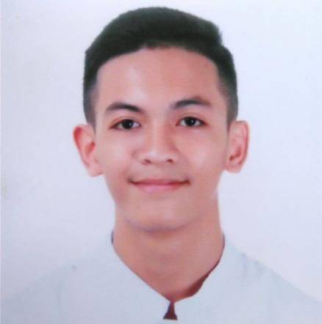**JUSTINE G. SORIANO**

 Purok 3, #324 San Pedro Cutud, City of San Fernando Pampanga

 *it.justinegsoriano@gmail.com*

 +09754281049/09481824157

**EDUCATION:**

|  |  |
| --- | --- |
| 2018 - Present | Bachelor of Science in Information Technology  Don Honorio Ventura State University |
| 2016 - 2018 | Senior High School  Our Lady of Fatima University |
| 2012 - 2016 | Junior High School  Pampanga High School |
| 2009 - 2012 | San Fernando Elementary School Elementary School |
| 2005 – 2009 | Sta. Lucia Elementary School |

**WORK EXPERIENCE:**

|  |  |
| --- | --- |
| 2021 | Advertising Analyst  Mama Merly’s Shop |
| 2020 | Virtual Assistant  RCJ Enterprise |
| 2019 | Graphic Designer  RCJ Enterprise |
| 2016 | Computer Technician/ Laborer  MSDY Cyber Café |

**GRANTS, HONORS, SCHOLARSHIPS**

|  |  |
| --- | --- |
| 2021 | Dean’s Lister ( 2nd Sem S.Y. 2020 – 2021)  College of Computing Studies (CCS) |
| 2020 | Battle of the Bands (1st Runner Up) |
| 2019 | President’s Lister ( 1st Sem S.Y. 2019 – 2020)  College of Computing Studies (CCS) |
| 2019 | Dean’s Lister ( 2nd Sem S.Y. 2020 – 2021)  College of Computing Studies (CCS) |
| 2018 | Dean’s Lister (1st Sem S.Y. 2020 – 2021)  College of Computing Studies (CCS) |
| 2018 | Senior High School Graduated with Honors |
| 2018 | Campus Sports Fest (Basketball) 1st Runner Up |
| 2018 | Science and Technology Fair Champion  Culminating Activity (OLFU Pampanga) |
| 2016 | PC Assembly & Networking Champion |
| 2014 | Tarpaulin Making Champion |
| 2013 | Speed Typing Champion |
| 2012 | 5th Honor (Medal Received) |
| 2009 | 6th Honor (Medal Received) |
| 2008 | 6th Honor (Medal Received) |
| 2007 | 5th Honor and Best in Character (Medals Received) |
| 2006 | 3rd Honor (Medal Received) |
| 2005 | 1st Honor (Medal Received) |

**SEMINAR ATTENDED:**

|  |  |
| --- | --- |
| 2019 | Disaster Risk Reduction and Management |
| 2018 | #SMLSEMINAR Social Media Literacy Seminar  Don Honorio Ventura State University |
| 2017 | SHS-ICT Microsoft Office Proficiency Exam  Our Lady of Fatima University |
| 2016 | Computer Programming, PC Assembly and Tarpaulin Making |

**PROFESSIONAL AFFILIATIONS**

|  |  |
| --- | --- |
| 2019 - 2020 | Board Member on Student Affairs  College of Computing Studies Student Council (CCSSC) |
| 2017 - 2018 | President  Sports Club |
| 2017 - 2018 | Campus Production Team  Our Lady of Fatima University (MASSCOM) |
| 2016 - 2018 | Auditor  Our Lady of Fatima University Officers Club |

**PERSONAL INFORMATION:**

|  |  |  |
| --- | --- | --- |
| Birthdate | : | Septermber 9, 1999 |
| Birthplace | : | Jose B. Lingad Memorial Hospital (CSFP) |
| Gender | : | Male |
| Height | : | 5’8 |
| Weight | : | 114 lbs |
| Civil Status | : | Single |
| Nationality | : | Filipino |
| Religion | : | Roman Catholic |
| Languages | : | English, Tagalog, Pampango |

**CHARACTER REFERENCE:**

**Rolly A. Manese**

Foreman

San Vicente, Sto. Tomas Pampanga

0917 417 1012

**Jenny Chua**

Business Woman

Purok 4 San Pedro Cutud, City of San Fernando Pampanga

0927 462 4383

***I hereby certify that the above information is true and correct to the best of my knowledge and belief.***

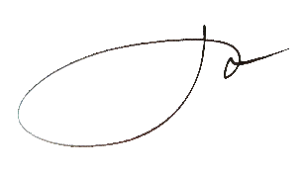

**JUSTINE G. SORIANO**

4th Year Information Technology Student

**APPENDICES**

**APPENDIX A**

(Approved Letters & Certification)

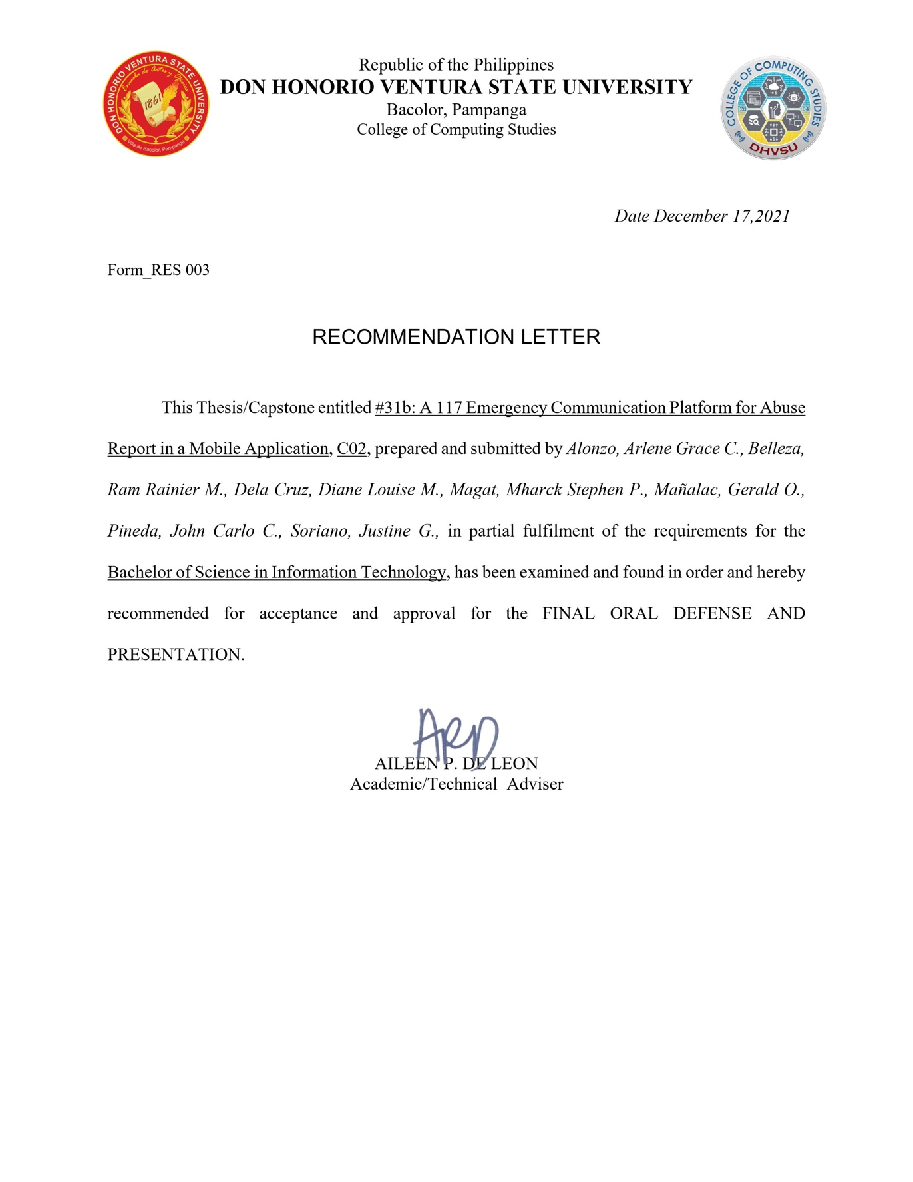

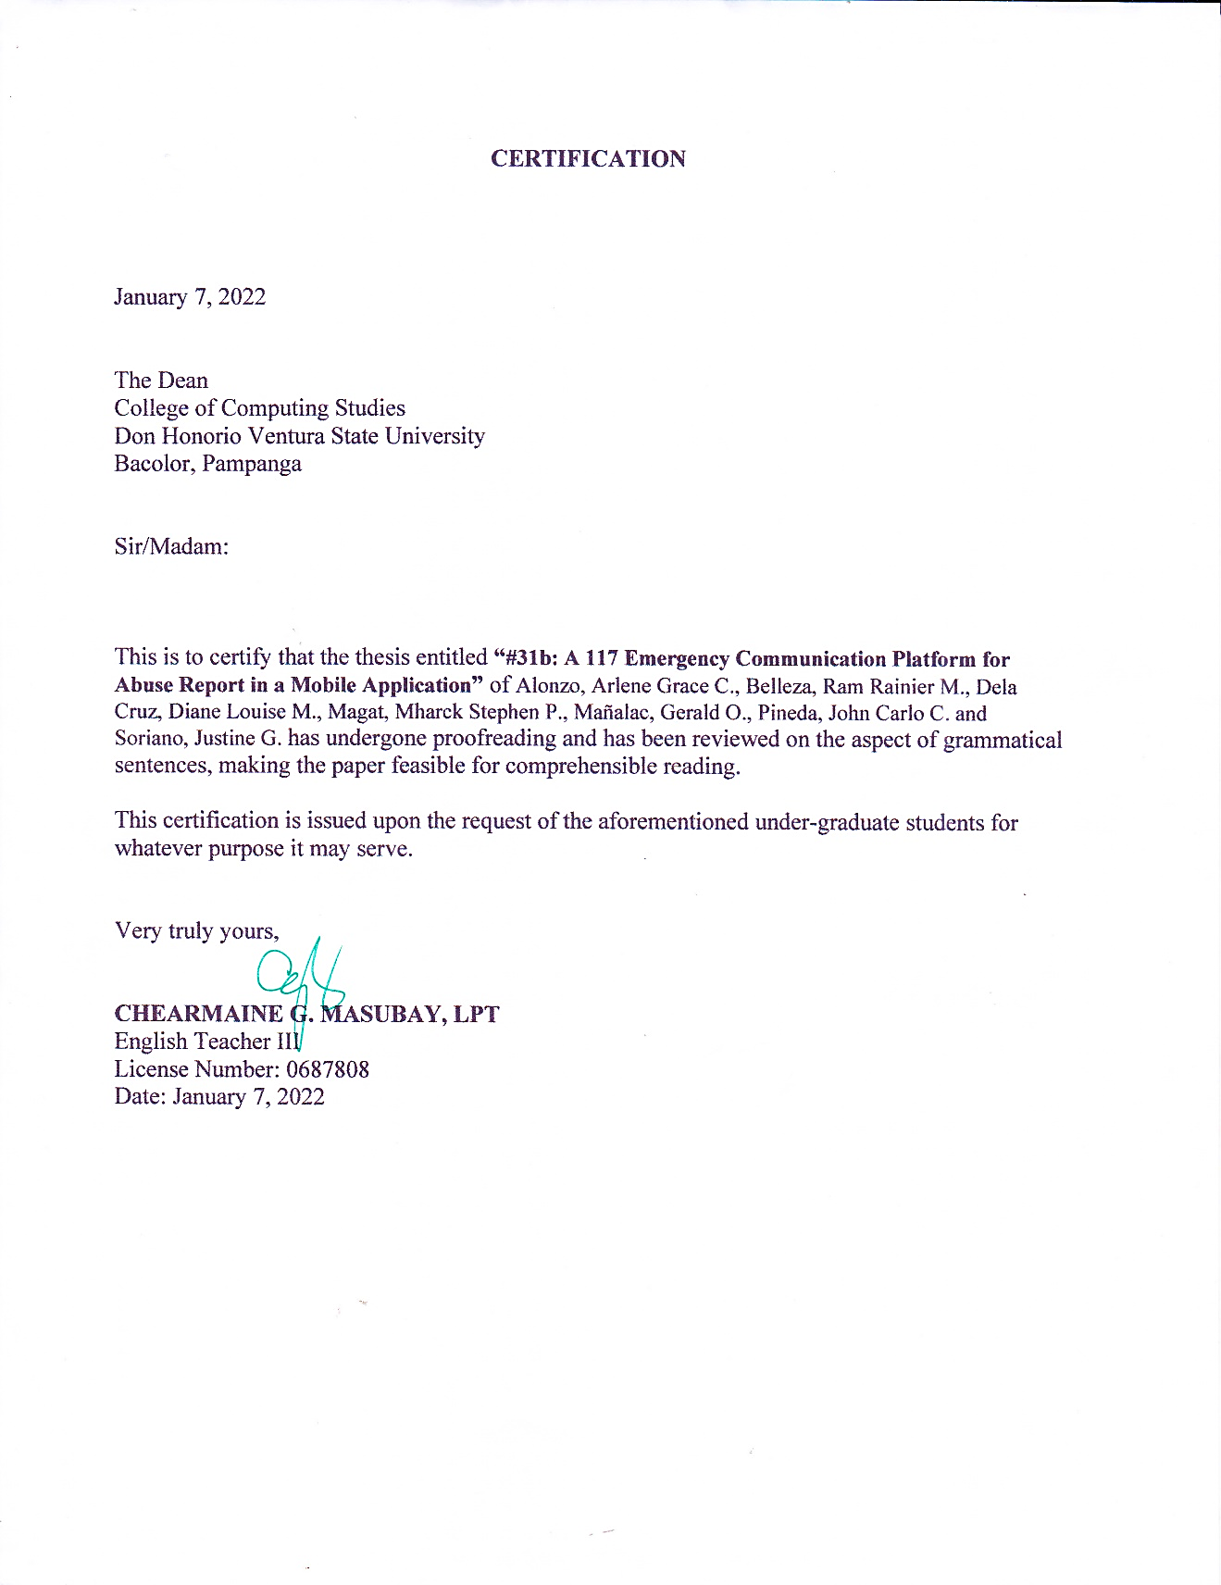

**APPENDIX B**

(Visual Table of Contents)

Visual Table of Contents (Proposed System)

**Login Page**

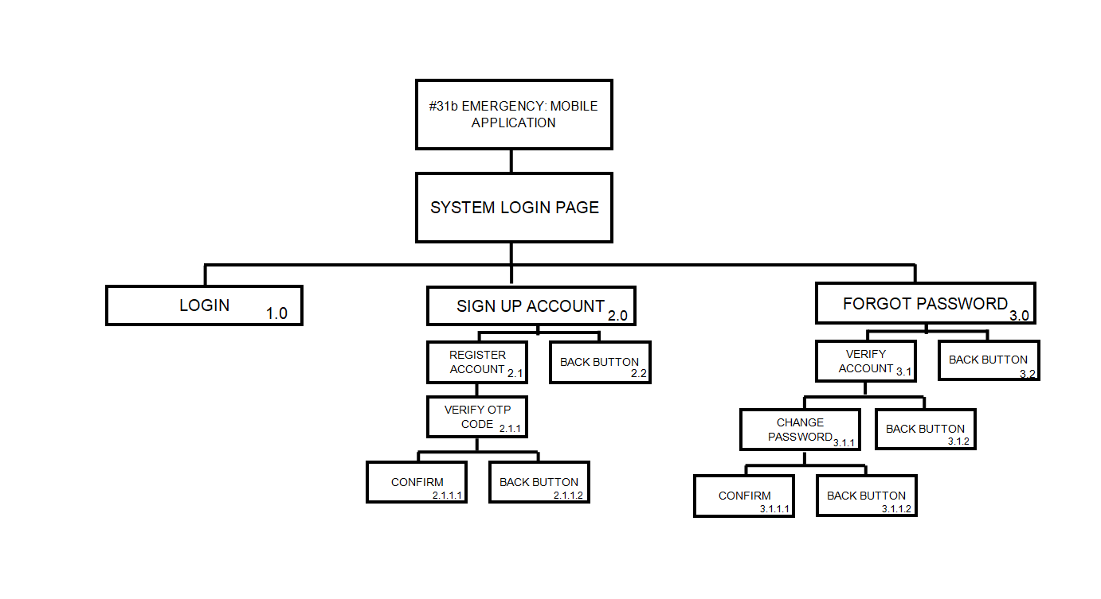

**Landing (Dashboard) Page**

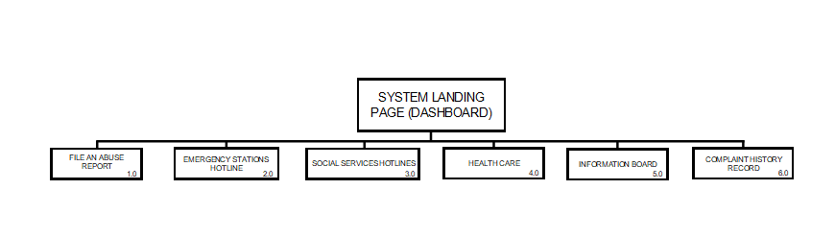

**File an Abuse Report Page**

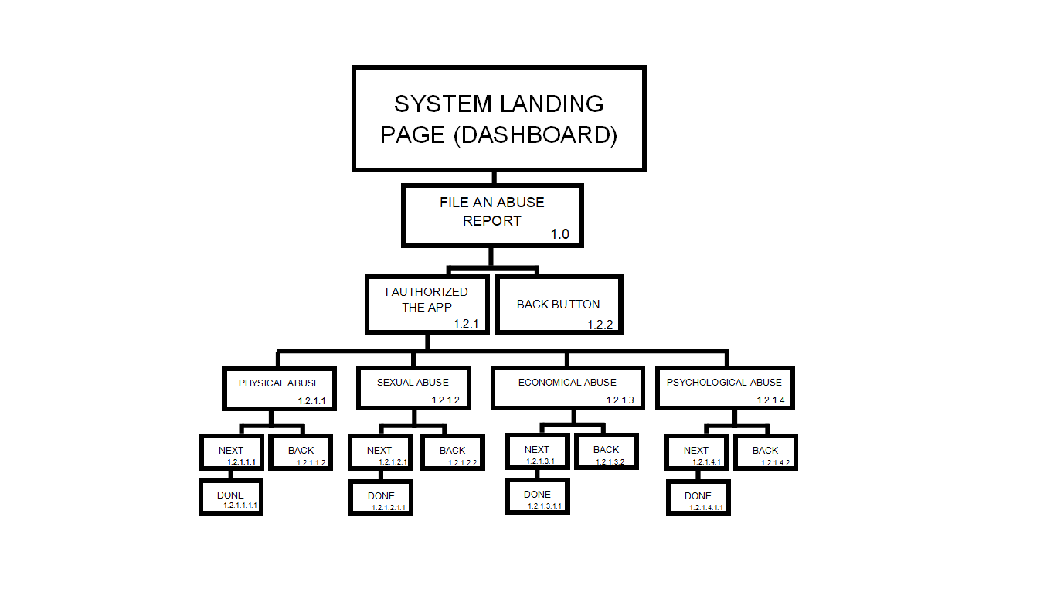

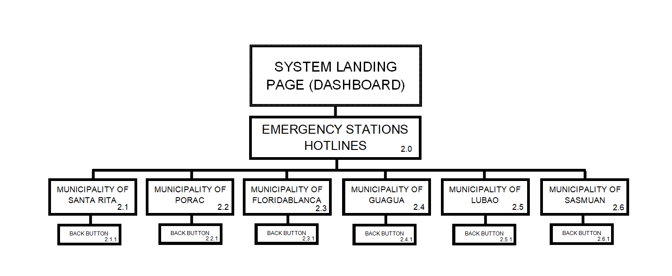**Emergency Stations Hotlines Page**

**Social Services Hotlines Page**

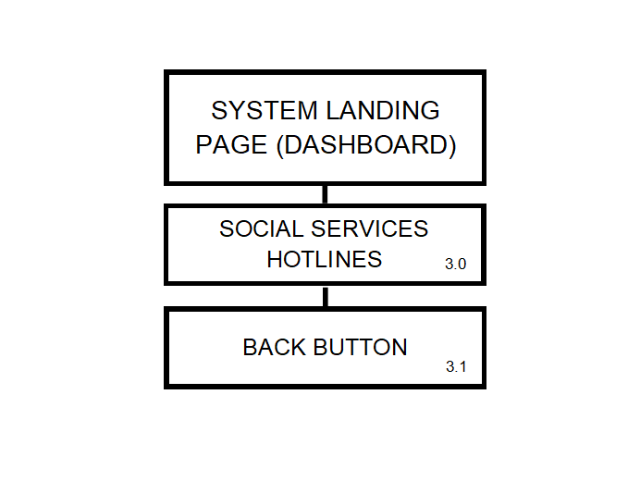

**Health Care Page**

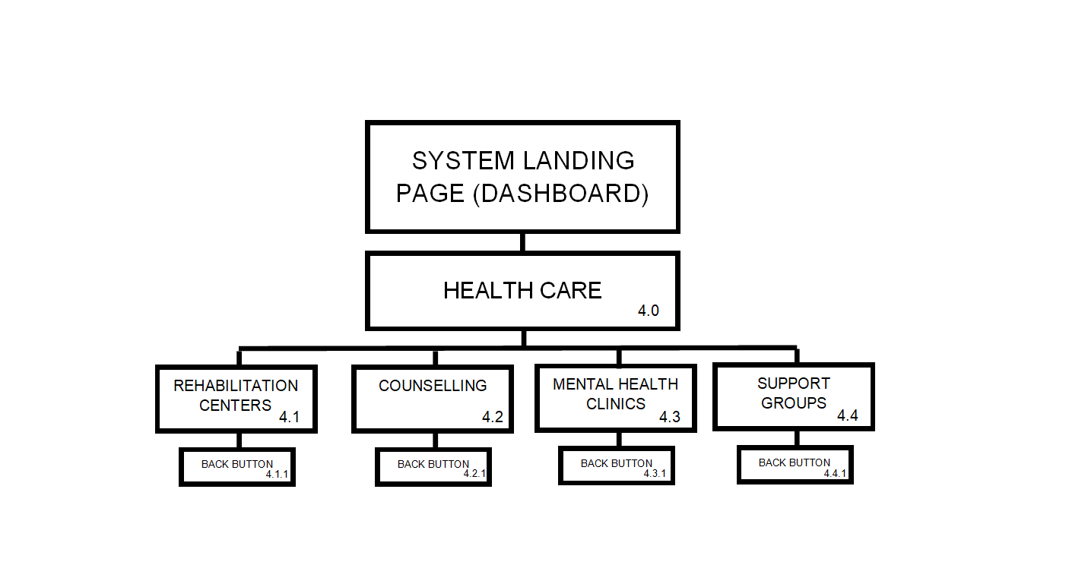

**Information Board Page**

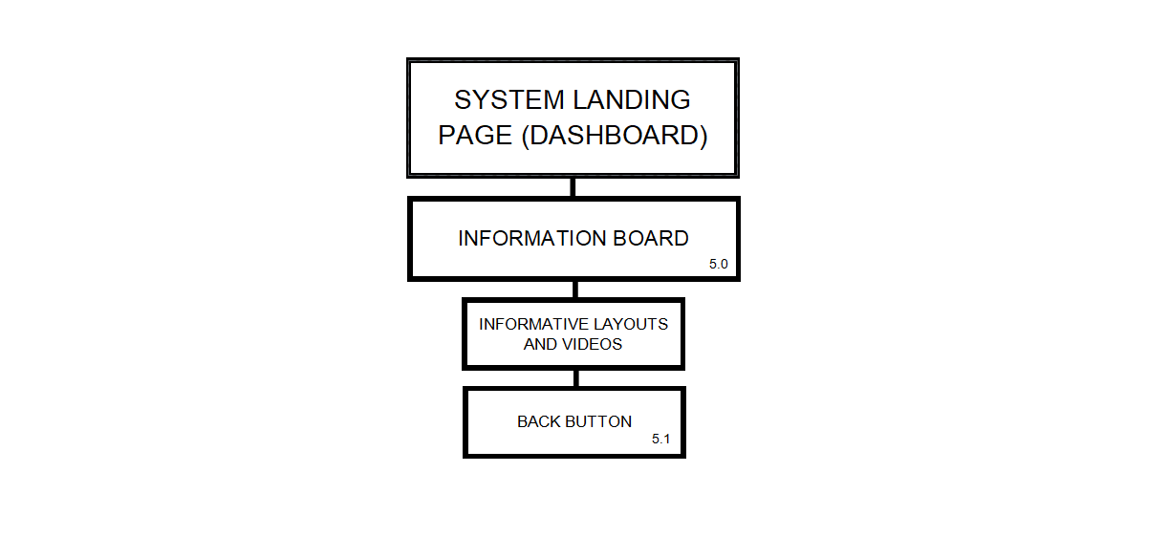

**History Page**

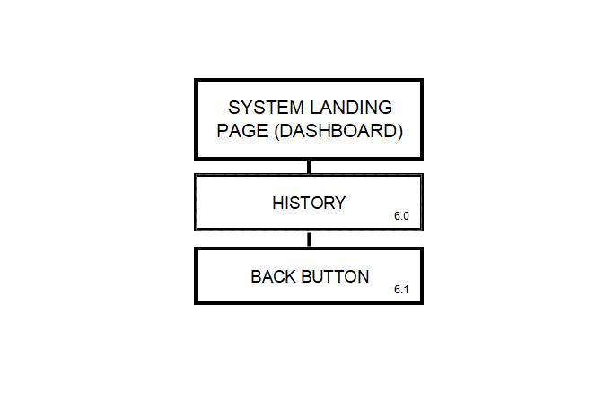

**(User) Side Navigation Panel**

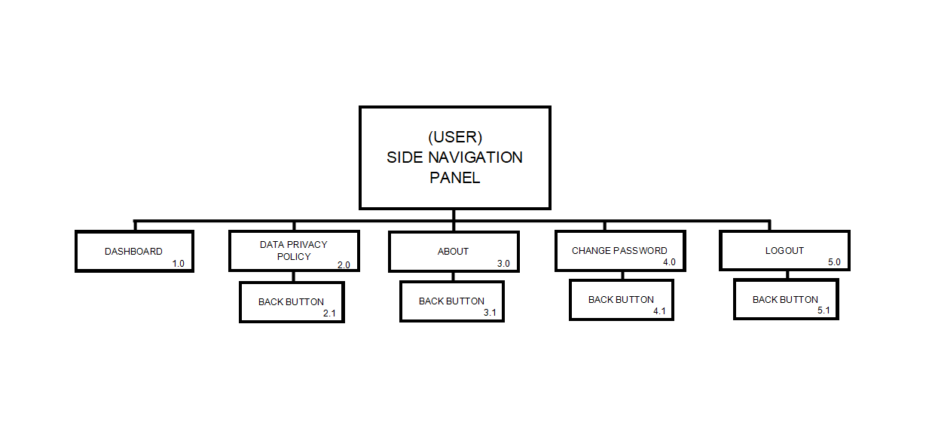

**APPENDIX C**

(Data Flow Diagram and Context Diagram)

**DFD Level 0**

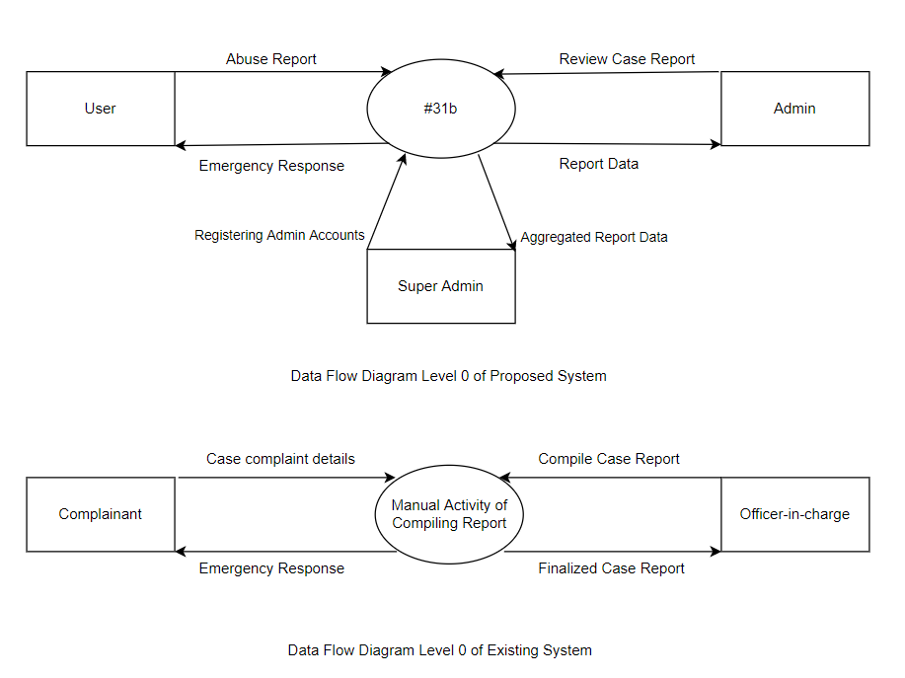



**Context Diagram**

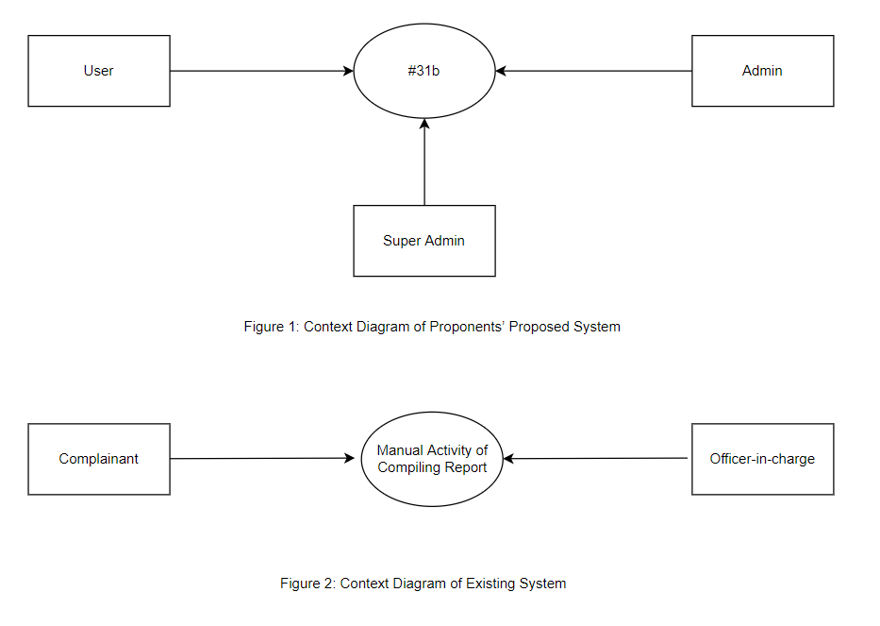

Context Diagram of Proposed System



Context Diagram of Existing System

**APPENDIX D**

(Entity Relationship Diagram)

**Entity Relationship Diagram**

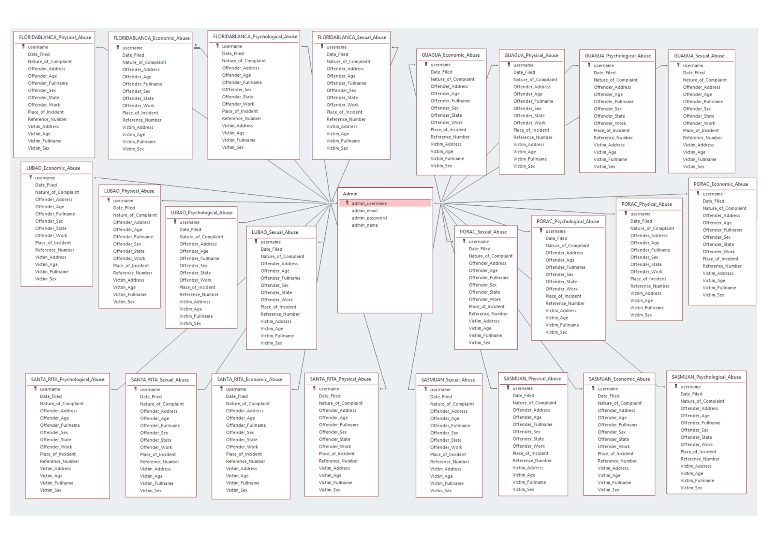

**ERD of #31b Mobile Application (Admin)**

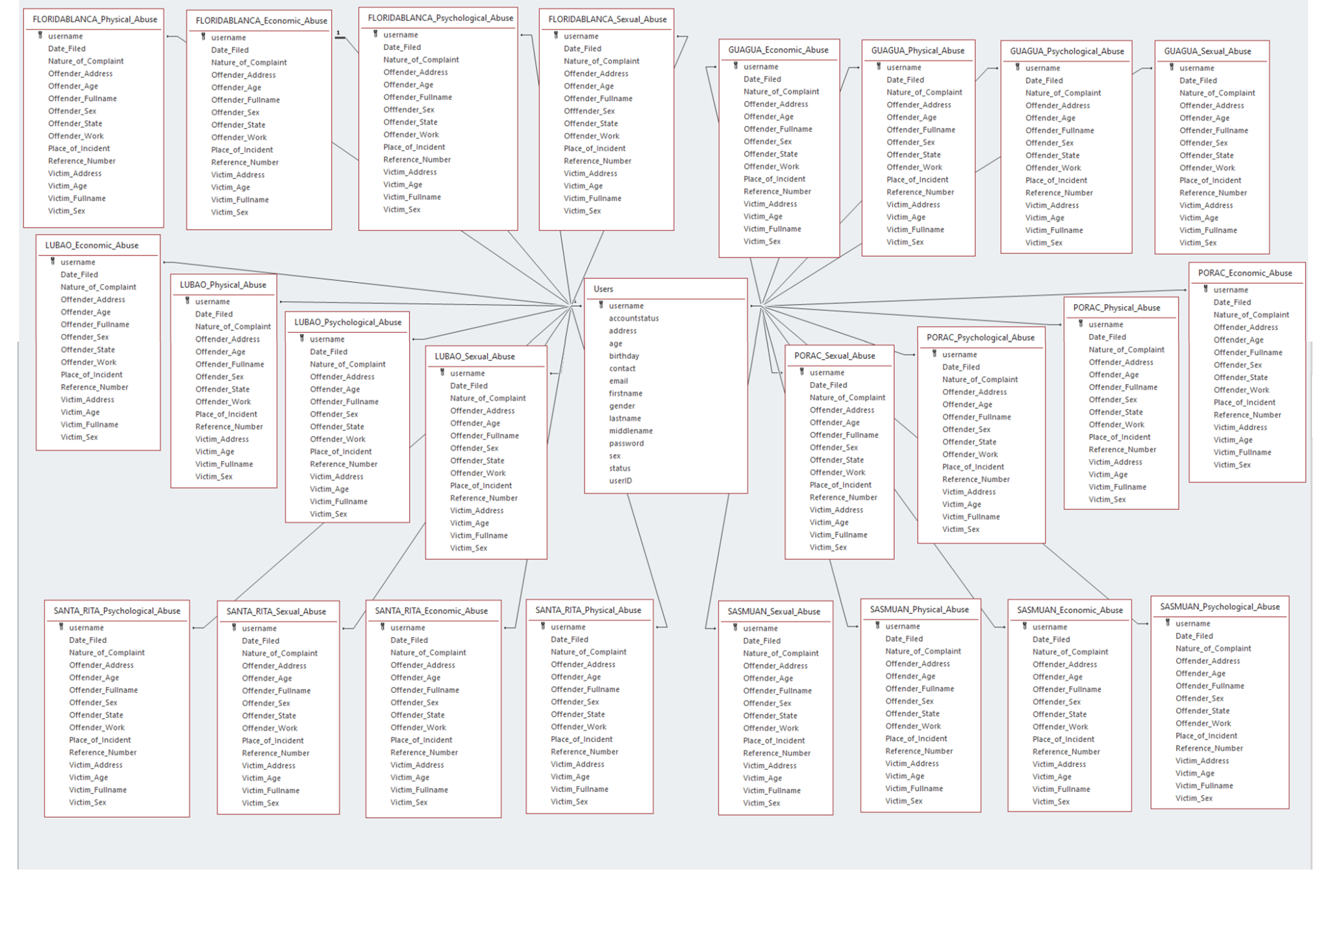

**ERD of #31b Mobile Application (User)**

**APPENDIX E**

(System Screenshots)

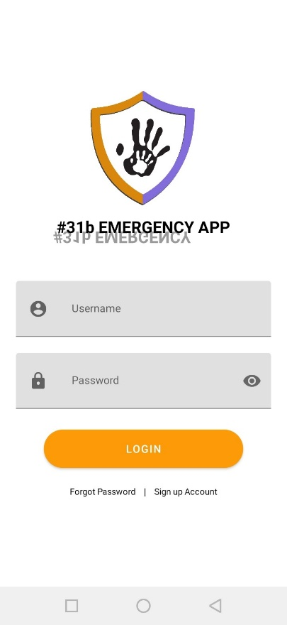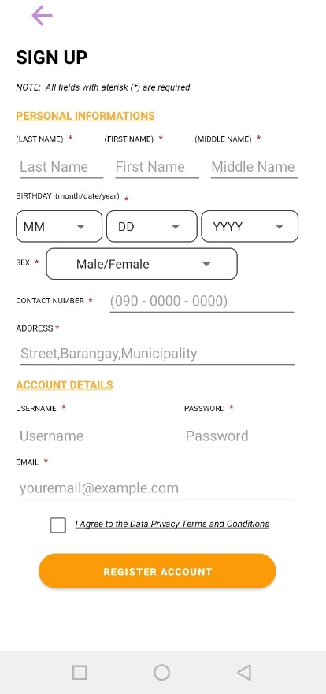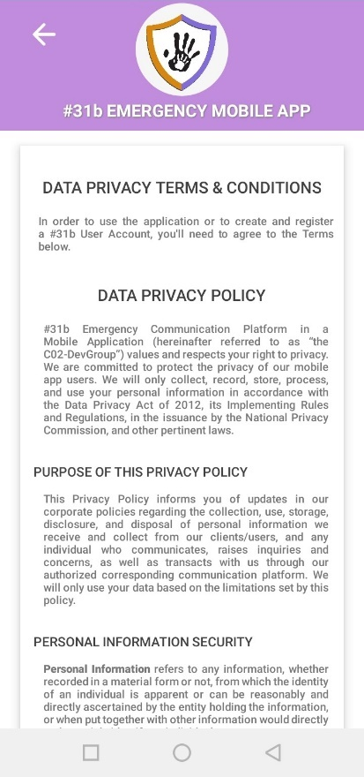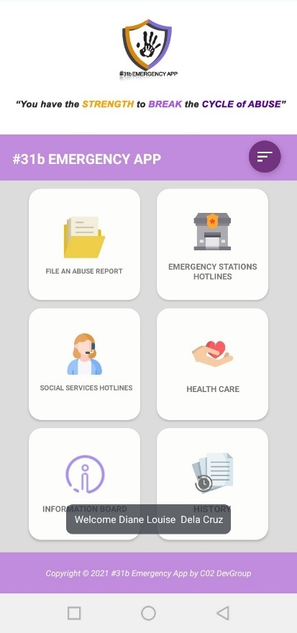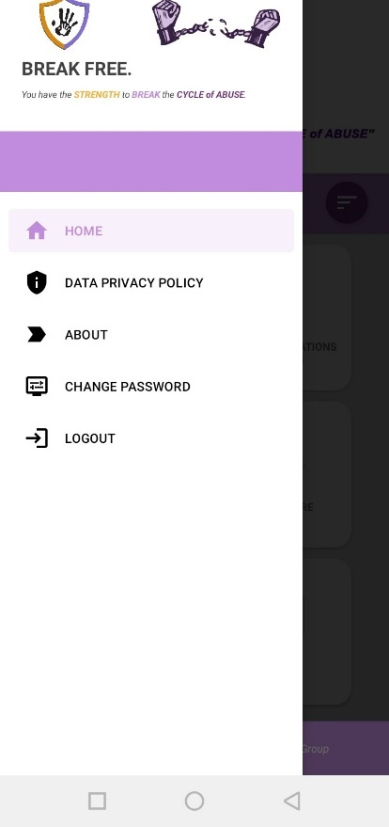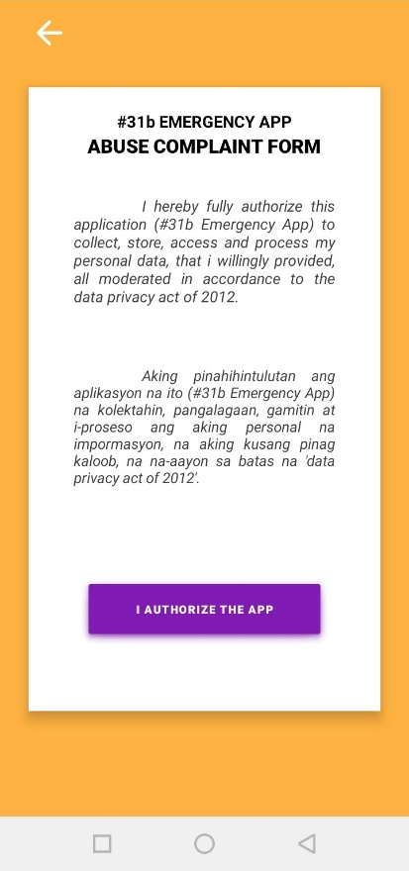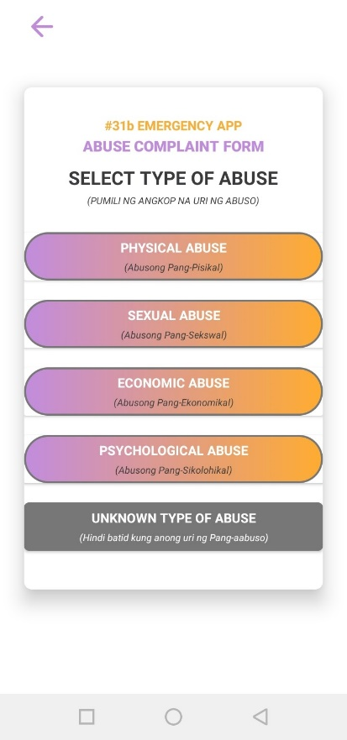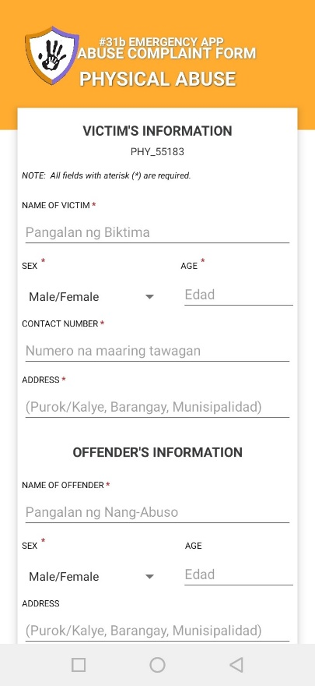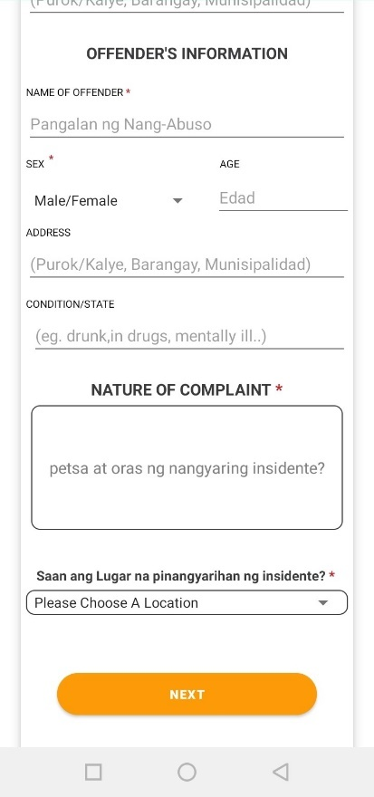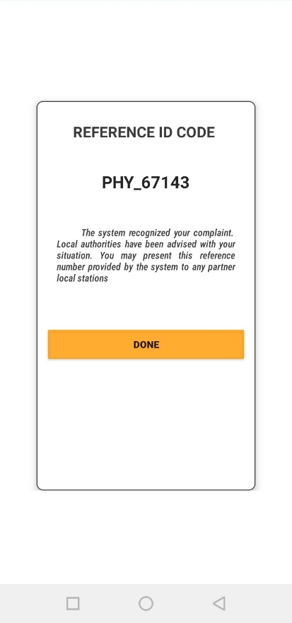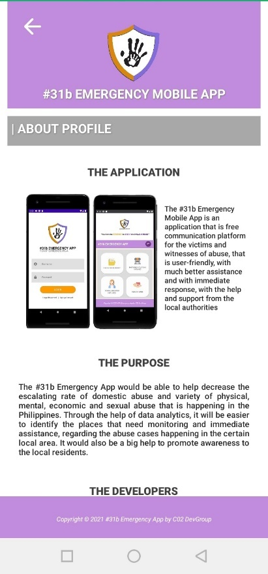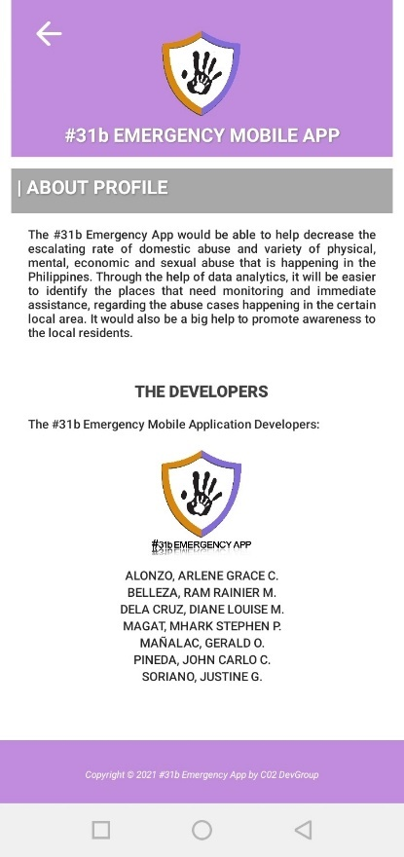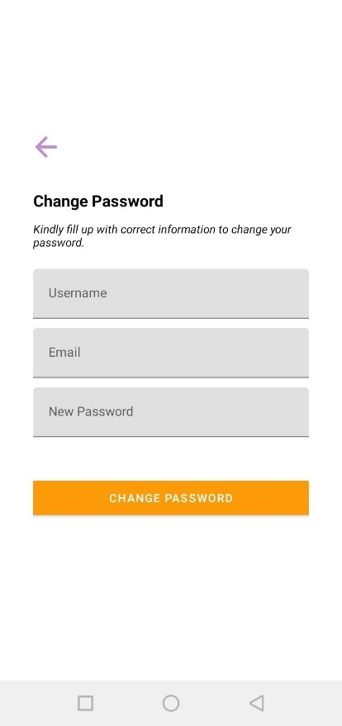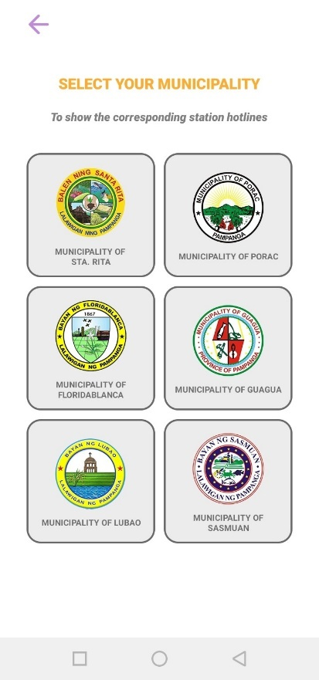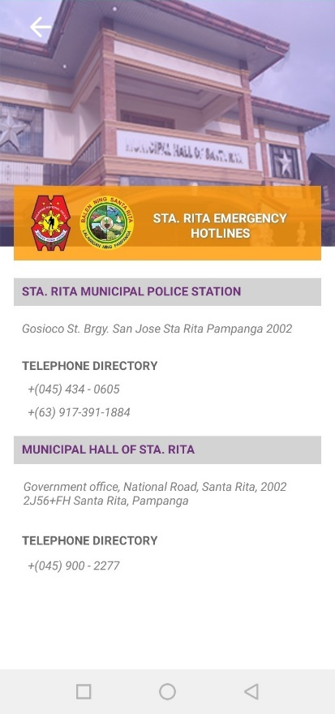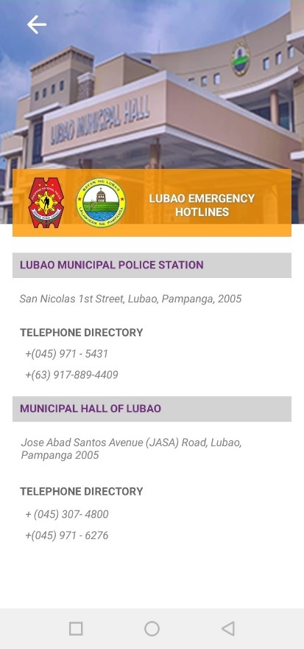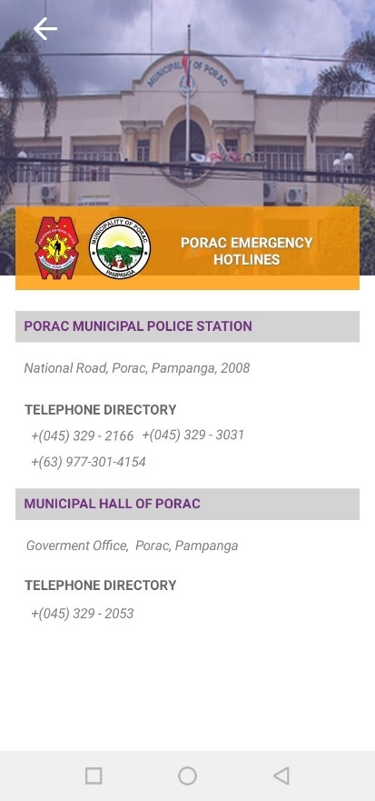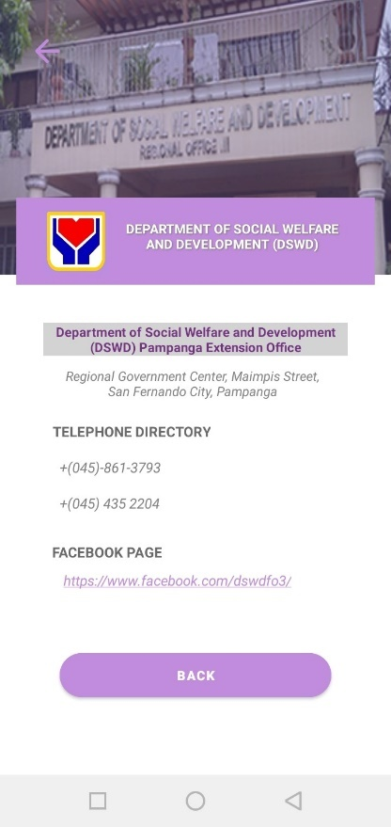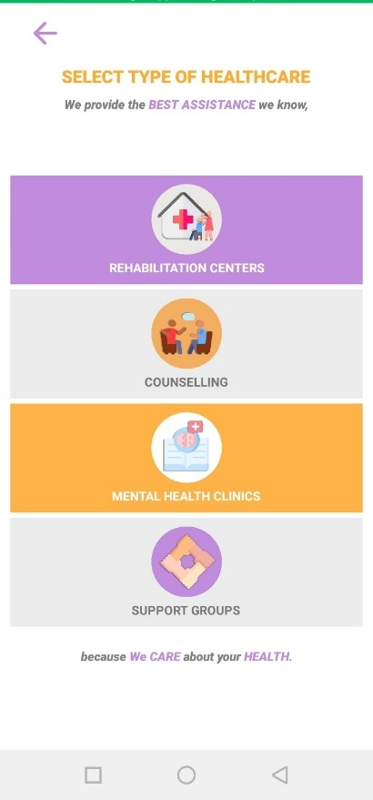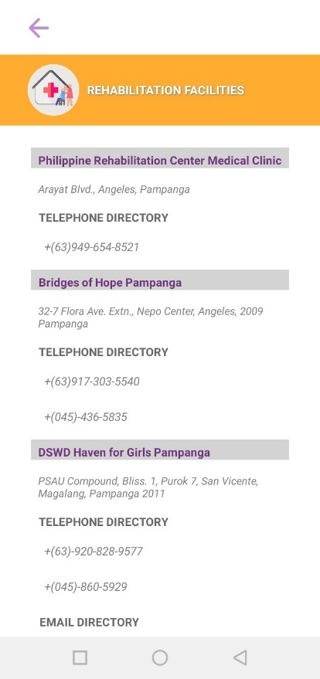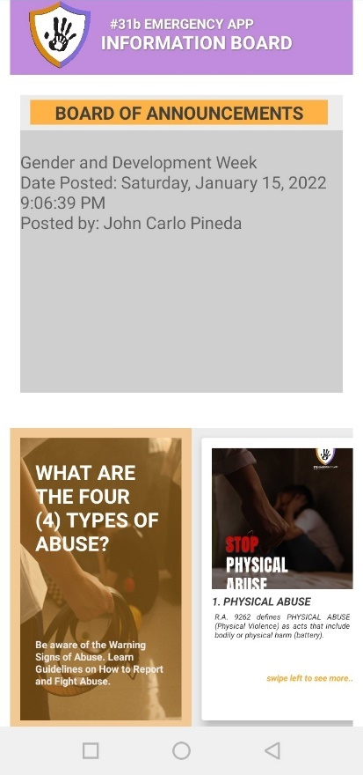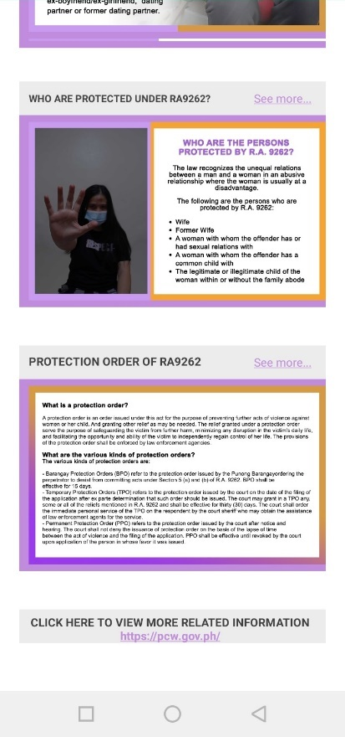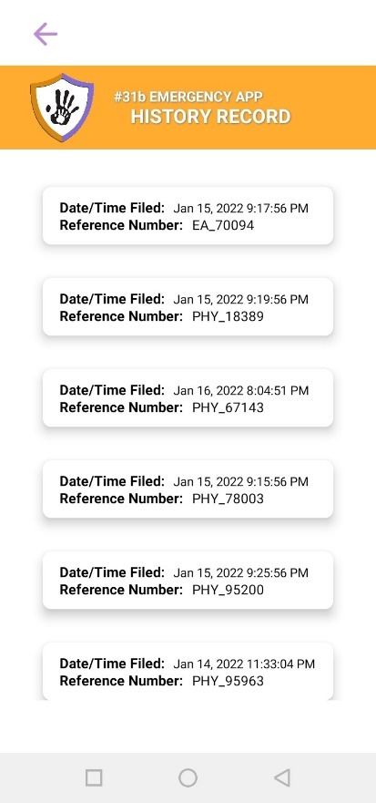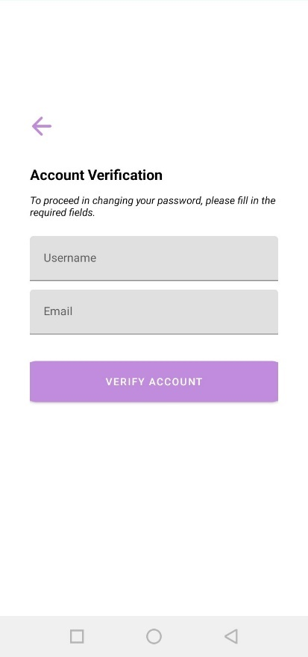

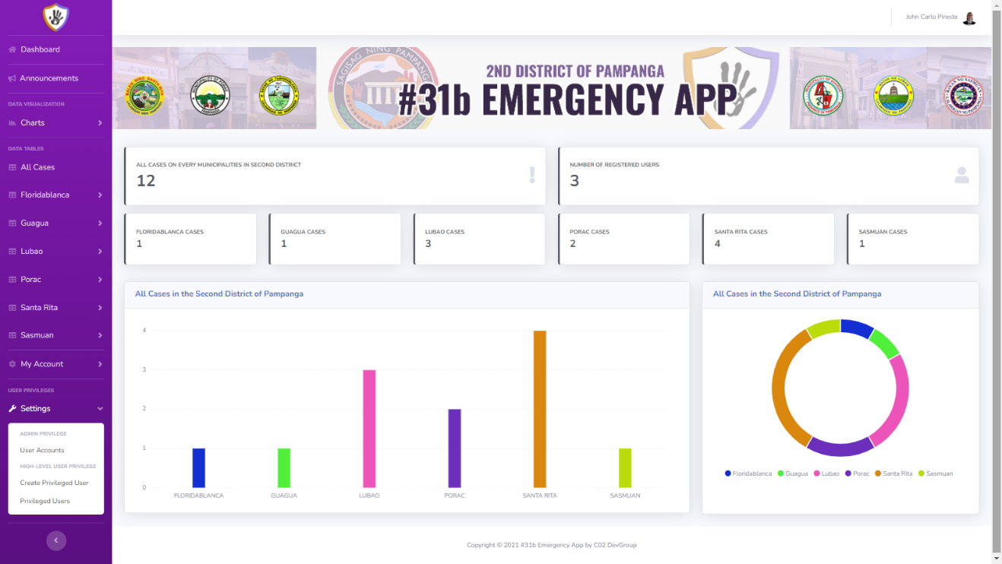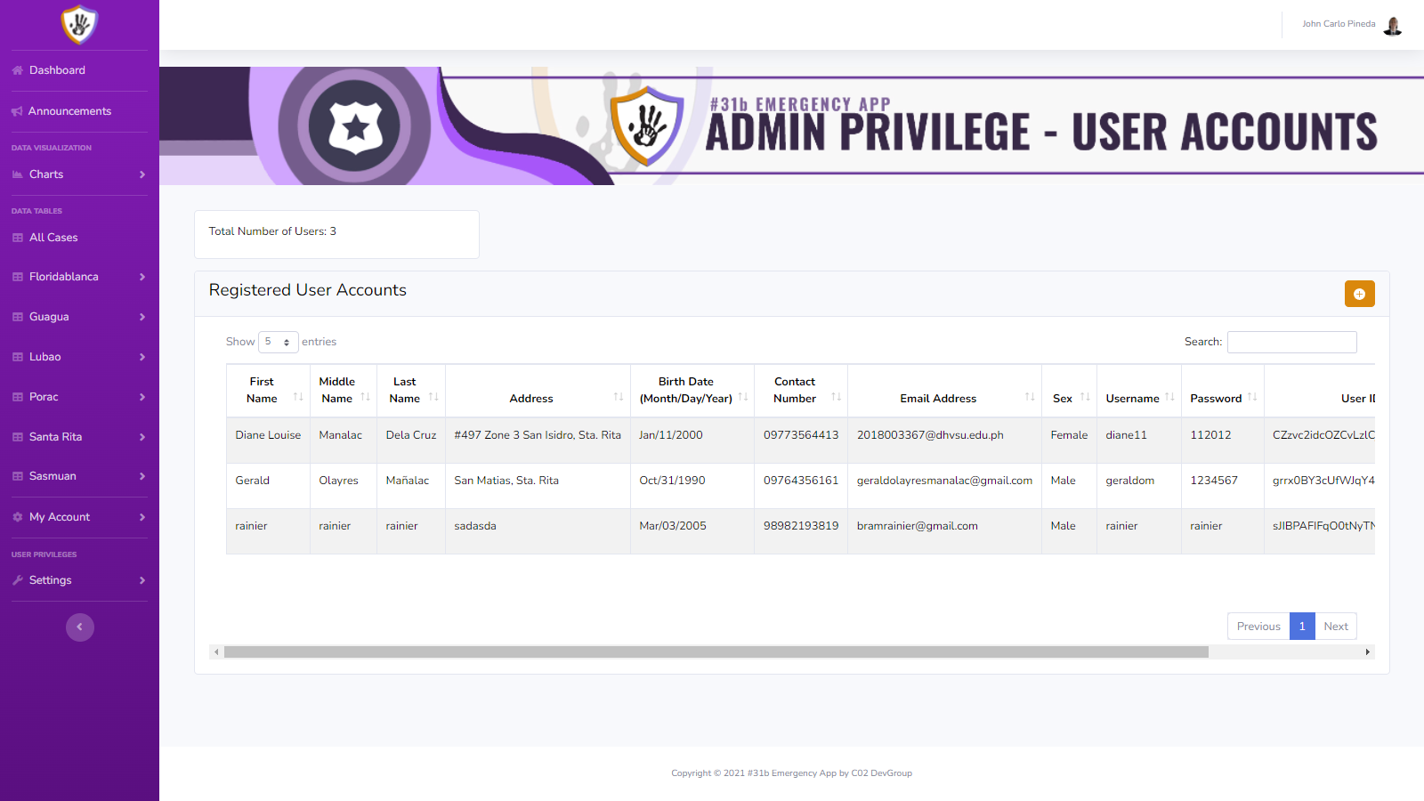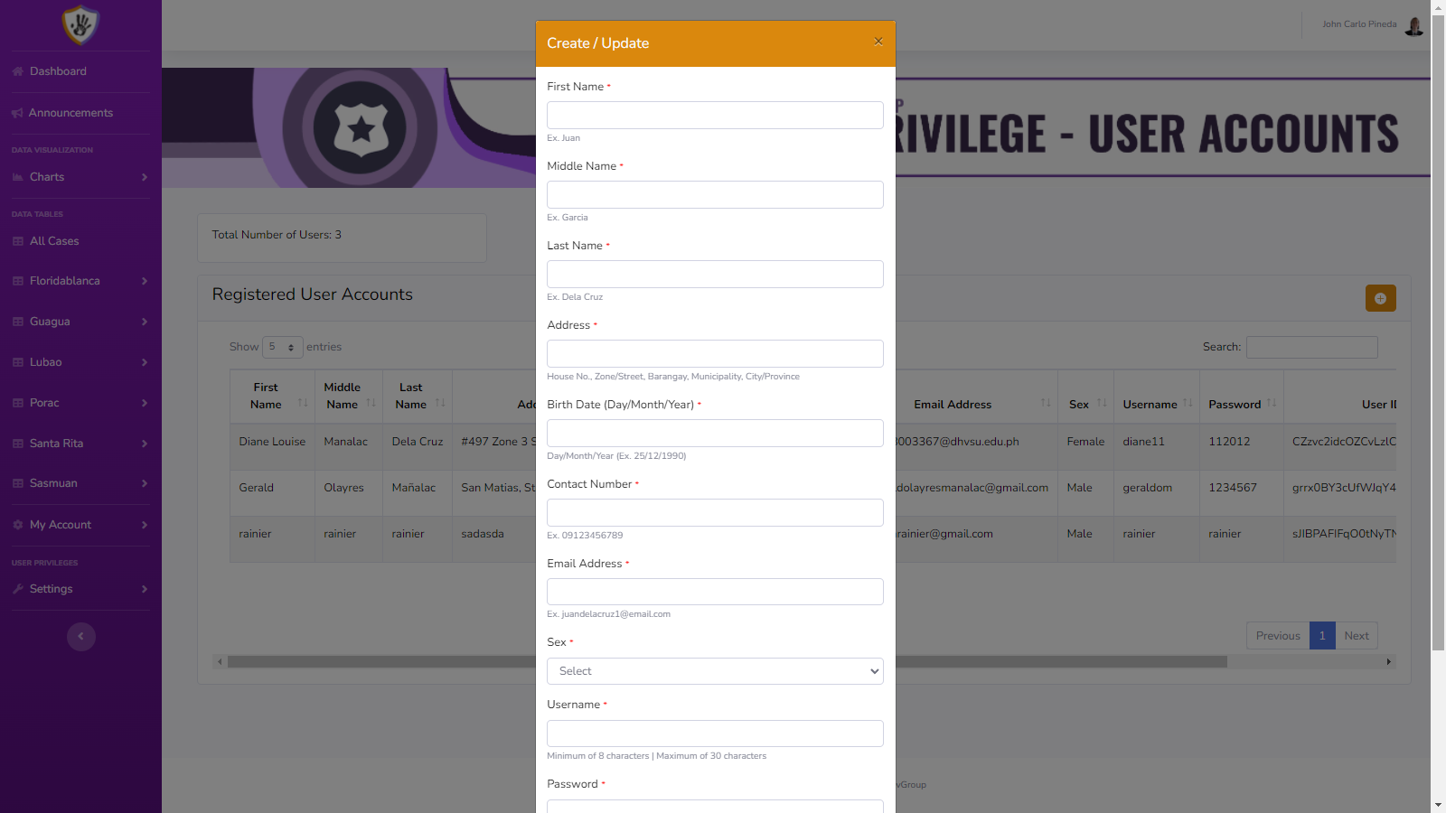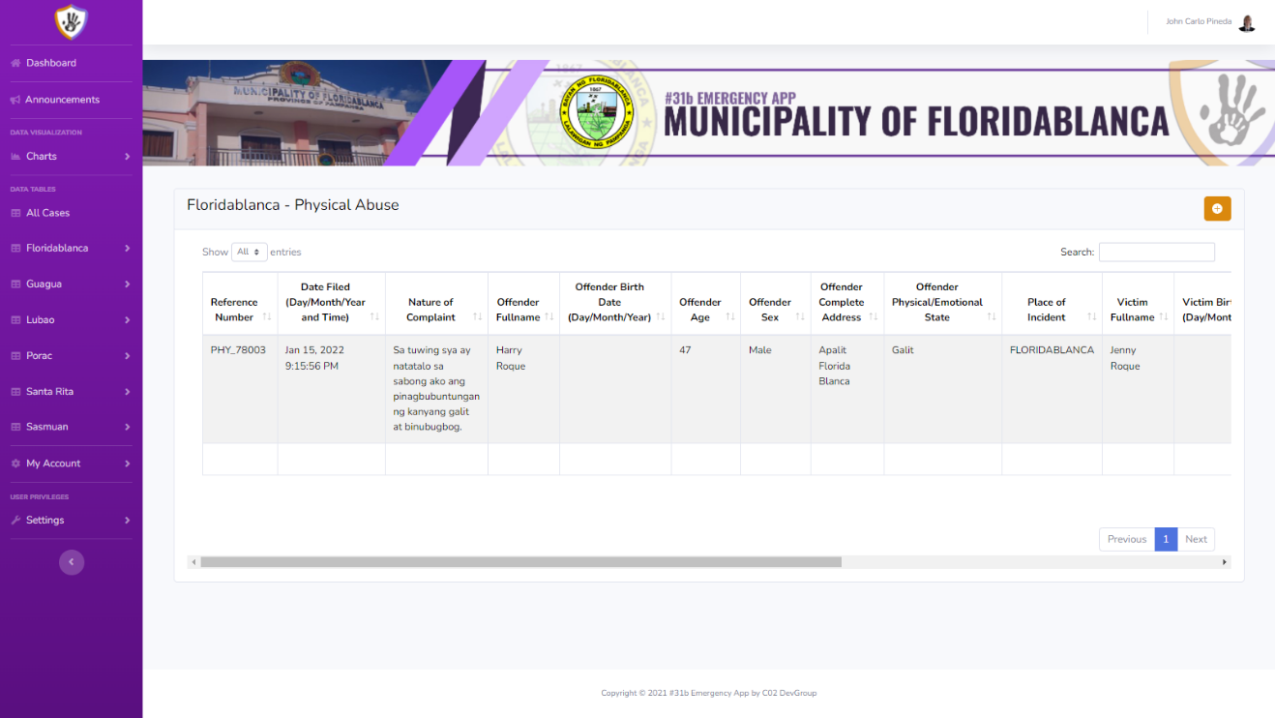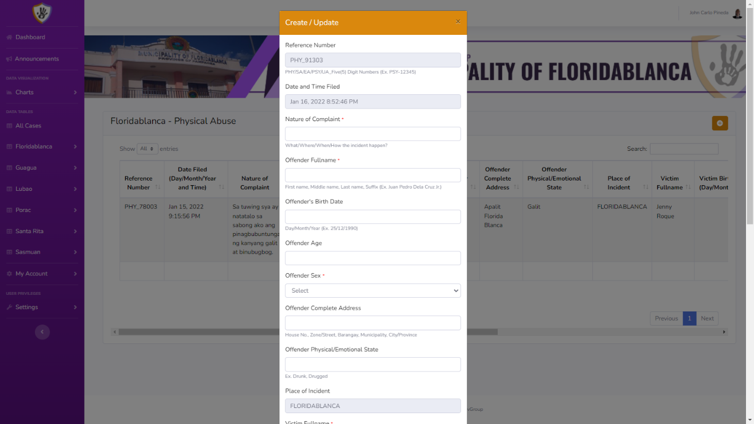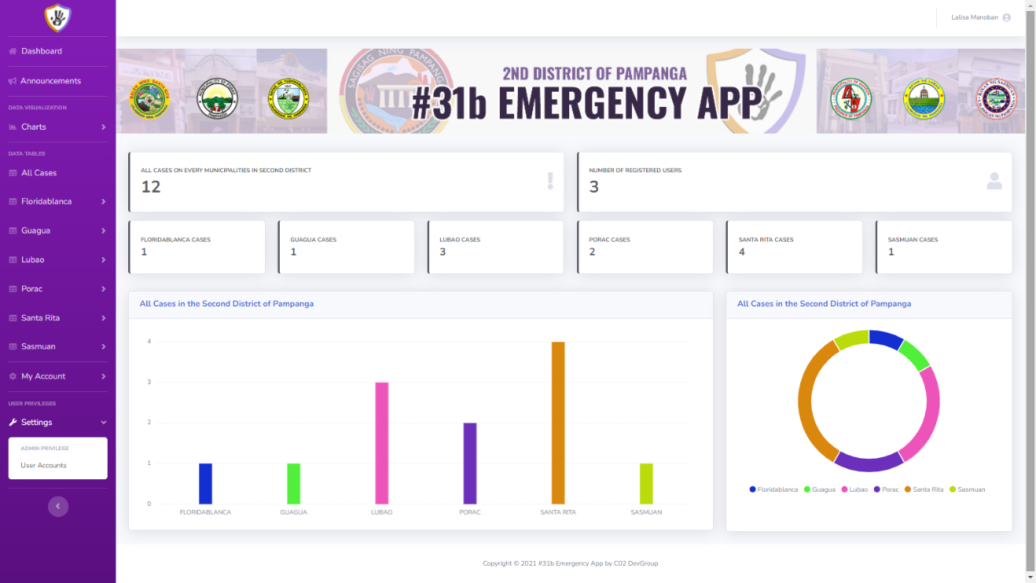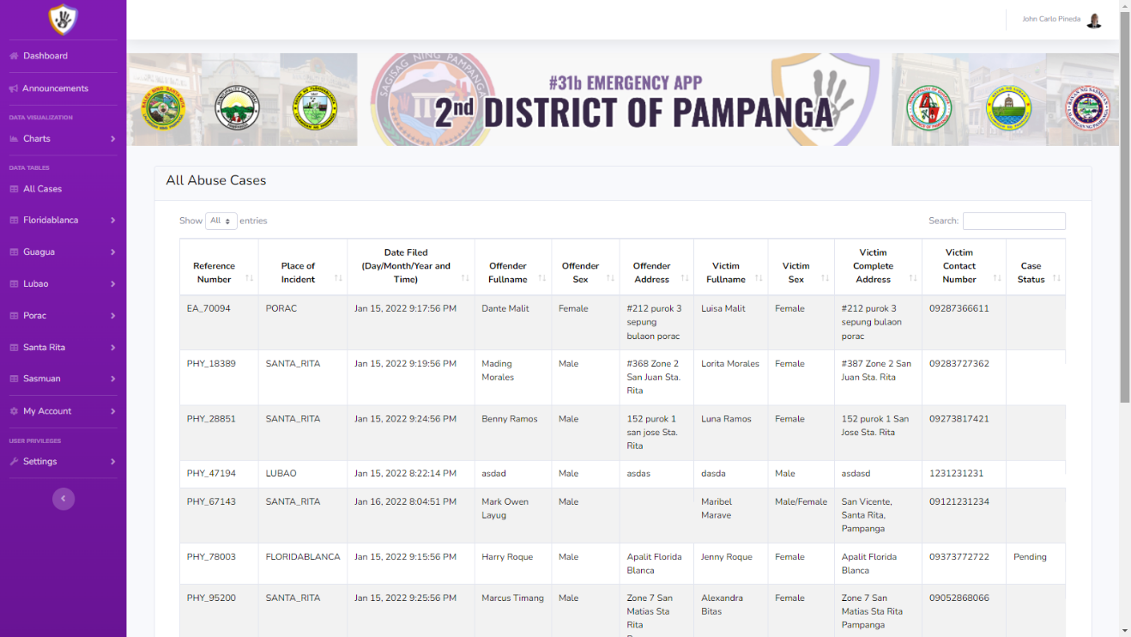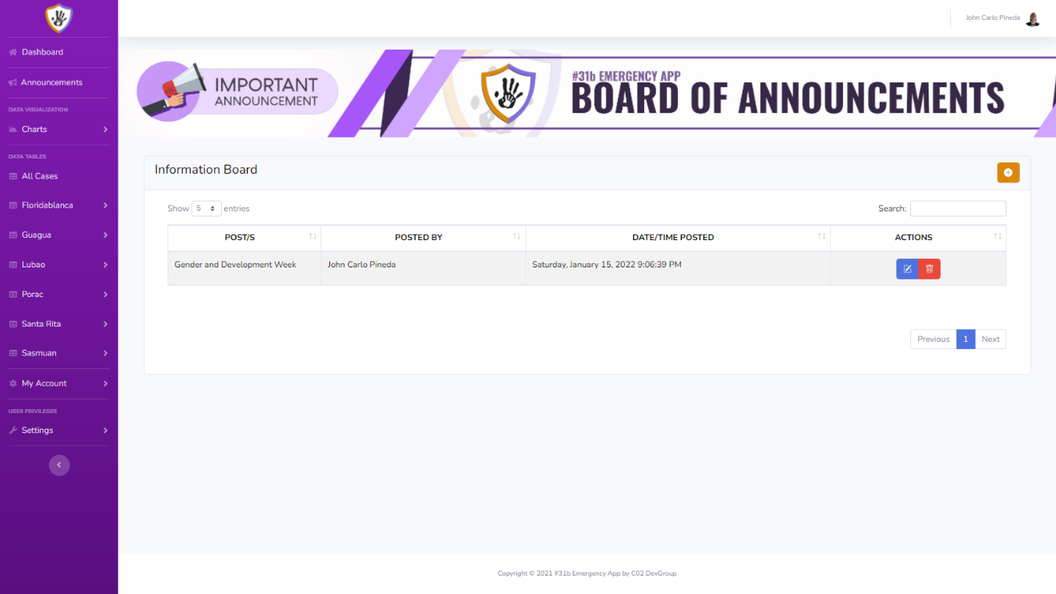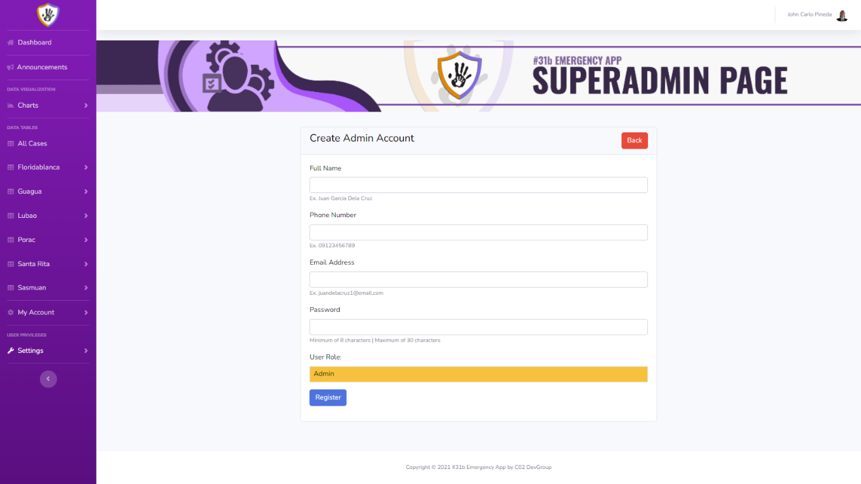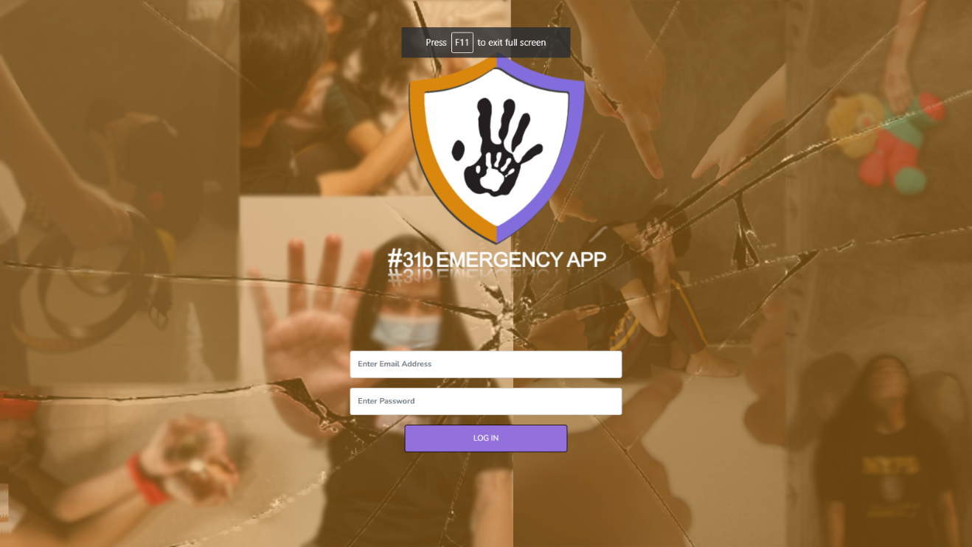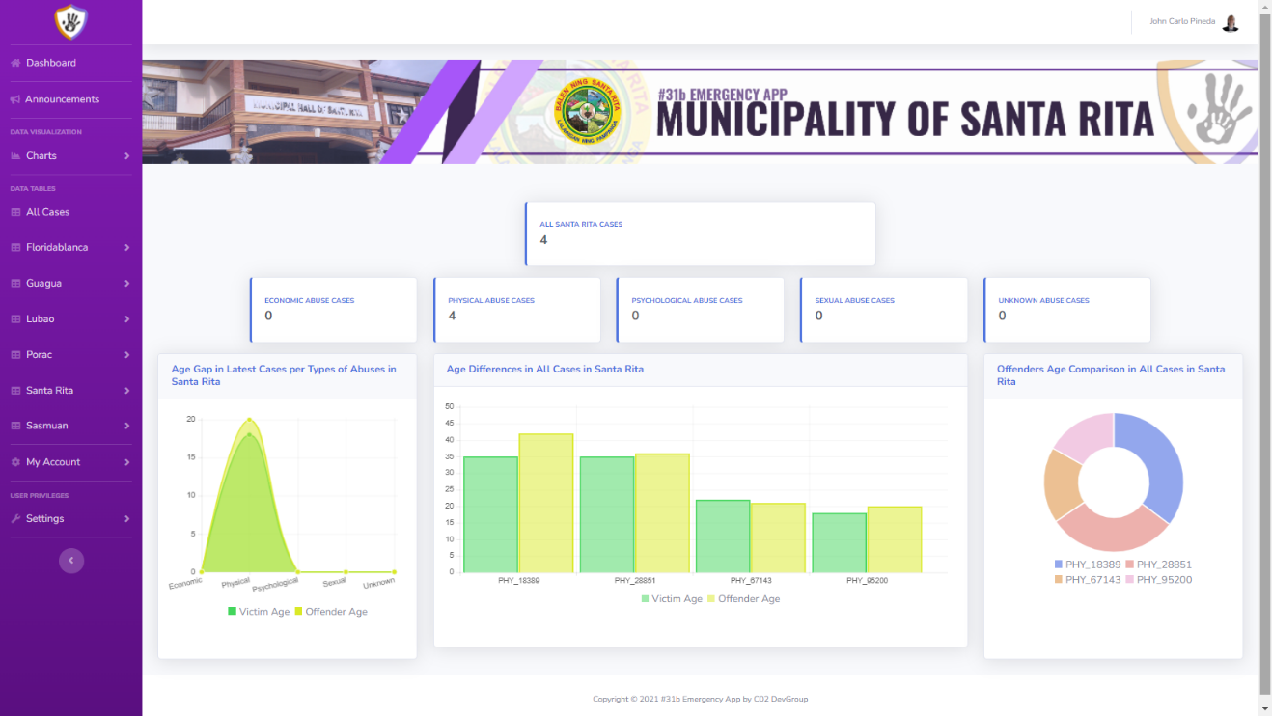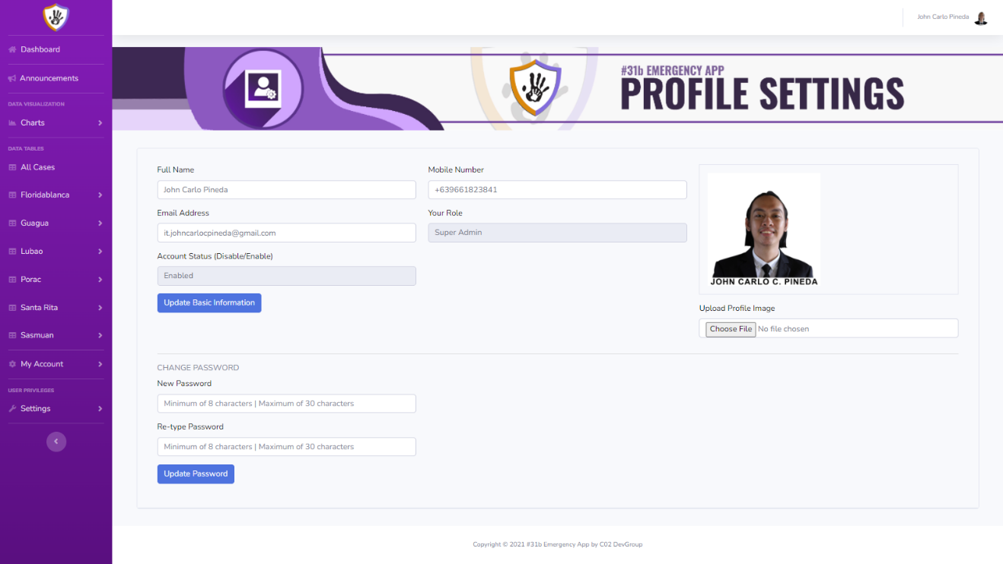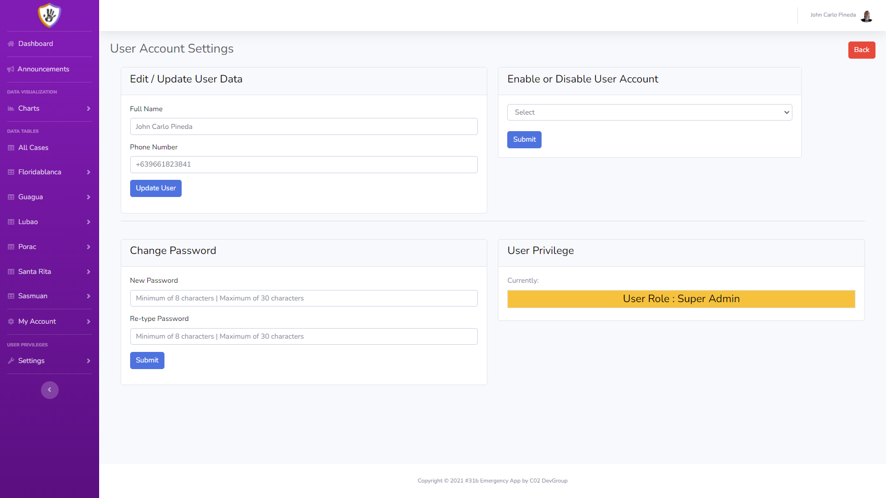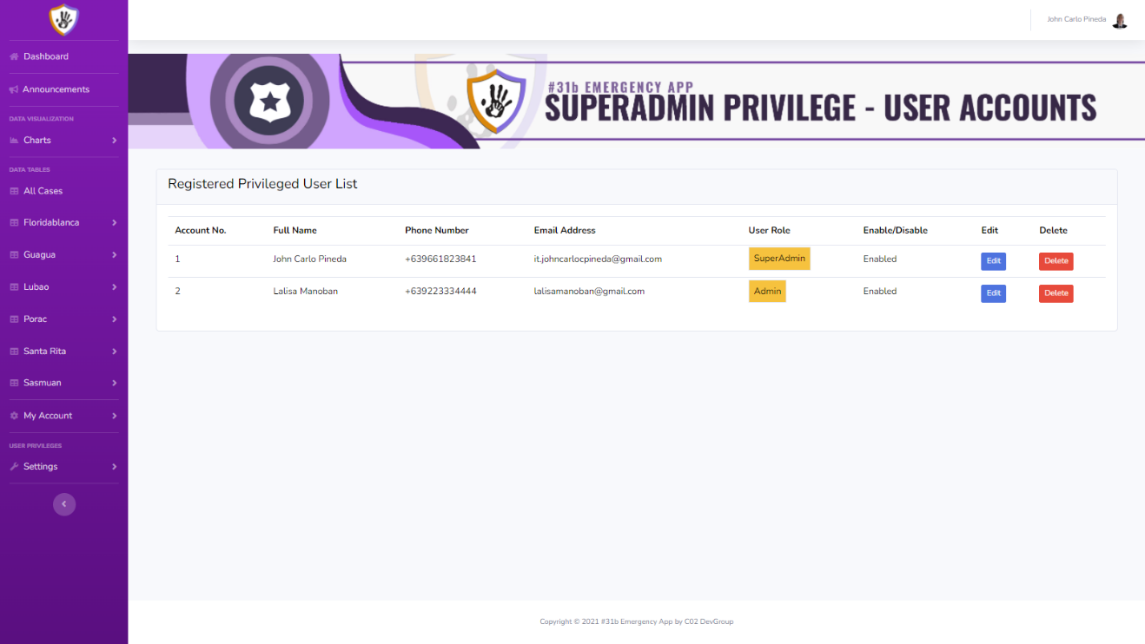

**APPENDIX F**

(System Flowchart)

**System Flowchart of Proposed System**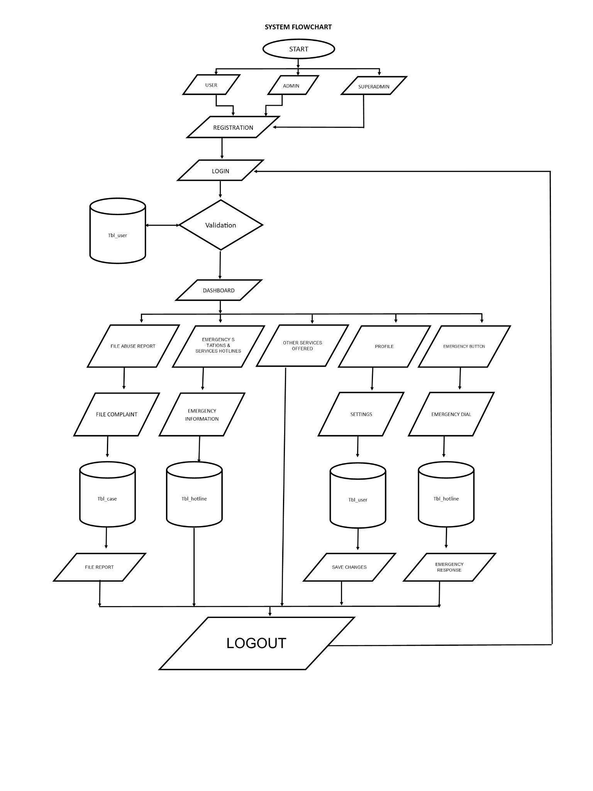

**Existing System Flowchart**

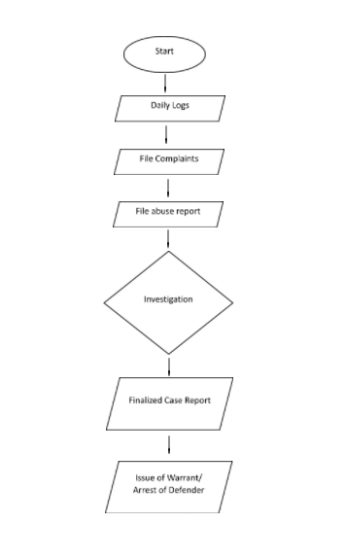

**APPENDIX G**

(Program Flowchart)

**Existing Program Flowchart**

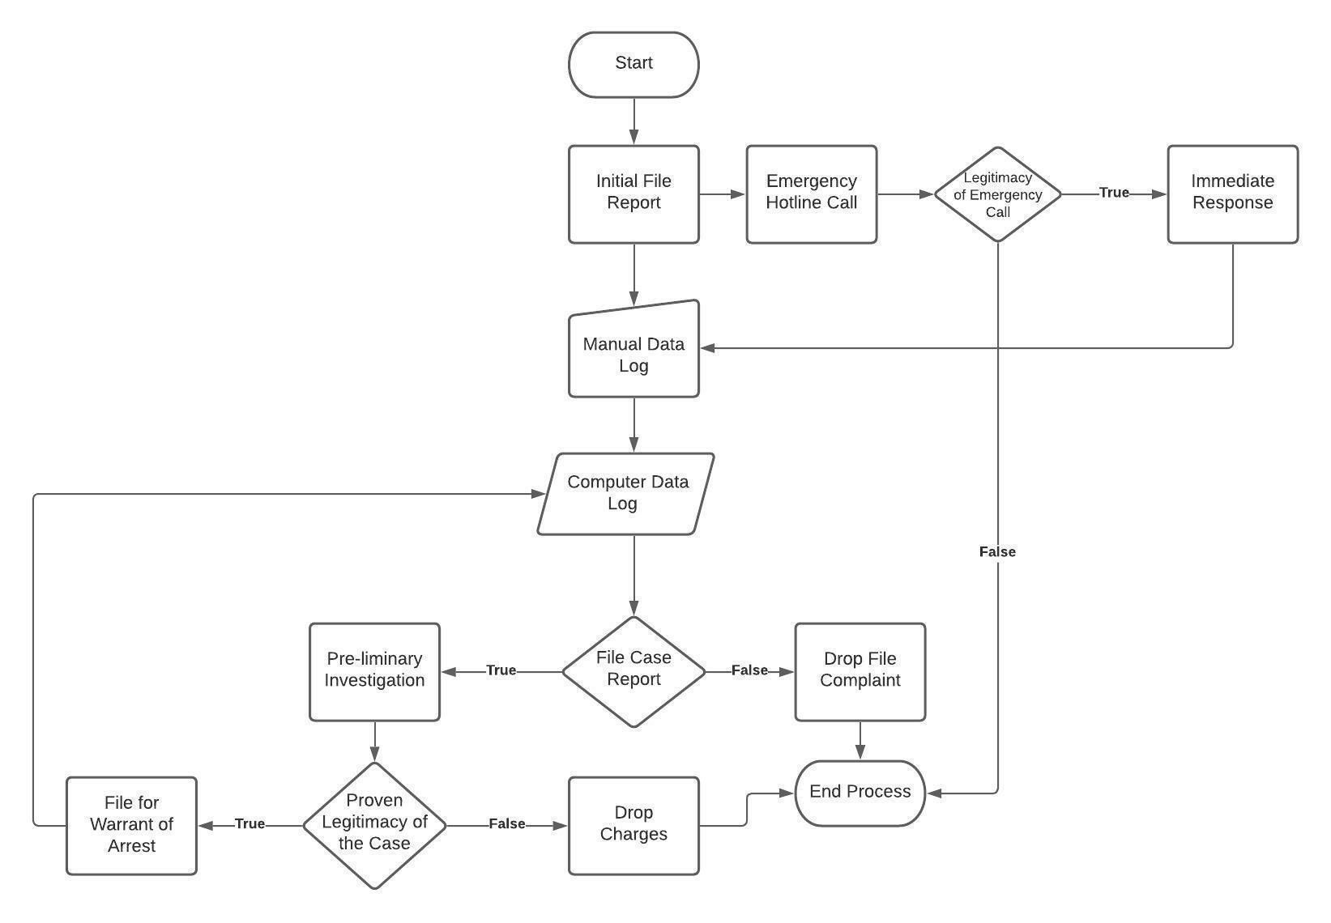

**Proposed System Program Flowchart**

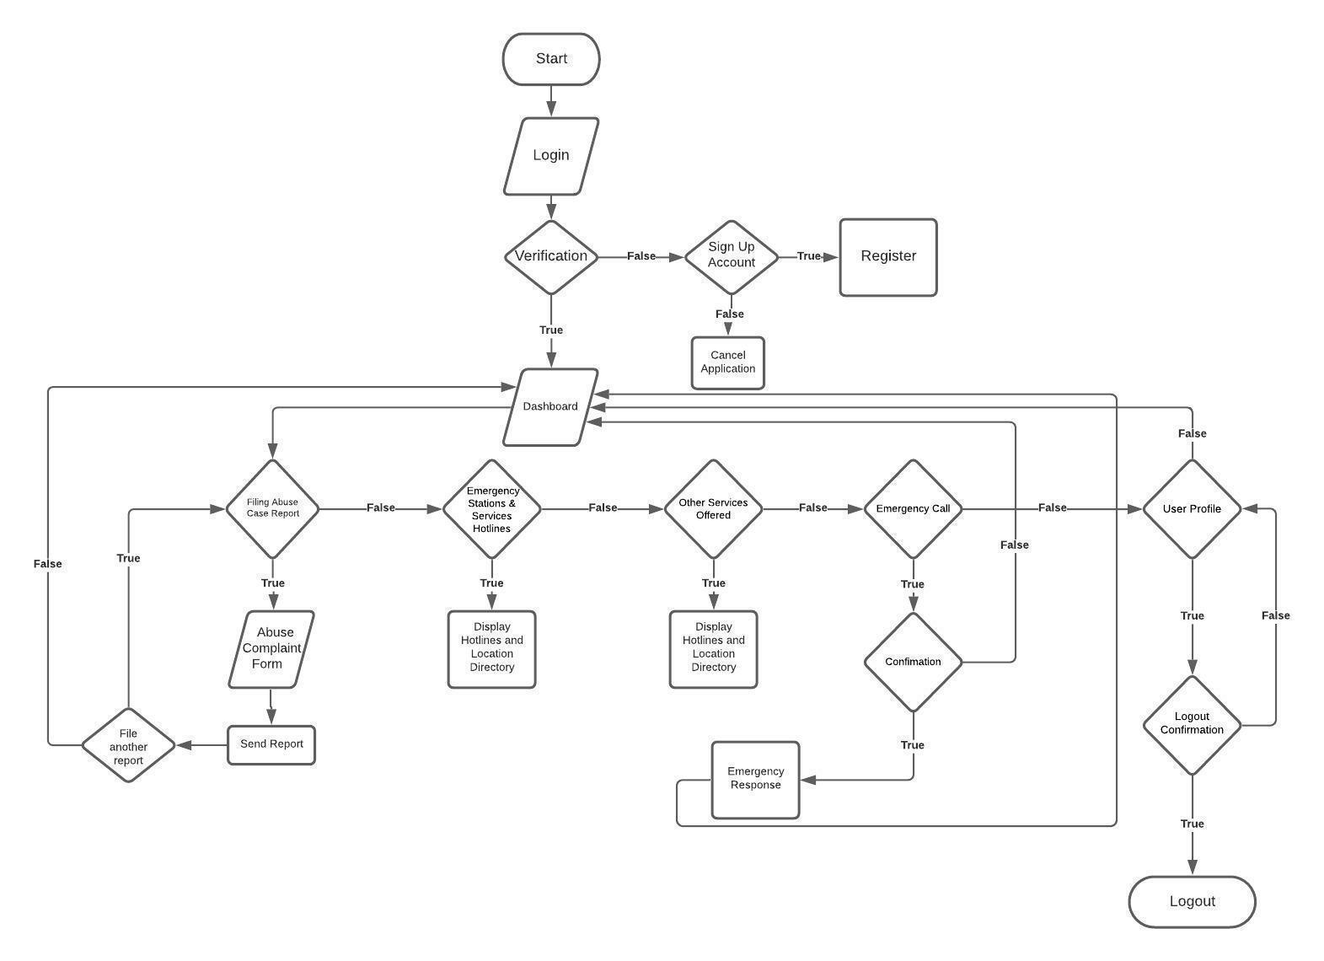

**APPENDIX H**

(Figures)

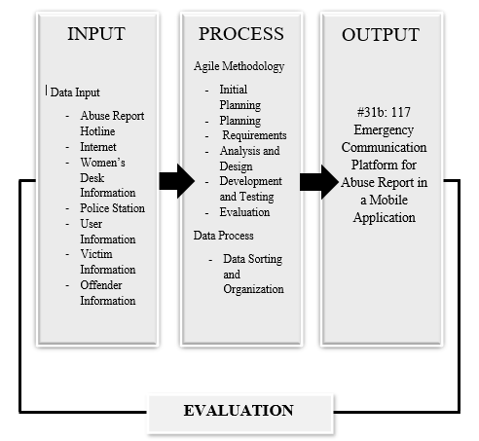

*Figure 1. Conceptual Framework*

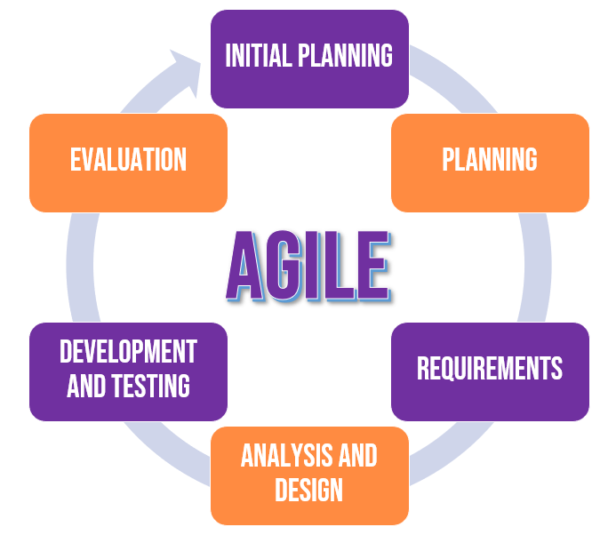

*Figure 2 Agile Systems Methodology*

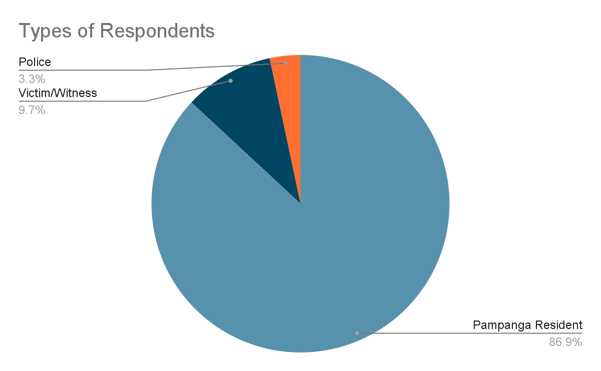

*Figure 3.  Types of Residents*

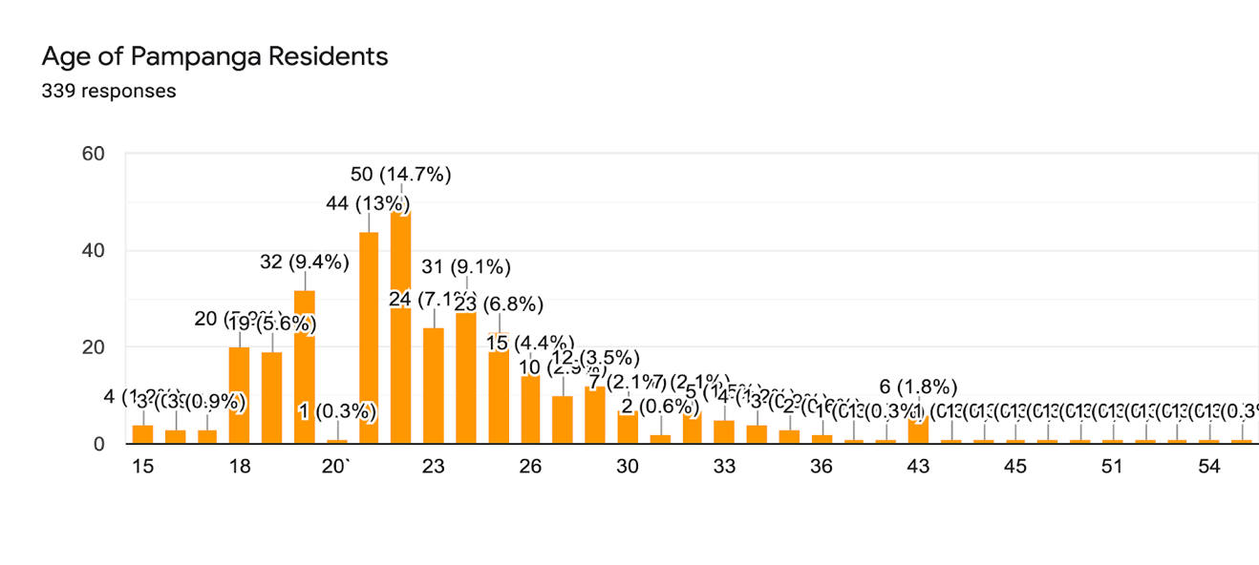

*Figure 4.  Age of Pampanga Residents*

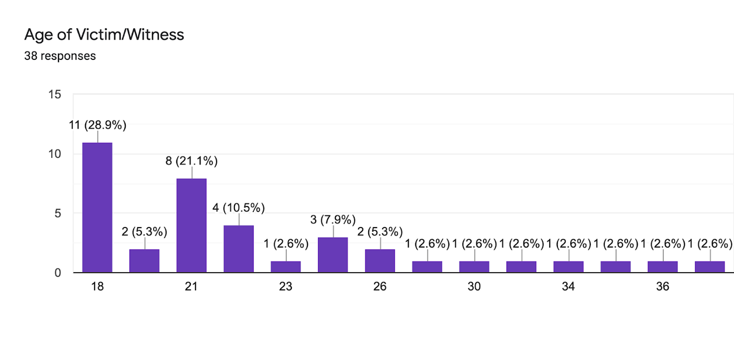

*Figure 5.  Age of Victim or Witness***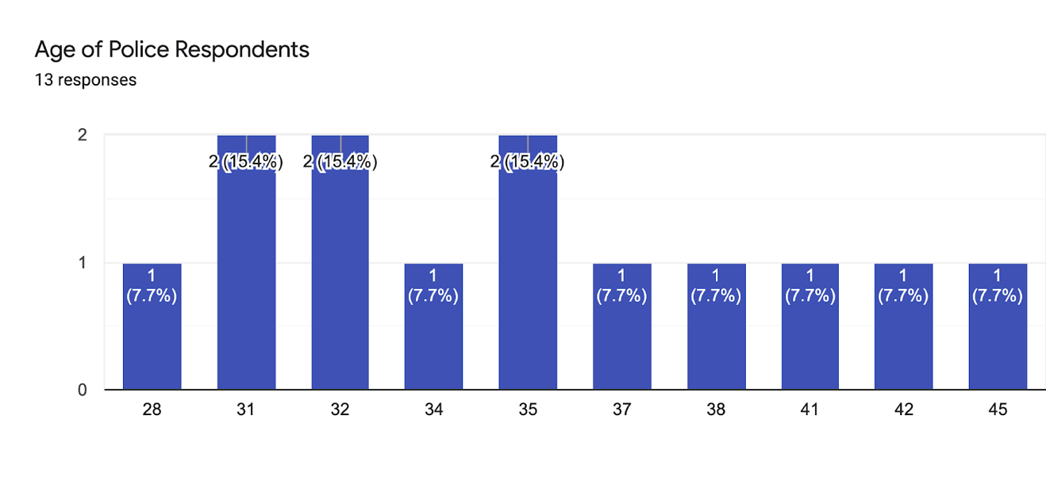**

*Figure 6  Police Respondents*

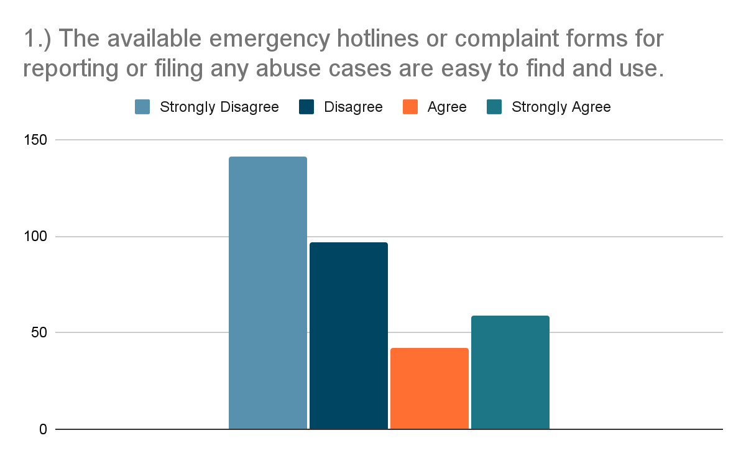

*Figure 7.  Pampanga Resident Survey question number 1 Results*

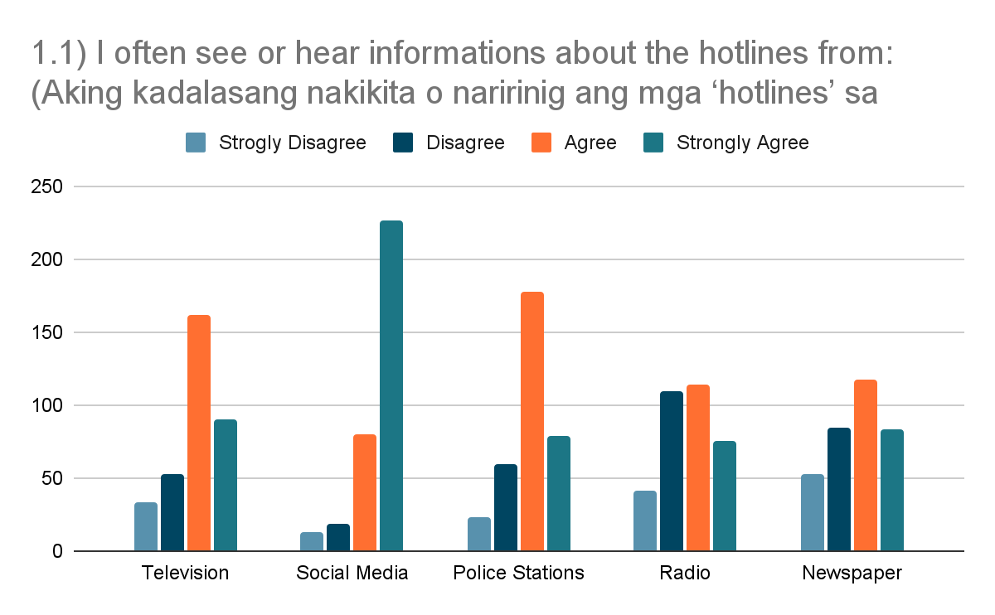

*Figure 8 Pampanga Resident Survey question number 1.1 Results*

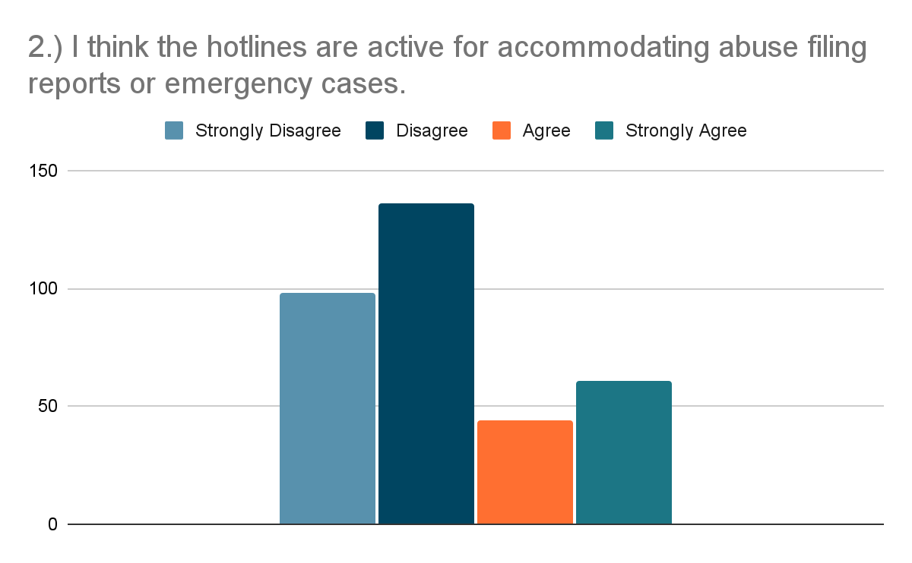

*Figure 9.  Pampanga Resident Survey question number 2 Results*

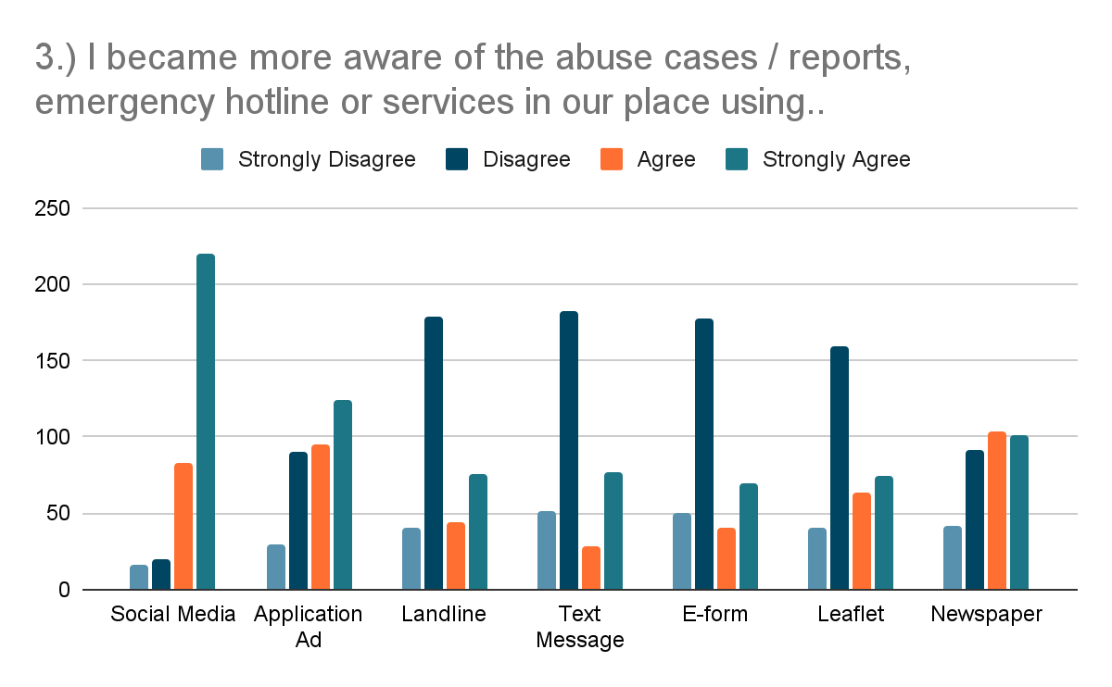

*Figure 10.  Pampanga Resident Survey question number 3 Results*

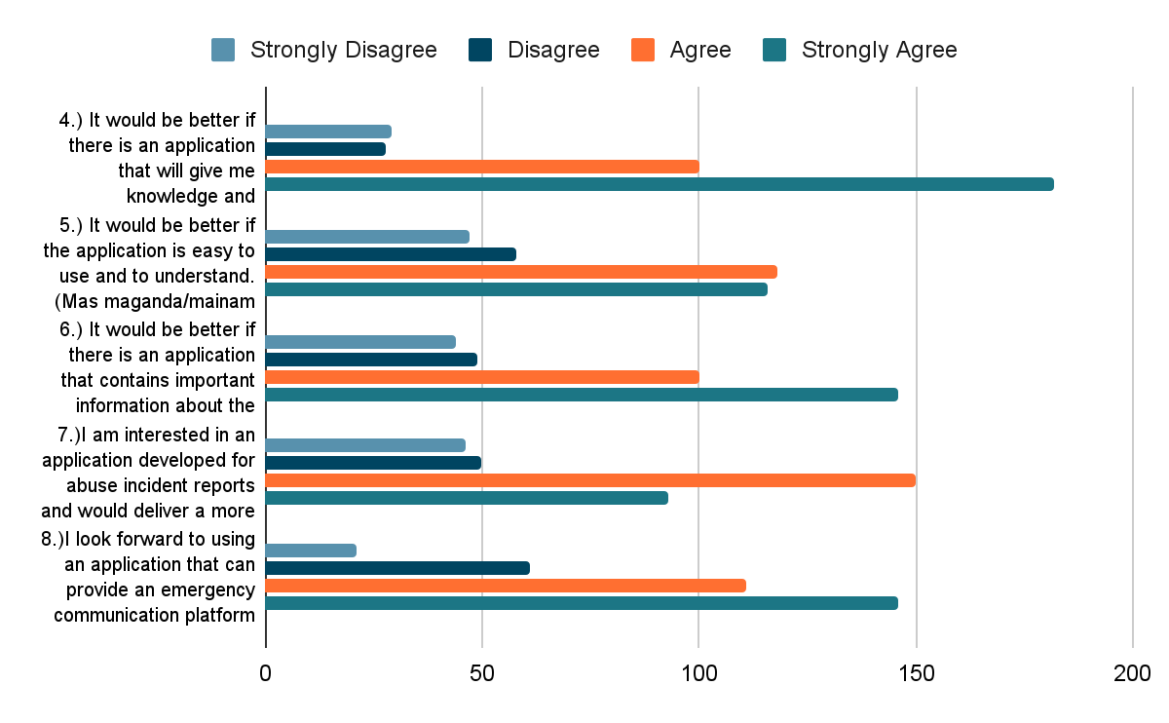

*Figure 11. Pampanga Resident Survey question number 4,5,6,7 and 8 Results*

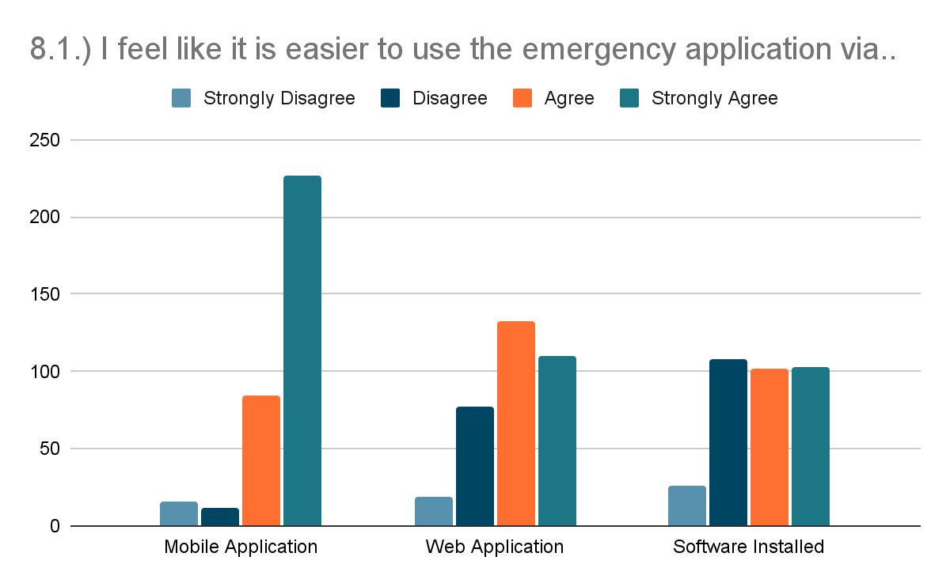

*Figure 12.  Pampanga Resident Survey question number 8.1 Results*

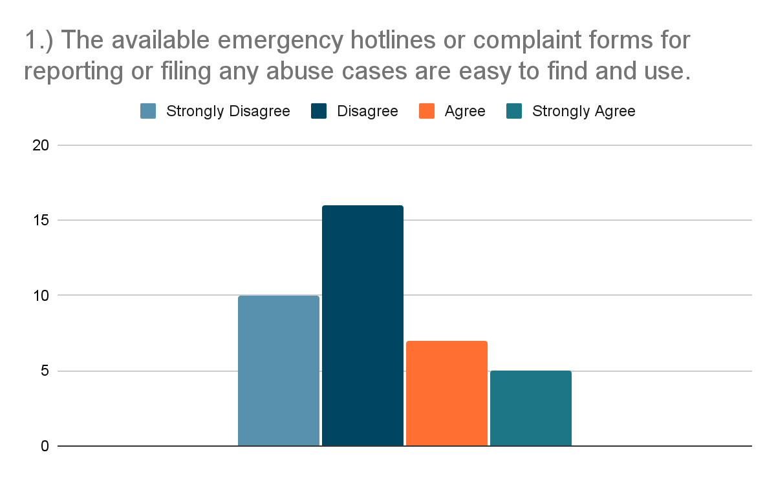

*Figure 13 Victim or Witness Survey question number 1 Results*

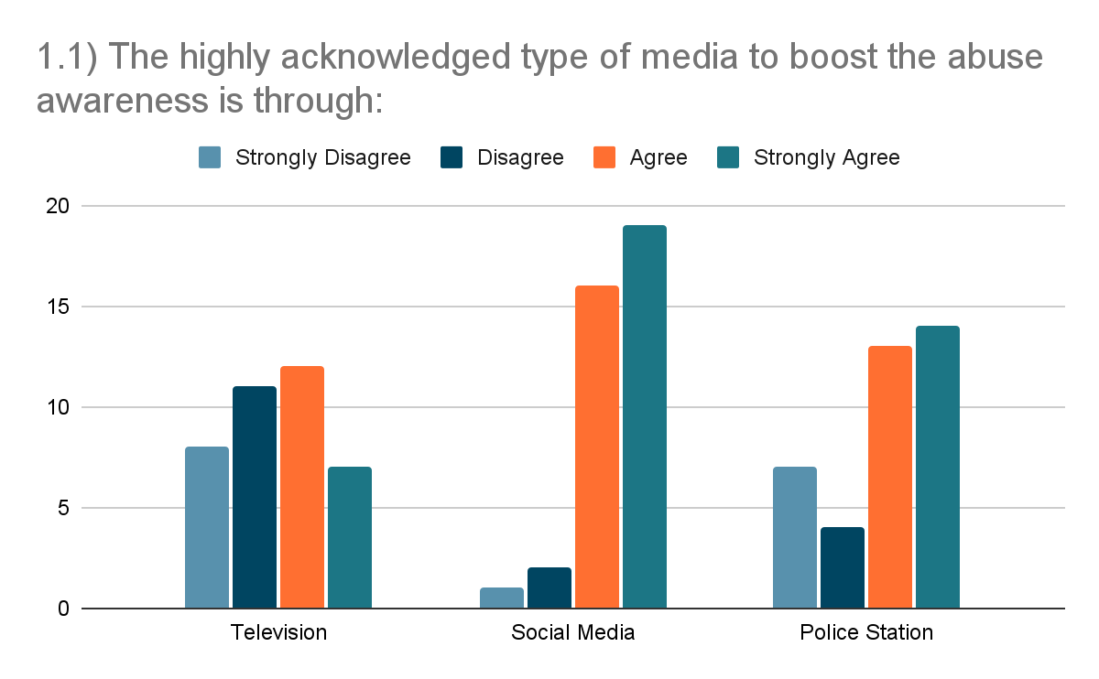

*Figure 14. Victim/Witness Survey question number 2 Results*

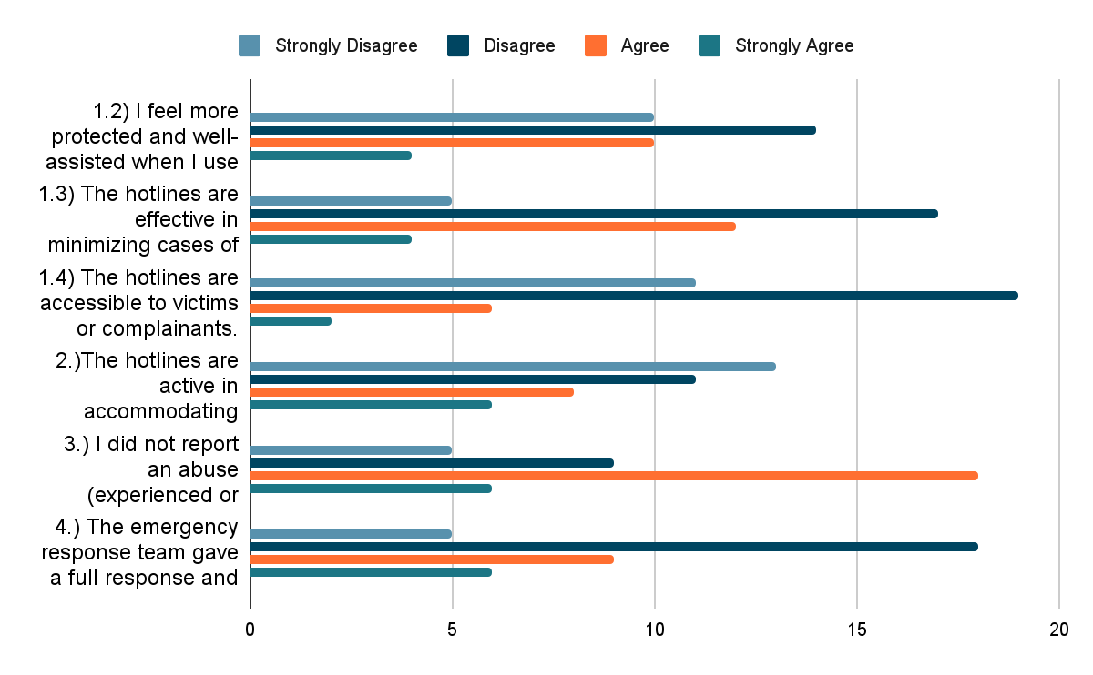

*Figure 15. Victim or Witness Survey question number 2,3,4 Results*

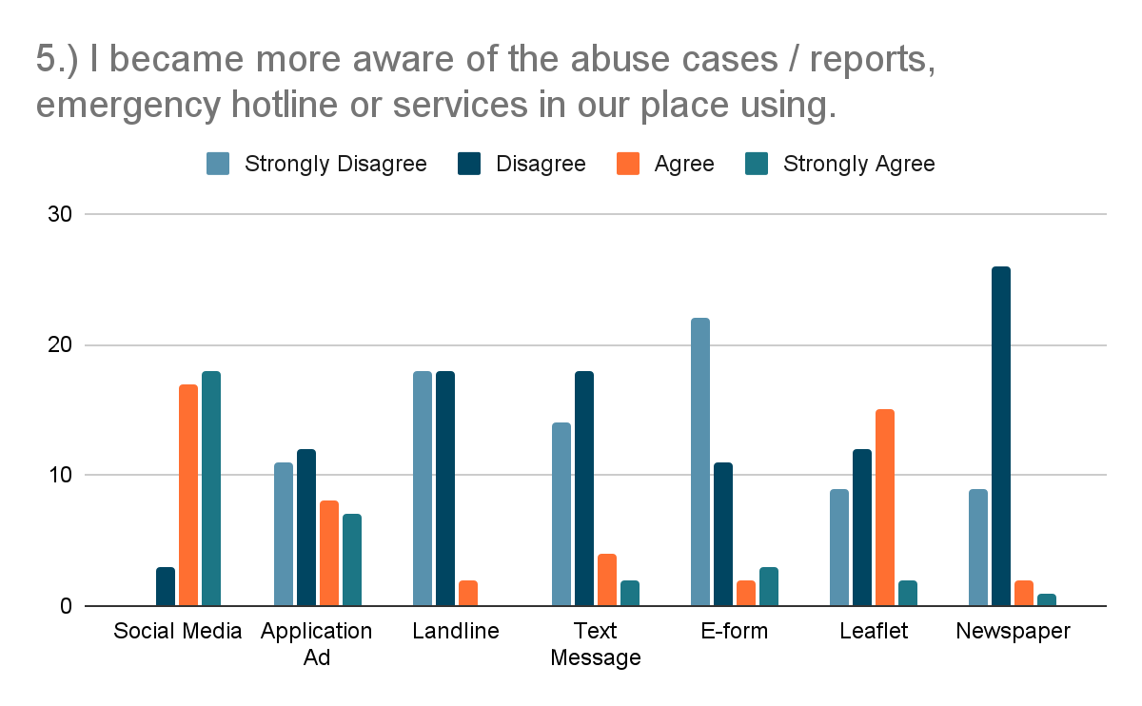

*Figure 16. Victim/Witness Survey question number 5 Results*

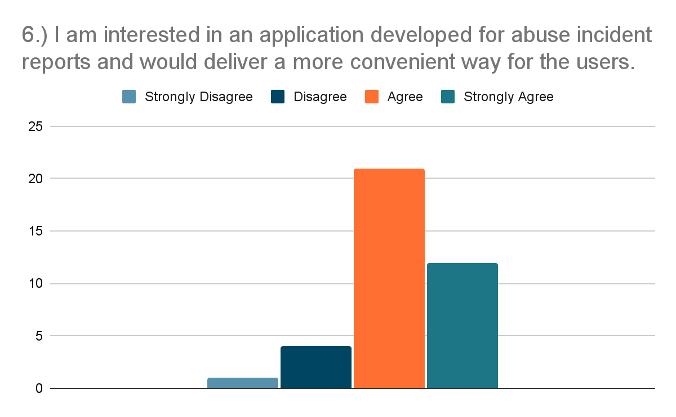

*Figure 17. Victim or Witness Survey question number 6 Results*

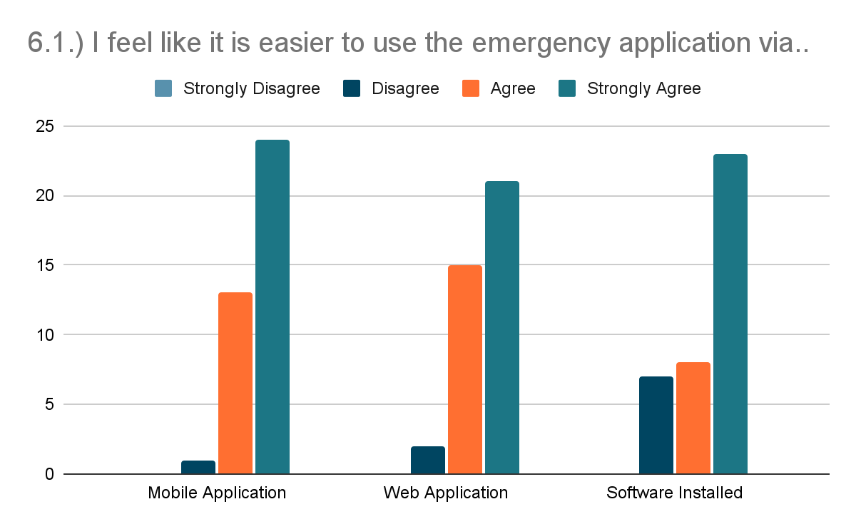

*Figure 18. Victim/Witness Survey question number 6.1 Results*

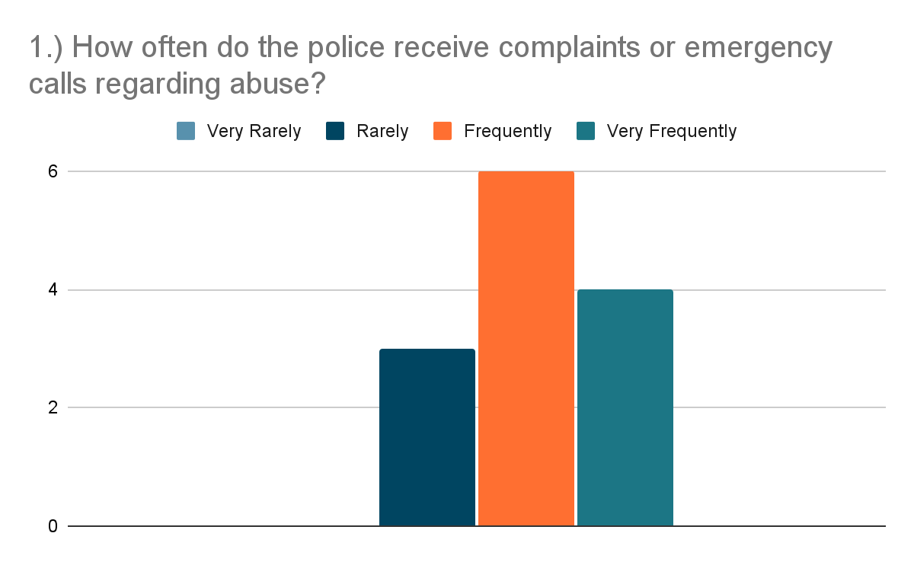

*Figure 19. Police Survey question number 1 Results*

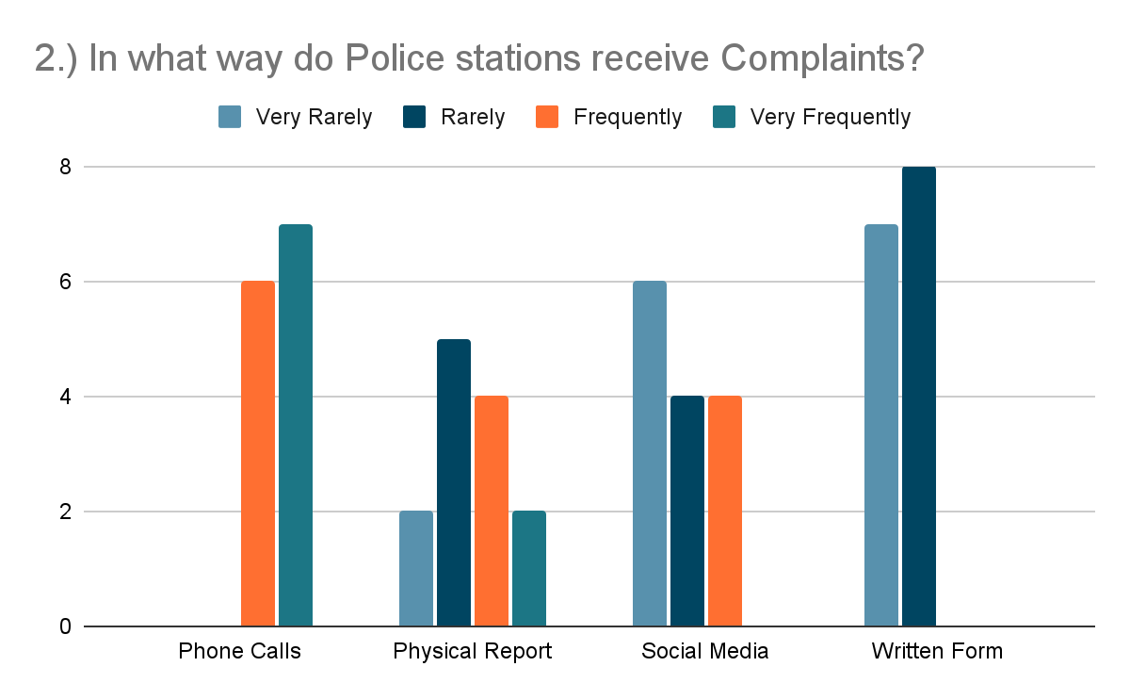

*Figure 20. Police Survey question number 2 Results*

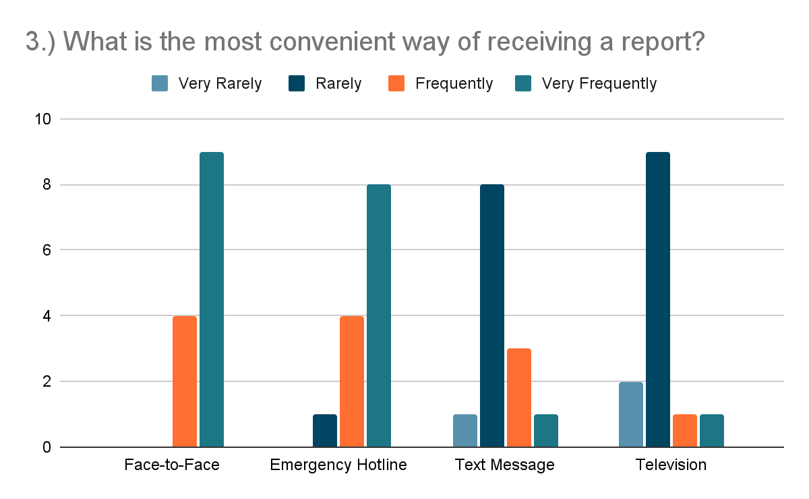

*Figure 21. Police Survey question number 3 Results*

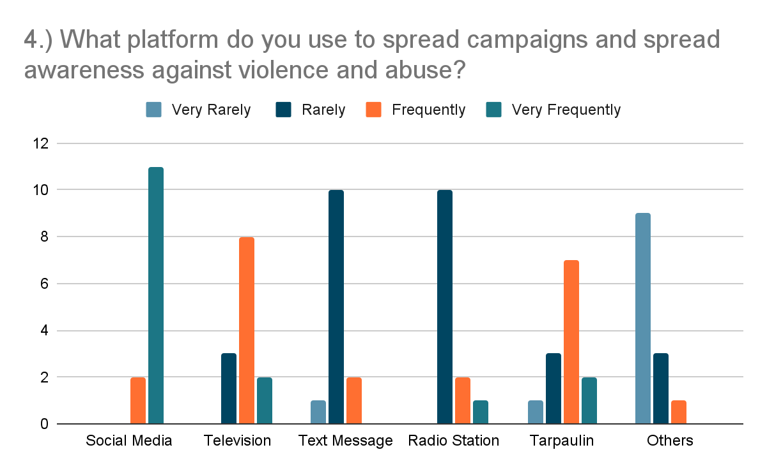

*Figure 22. Police Survey question number 4 Results*

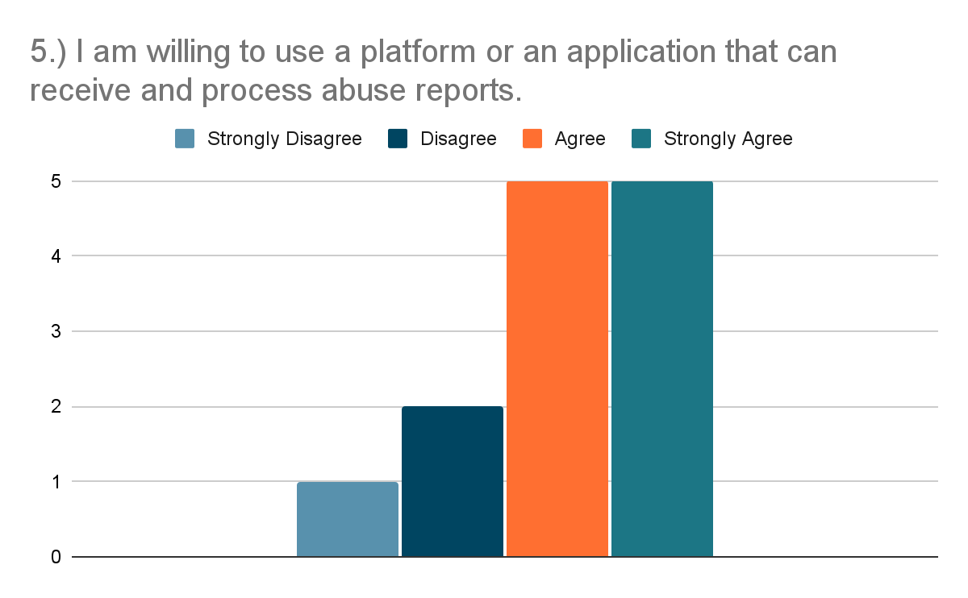

*Figure 23. Police Survey question number 5 Results*

**APPENDIX I**

(Tables)

*Table 1.: Likert Four-Point Scale Interpretation*

|  |  |  |
| --- | --- | --- |
| **POINT** | **SCALE RANGE** | **INTERPRETATION** |
| 4 | 3.26 - 4.00 | Strongly Agree |
| 3 | 2.51 - 3.25 | Agree |
| 2 | 1.76 - 2.50 | Disagree |
| 1 | 1.00 - 1.75 | Strongly Disagree |

*Table 2.: Development Hardware Specifications*

|  |  |
| --- | --- |
| **HARDWARE SPECIFICATIONS** | |
| **Item (Laptop)** | **Specifications** |
| Processor | Intel® Core™ i5-8300H 2.30GHz |
| Memory | 20480MB DDR4 SDRAM |
| Disk Space | 240GB SSD, 1TB HDD |
| Graphics | Nvidia GTX 1050 Ti 4GB |
|  | |
| **Item (Android Phone)** | **Specifications** |
| Processor | MediaTek Helio G85 Octa-core |
| Memory | 6GB RAM |
| Disk Space | 128GB ROM |
| Graphics | Mali-G52 MC2 |

*Table 3. Development Software Specifications*

|  |  |  |
| --- | --- | --- |
| **SOFTWARE SPECIFICATIONS** | | |
| **Item (Laptop)** | **Name** | **Version** |
| Operating System | Microsoft Windows | 10 |
| Integrated Development Environment (IDE) | Android Studio | 4.2.1 |
| Database | Firebase Realtime Database |  |
|  | | |
| **Item (Android Phone)** | **Name** | **Version** |
| Operating System | Android 11 XOS | 7.6 |

**Table 4. Evaluation of the Functional Stability of the Existing System.**

|  |  |  |  |  |  |  |  |
| --- | --- | --- | --- | --- | --- | --- | --- |
| **Indicators** | **4** | **3** | **2** | **1** | **WV** | **WM** | **I** |
| **Completeness**  The set of functions covers all the specified tasks and user objectives | **18**  (72) | **165**  (495) | **174**  (348) | **20**  (20) | **377**  **(935)** | **2.48** | **Disagree** |
| **Correctness**  The function provides the correct results with the needed degree of precision | **46**  (184) | **142**  (426) | **151**  (302) | **38**  (38) | **377**  **(950)** | **2.52** | **Agree** |
| **Appropriateness**  The function facilitate**s** the accomplishment of specified tasks and objectives | **38**  (152) | **173**  (519) | **124**  (248) | **42**  (42) | **377**  **(961)** | **2.55** | **Agree** |
| **Average Weighted Mean = 2.52 (Agree)** | | | | | | | |

**Table 5. Evaluation of the Reliability of the Existing System**

|  |  |  |  |  |  |  |  |
| --- | --- | --- | --- | --- | --- | --- | --- |
| **Indicators** | **4** | **3** | **2** | **1** | **WV** | **WM** | **I** |
| **Maturity**  The   system meets for reliability under normal operation | **32**  (128) | **134**  (402) | **126**  (252) | **85**  (85) | **377**  **(867)** | **2.30** | **Disagree** |
| **Availability**  The   system is operational and accessible when require for use | **49**  (196) | **144**  (432) | **147**  (294) | **37**  (37) | **377**  **(959)** | **2.54** | **Agree** |
| **Average Weighted Mean = 2.42 (Disagree)** | | | | | | | |

**Table 6.   Evaluation of the Usability of the Existing System**

|  |  |  |  |  |  |  |  |
| --- | --- | --- | --- | --- | --- | --- | --- |
| **Indicators** | **4** | **3** | **2** | **1** | **WV** | **WM** | **I** |
| **Appropriateness Recognizability**  User can recognize whether the   system is appropriate for their needs | **46**  (184) | **149**  (447) | **139**  (278) | **43**  (43) | **377**  **(952)** | **2.53** | **Agree** |
| **Operability**  The   system is easy to operate, control and appropriate to use | **42**  (168) | **465**  (495) | **125**  (250) | **77**  (77) | **377**  **(990)** | **2.63** | **Agree** |
| **User Interface Aesthetics**  A user interface enables pleasing and satisfying interactions for the user | **48**  (192) | **155**  (465) | **112**  (224) | **62**  (62) | **377**  **(943)** | **2.50** | **Disagree** |
| **Accessibility**  The   system can be used by people with the widest range of characteristics and capabilities to achieve a specified goal in a specified context of use. | **43**  (172) | **116**  (348) | **166**  (332) | **52**  (52) | **377**  **(904)** | **2.40** | **Disagree** |
| **Average Weighted Mean = 2.52 (Agree)** | | | | | | | |

**Table 7. Evaluation of the Performance Efficiency of the Existing System**

|  |  |  |  |  |  |  |  |
| --- | --- | --- | --- | --- | --- | --- | --- |
| **Indicators** | **4** | **3** | **2** | **1** | **WV** | **WM** | **I** |
| **Time- behavior**  The response and processing times and throughout rates of the   system, when performing its functions meets the requirements | **39**  (156) | **166**  (498) | **109**  (218) | **63**  (63) | **377**  (935) | **2.48** | **Disagree** |
| **Average Weighted Mean = 2.48 (Disagree)** | | | | | | | |

**Table 8.  Evaluation of the Security of the Existing System**

|  |  |  |  |  |  |  |  |
| --- | --- | --- | --- | --- | --- | --- | --- |
| **Indicators** | **4** | **3** | **2** | **1** | **WV** | **WM** | **I** |
| **Confidentiality**  The   system ensures that data are accessible only to those authorized to have access | **71**  (284) | **154**  (441) | **114**  (228) | **45**  (45) | **377**  **(998)** | **2.65** | **Agree** |
| **Integrity**  The   system prevents unauthorized access to, or modification of, computer programs or data | **74**  (296) | **161**  (483) | **79**  (158) | **63**  (63) | **377**  **(1000)** | **2.65** | **Agree** |
| **Average Weighted Mean = 2.65 (Agree)** | | | | | | | |

**Table 9.  Evaluation of the Functional Stability of the Proposed System**

|  |  |  |  |  |  |  |  |
| --- | --- | --- | --- | --- | --- | --- | --- |
| **Indicators** | **4** | **3** | **2** | **1** | **WV** | **WM** | **I** |
| **Completeness**  The set of functions covers all the specified tasks and user objectives | **275**  (1100) | **102**  (306) | **0** | **0** | **377**  **(1406)** | **3.73** | **Strongly Agree** |
| **Correctness**  The function provides the correct results with the needed degree of precision | **262**  (1048) | **115**  (345) | **0** | **0** | **377**  **(1393)** | **3.69** | **Strongly Agree** |
| **Appropriateness**  The function facilitate**s** the accomplishment of specified tasks and objectives | **277**  (1108) | **98**  (294) | **0** | **0** | **377**  **(1402)** | **3.72** | **Strongly Agree** |
| **Average Weighted Mean = 3.71 (Strongly Agree)** | | | | | | | |

**Table 10. Evaluation of the Reliability of the Proposed System**

|  |  |  |  |  |  |  |  |
| --- | --- | --- | --- | --- | --- | --- | --- |
| **Indicators** | **4** | **3** | **2** | **1** | **WV** | **WM** | **I** |
| **Maturity**  The system meets for reliability under normal operation | **252**  (1004) | **117**  (351) | **9**  (18) | **0** | **377**  **(1373)** | **3.64** | **Strongly Agree** |
| **Availability**  The   system is operational and accessible when require for use | **280**  (1120) | **93**  (279) | **4**  (8) | **0** | **377**  **(1407)** | **3.73** | **Strongly Agree** |
| **Average Weighted Mean = 3.69 (Strongly Agree)** | | | | | | | |

**Table 11.  Evaluation of the Usability of the Proposed System**

|  |  |  |  |  |  |  |  |
| --- | --- | --- | --- | --- | --- | --- | --- |
| **Indicators** | **4** | **3** | **2** | **1** | **WV** | **WM** | **I** |
| **Appropriateness Recognizability**  User can recognize whether the   system is appropriate for their needs | **284**  (1132) | **90**  (270) | **4**  (8) | **0** | **377**  **(1407)** | **3.73** | **Strongly Agree** |
| **Operability**  The   system is easy to operate, control and appropriate to use | **298**  (1192) | **79**  (237) | **0** | **0** | **377**  **(1429)** | **3.79** | **Strongly Agree** |
| **User Interface Aesthetics**  A user interface enables pleasing and satisfying interactions for the user | **314**  (1256) | **62**  (186) | **0** | **0** | **377**  **(1442)** | **3.82** | **Strongly Agree** |
| **Accessibility**  The   system can be used by people with the widest range of characteristics and capabilities to achieve a specified goal in a specified context of use. | **280**  (1120) | **92**  (276) | **5**  (10) | **0** | **377**  **(1406)** | **3.73** | **Strongly Agree** |
| **Average Weighted Mean = 3.77 (Strongly Agree)** | | | | | | | |

**Table 12. Evaluation of the Performance Efficiency of the Proposed System**

|  |  |  |  |  |  |  |  |
| --- | --- | --- | --- | --- | --- | --- | --- |
| **Indicators** | **4** | **3** | **2** | **1** | **WV** | **WM** | **I** |
| **Time- behavior**  The response and processing times and throughout rates of the   system, when performing its functions meets the requirements | **273**  (1092) | **97**  (291) | **7**  (14) | **0** | **377**  **(1397)** | **3.70** | **Strongly Agree** |
| **Average Weighted Mean = 3.70 (Strongly Agree)** | | | | | | | |

**Table 13.  Evaluation of the Security of the Proposed System**

|  |  |  |  |  |  |  |  |
| --- | --- | --- | --- | --- | --- | --- | --- |
| **Indicators** | **4** | **3** | **2** | **1** | **WV** | **WM** | **I** |
| **Confidentiality**  The   system ensures that data are accessible only to those authorized to have access | **308**  **(1228)** | **64**  **(192)** | **6**  **(12)** | **0** | **377 (1432)** | **3.79** | **Strongly Agree** |
| **Integrity**  The   system prevents unauthorized access to, or modification of, computer programs or data | **286(1144)** | **87**  **(261)** | **4**  **(8)** | **0** | **377**  **(1413)** | **3.74** | **Strongly Agree** |
| **Average Weighted Mean = 3.77 (Strongly Agree)** | | | | | | | |

**Table 14.  Proposed System Testing Result Summary**

|  |  |  |  |  |
| --- | --- | --- | --- | --- |
|  | **Existing System** | | **Proposed System** | |
| **Indicators** | **Mean** | **Interpretation** | **Mean** | **Interpretation** |
| Functional Stability | 2.52 | Agree | 3.71 | Strongly Agree |
| Reliability | 2.42 | Disagree | 3.69 | Strongly Agree |
| Usability | 2.52 | Agree | 3.77 | Strongly Agree |
| Performance Efficiency | 2.48 | Disagree | 3.70 | Strongly Agree |
| Security | 2.65 | Agree | 3.77 | Strongly Agree |
| **AVERAGE MEAN** | **2.52** | **Agree** | **3.73** | **Strongly Agree** |

**APPENDIX J**

(Survey Questionnaires)

PRE-STUDY SURVEY QUESTIONNAIRE ( FOR VICTIM / WITNESS)

Overview of the Study

The researchers reconstructed and validated a simple questionnaire to be completed by respondents age 13 and above. All responses will be kept confidential and combined with other responses when reporting the result. We certainly would like to request your full cooperation and honest feedback.

Name (Optional): ___________________________________________ Date: ______________

Age: ______________ Gender: ○Female ○Male ○Prefer not to say

Municipality:

* Guagua
* Porac
* Lubao
* Santa Rita
* Floridablanca
* Sasmuan

Barangay: _____________________________________

Educational Attainment:

* Elementary
* Junior High School
* Senior High School
* Undergraduate
* Bachelor’s Degree
* Master’s Degree
* Doctorate Degree

**4 - Strongly Agree 3 -Agree 2 - Disagree 1 - Strongly Disagree**

|  |  |  |  |  |
| --- | --- | --- | --- | --- |
| **SURVEY QUESTIONS** | **4** | **3** | **2** | **1** |
| 1.) The available emergency hotlines or complaint forms for reporting or filing any abuse cases are easy to find and use.  *(Ang mga maaaring tawagan na emergency hotlines o mga complaint forms upang makapaghain ng reklamo ng pang-aabuso ay madaling mahanap at gamitin.)* |  |  |  |  |
| 1.1)The highly acknowledged type of media to boost the abuse awareness is through:  (Ang mga pinakakilala na uri ng midya na naglalayong mabigyan ng kamalayan ang pang-aabuso ay sa pamamagitan ng sumusunod:) | | | | |
| * television (telebisyon) |  |  |  |  |
| * social media (sosyal medya) |  |  |  |  |
| * police stations (istasyon ng mga pulis) |  |  |  |  |
| 1.2) I feel more protected and well-assisted when I use the available hotlines to report my abuse case or experience..  *(Mas ramdam ko na ako ay protektado at lubos na natutulungan sa tuwing nakakagamit ako ng mga maaring tawagan para iulat ang mga karanasan o pangyayaring pang-aabuso)* |  |  |  |  |
| 1.3) The hotlines are effective in minimizing cases of abuse.  *(Ang mga numerong maaring tawagan ay epektibo sa pagpapababa ng mga bilang ng kaso sa pang-aabuso)* |  |  |  |  |
| 1.4) The hotlines are accessible to victims or complainants.  *(Ang mga numerong maaring tawagan ay madaling makukuha ng mga biktima o nag-uulat ng reklamo.)* |  |  |  |  |
| 2.)The hotlines are active in accommodating abuse filing reports or emergency cases.  *(Ang mga ibinigay na ‘hotlines’ ay aktibo anumang oras at mabilis rumesponde sa mga kaso or sumbong ng pang aabuso)* |  |  |  |  |
| 3.) I did not report an abuse (experienced or witnessed) because I feel scared, unprotected and uncomfortable reporting it via phone call or in a written complaint form.  *(Hindi ako nag-uulat ng pang-aabuso (biktima*  *man o saksi) dahil nakakaramdam ako ng takot,*  *hindi ako protektado at komportable na iulat ito*  *gamit ang telepono o kahit na sa paraang*  *pasulat.)* |  |  |  |  |
| 4.) The emergency response team gave a full response and accommodated the complaint very well.  *(Ang mga grupo ng mga tumutugon sa oras ng pangangailangan ay nagbibigay ng buong aksyon at tinatanggap ng napakahusay ang reklamo.)* |  |  |  |  |
| 5.) I became more aware of the abuse cases / reports, emergency hotline or services in our place using…  *(Ako ay mas naging maalam sa mga balita/kaso ng pang-aabuso, at mga numero ng pangangailangan at serbisyo sa aming lugar gamit ang mga sumusunod:)* | | | | |
| * Social Media |  |  |  |  |
| * Application Advertisement (Ads) *(pang-aplikasyon anunsyo)* |  |  |  |  |
| * Landline / Mobile phone *(‘landline’ o numero ng telepono)* |  |  |  |  |
| * Text Messages or E-mail (‘*tekstong mensahe o elektronikong mensahe)* |  |  |  |  |
| * Electronic Form (Google Form) *(elektronikong ‘forms’)* |  |  |  |  |
| * Leaflet / Flyers / Tarpaulin *(polyeto)* |  |  |  |  |
| * Newspaper *(dyaryo)* |  |  |  |  |
| 6.) I am interested in an application developed for abuse incident reports and would deliver a more convenient way for the users.  *(Ako ay interasado sa isang aplikasyon na binuo para sa pag-uulat ng mga kaso ng pang-aabuso, at para maghatid ng mas maginhawang paraan sa mga gagamit.)* |  |  |  |  |
| 6.1.) I feel like it is easier to use the emergency application via…  *(Sa aking pakiramdam o palagay ay mas*  *madaling gamitin ang emergency application*  *gamit ang mga sumusunod)* |  |  |  |  |
| * Mobile Application |  |  |  |  |
| * Web Application |  |  |  |  |
| * Installed Software |  |  |  |  |

( ) I hereby give my full consent to the Don Honorio Ventura State University (DHVSU) researchers of this survey, to collect and process my personal information and survey response. I understand that this pre-study survey is strictly monitored and protected by the Data Privacy Act of 2012.

( ) Ibinibigay ko ang aking buong pahintulot sa mga mag-aaral ng Don Honorio Ventura State University (DHVSU) na nagsasaliksik, at maaring kolektahin at i-proseso ang aking mga personal na impormasyon at kasagutan sa kanilang katanungan. Nauunawaan ko na ang *Pre-Study Survey* na ito ay mahigpit na tumutugon at pinoprotektahan ayon sa *Data Privacy Act of 2012.*

PRE-STUDY SURVEY QUESTIONNAIRE (FOR POLICE)

Overview of the Study

The researchers reconstructed and validated a simple questionnaire to be completed by the police respondents. All responses will be kept confidential and combined with other responses when reporting the result. We certainly would like to request your full cooperation and honest feedback.

Name (Optional): ___________________________________________ Date: ______________

Age: ______________ Sex: ○Female ○Male

Police Officer Rank & Division:__________________________________________

Assigned Police Stations:

○Sta. Rita Municipal Police Station ○Porac Municipal Police Station

○Guagua Municipal Police Station ○Floridablanca Municipal Police Station

○Lubao Municipal Police Station ○Sasmuan Municipal Police Station

**4 - Very Frequently 3 - Frequently 2 - Rarely 1 - Very Rarely**

|  |  |  |  |  |
| --- | --- | --- | --- | --- |
| **SURVEY QUESTIONS** | **4** | **3** | **2** | **1** |
| 1.) How often do the police receive complaints or emergency calls regarding abuse? |  |  |  |  |
| 2.) In what way do Police stations receive Complaints? | | | | |
| * Phone Calls |  |  |  |  |
| * Personal / Physical Report |  |  |  |  |
| * Social Media |  |  |  |  |
| * Written Form |  |  |  |  |
| 3.) What is the most convenient way of receiving a report? | | | | |
| * Face-to-Face |  |  |  |  |
| * Emergency Hotline |  |  |  |  |
| * Text Message |  |  |  |  |
| * Through Television/ Radio |  |  |  |  |
| 4.) What platform do you use to spread campaigns and spread awareness against violence and abuse? |  |  |  |  |
| * Social Media |  |  |  |  |
| * Television |  |  |  |  |
| * Radio Stations |  |  |  |  |
| * Flyers / Tarpaulins |  |  |  |  |
| * Others, pls specify: __________ |  |  |  |  |
| 5.) I am willing to use a platform or an application that can receive and process abuse reports. |  |  |  |  |

( ) I hereby give my full consent to the Don Honorio Ventura State University (DHVSU) researchers of this survey, to collect and process my personal information and survey response. I understand that this pre-study survey is strictly monitored and protected by the Data Privacy Act of 2012.

( ) Ibinibigay ko ang aking buong pahintulot sa mga mag-aaral ng Don Honorio Ventura State University (DHVSU) na nagsasaliksik, at maaring kolektahin at i-proseso ang aking mga personal na impormasyon at kasagutan sa kanilang katanungan. Nauunawaan ko na ang *Pre-Study Survey* na ito ay mahigpit na tumutugon at pinoprotektahan ayon sa *Data Privacy Act of 2012.*

PRE-STUDY SURVEY QUESTIONNAIRE (ORDINARY RESIDENT)

Overview of the Study

The researchers reconstructed and validated a simple questionnaire to be completed by respondents age 13 and above. All responses will be kept confidential and combined with other responses when reporting the result. We certainly would like to request your full cooperation and honest feedback.

*(Sa kabuuan ng Pag-aaral)*

*(Ang mga mananaliksik muling buuin at pinapatunayan ang mga simpleng katanungan na sasagutin ng mga kasangkot mula edad 13 hanggang pataas. Ang lahat ng mga tugon ay pananatilihing kumpidensyal at isasama sa iba pang mga tugon kapag ini-uulat ang resulta. Ninanais din ng mga mananaliksik na hilingin at hingian ang iyong buong kooperasyon at tapat na pagsagot.)*

Name (Optional): ___________________________________________ Date: ______________

Age: ______________ Gender: ○Female ○Male ○Prefer not to say

Municipality:

* Guagua
* Porac
* Lubao
* Santa Rita
* Floridablanca
* Sasmuan

Barangay: _____________________________________

Educational Attainment:

* Elementary
* Junior High School
* Senior High School
* Undergraduate
* Bachelor’s Degree
* Doctorate

**4 - Strongly Agree 3 -Agree 2 - Disagree 1 - Strongly Disagree**

|  |  |  |  |  |
| --- | --- | --- | --- | --- |
| **SURVEY QUESTIONS** | **4** | **3** | **2** | **1** |
| 1.) The available emergency hotlines or complaint forms for reporting or filing any abuse cases are easy to find and use.  *(Ang mga emergency hotlines o mga forms ay madaling gamitin at mahanap.)* |  |  |  |  |
| 1.1) I often see or hear informations about the hotlines from: *(Aking kadalasang nakikita o naririnig ang mga ‘hotlines’ sa pamamagitan ng..)* | | | | |
| * television *(telebisyon)* |  |  |  |  |
| * social media |  |  |  |  |
| * police stations *(istasyon ng mga pulis)* |  |  |  |  |
| * radio *(radyo)* |  |  |  |  |
| * newspaper *(dyaryo)* |  |  |  |  |
| 2.) I think the hotlines are active for accommodating abuse filing reports or emergency cases.  *(Sa aking palagay ang mga numero o hotlines ay aktibo na tumatanggap ng tugon sa mga nag uulat ng kaso sa pang-aabuso.)* |  |  |  |  |
| 3.) I became more aware of the abuse cases / reports, emergency hotline or services in our place using…  *(Ako ay mas naging maalam sa mga balita/kaso ng pang-aabuso, at mga numero ng pangangailangan at serbisyo sa aming lugar gamit ang mga sumusunod:)* | | | | |
| * Social Media |  |  |  |  |
| * Application Advertisement (Ads) *(pang-aplikasyon anunsyo)* |  |  |  |  |
| * Landline / Mobile phone *(‘landline’ o numero ng telepono)* |  |  |  |  |
| * Text Messages or E-mail (‘*tekstong mensahe o elektronikong mensahe)* |  |  |  |  |
| * Electronic Form (Google Form) *(elektronikong ‘forms’)* |  |  |  |  |
| * Leaflet / Flyers / Tarpaulin *(polyeto)* |  |  |  |  |
| * Newspaper *(dyaryo)* |  |  |  |  |
| 3.) It would be better if there is an application that will give me knowledge and awareness about abuse cases.  *(Mas maganda/mainam kung may application na magbibigay ng kaalaman at kamalayan ukol sa mga kaso ng pang-aabuso.)* |  |  |  |  |
| 4.) It would be better if the application is easy to use and to understand.  *(Mas maganda/mainam kung ang application ay madaling magamit at maintindihan.)* |  |  |  |  |
| 5.) It would be better if there is an application that contains important information about the sectors that are involved in helping abused victims.  *(Mas mainam/maganda kung may application na*  *naglalaman ng mahahalagang impormasyon ukol sa mga taong bahagi ng pagtulong sa mga*  *biktima ng pang-aabuso.)* |  |  |  |  |
| 6.)I am interested in an application developed for abuse incident reports and would deliver a more effective and convenient way for the users.  *(Ako ay interasado sa isang aplikasyon na binuo para sa pag-uulat ng mga kaso ng pang-aabuso, at para maghatid ng mas epektibo at maginhawang paraan sa mga gagamit.)* |  |  |  |  |
| 7.)I look forward to using an application that can provide an emergency communication platform and quick response assistance for any abuse cases.  *(Inaasahan kong magagamit ko ang aplikasyon na magbibigay sa akin ng komunikasyon sa oras ng pangangailan at may bilis sa pagtugon sa pagtulong ng mga kaso ng pang-aabuso.)* |  |  |  |  |
| 7.1.) I feel like it is easier to use the emergency application via…  *(Sa aking pakiramdam o palagay ay mas madaling gamitin ang emergency application gamit ang mga sumusunod)* |  |  |  |  |
| * Mobile Application *(aplikasyon pang ‘mobile’)* |  |  |  |  |
| * Web Application *(aplikasyon pang ‘web’)* |  |  |  |  |
| * Software Installed |  |  |  |  |

( ) I hereby give my full consent to the Don Honorio Ventura State University (DHVSU) researchers of this survey, to collect and process my personal information and survey response. I understand that this pre-study survey is strictly monitored and protected by the Data Privacy Act of 2012.

( ) Ibinibigay ko ang aking buong pahintulot sa mga mag-aaral ng Don Honorio Ventura State University (DHVSU) na nagsasaliksik, at maaring kolektahin at i-proseso ang aking mga personal na impormasyon at kasagutan sa kanilang katanungan. Nauunawaan ko na ang *Pre-Study Survey* na ito ay mahigpit na tumutugon at pinoprotektahan ayon sa *Data Privacy Act of 2012.*

**APPENDIX K**

(Evaluation Tool)

**Evaluation Tools for the Proposed System**

Name: (*Optional)*____________________ Age: _____

Gender: ○Female ○Male ○Prefer not to say

Municipality:

* Guagua
* Porac
* Lubao
* Santa Rita
* Floridablanca
* Sasmuan

Barangay: _____________________________________

Type of Respondent: ○Victim/Witness ○ Police ○Ordinary Resident

Please rate each statement based on your Expectations and opinions of the proposed system by showing the extent to which you think you should possess the following feature. If you strongly disagree on the statement, check 1, if you strongly agree on the statement check 4, if your feeling is less strong check one of the numbers in the middle. There are no right or wrong answers; all we are interested in is the number that truly reflects your feelings about the proposed system.

**LEGEND: 4 –Strongly Agree 3 –Agree 2 – Disagree 1 – Strongly disagree**

1. **Functional Stability**

|  |  |  |  |  |  |
| --- | --- | --- | --- | --- | --- |
| **Indicators** | | **4** | **3** | **2** | **1** |
| **Completeness** | The set of functions covers all the specified tasks and user objectives |  |  |  |  |
| **Correctness** | The function provides the correct results with the needed degree of precision |  |  |  |  |
| **Appropriateness** | The function facilitate**s** the accomplishment of specified tasks and objectives |  |  |  |  |

1. **Reliability**

|  |  |  |  |  |  |
| --- | --- | --- | --- | --- | --- |
| **Indicators** | | **4** | **3** | **2** | **1** |
| **Maturity** | The proposed system meets for reliability under normal operation |  |  |  |  |
| **Availability** | The proposed system is operational and accessible when require for use |  |  |  |  |

1. **Usability**

|  |  |  |  |  |  |
| --- | --- | --- | --- | --- | --- |
| **Indicators** | | **4** | **3** | **2** | **1** |
| **Appropriateness Recognizability** | User can recognize whether the proposed system is appropriate for their needs |  |  |  |  |
| **Operability** | The proposed system is easy to operate, control and appropriate to use |  |  |  |  |
| **User Interface Aesthetics** | A user interface enables pleasing and satisfying interactions for the user |  |  |  |  |
| **Accessibility** | The proposed system can be used by people with the widest range of characteristics and capabilities to achieve a specified goal in a specified context of use. |  |  |  |  |

1. **Performance Efficiency**

|  |  |  |  |  |  |
| --- | --- | --- | --- | --- | --- |
| **Indicators** | | **4** | **3** | **2** | **1** |
| **Time- behavior** | The response and processing times and throughout rates of the proposed system, when performing its functions meets the requirements |  |  |  |  |
| **Capacity** | The maximum limits of the proposed system parameter meets the requirements |  |  |  |  |

1. **Security**

|  |  |  |  |  |  |
| --- | --- | --- | --- | --- | --- |
| **Indicators** | | **4** | **3** | **2** | **1** |
| **Confidentiality** | The proposed system ensures that data are accessible only to those authorized to have access |  |  |  |  |
| **Integrity** | The proposed system prevents unauthorized access to, or modification of, computer programs or data |  |  |  |  |

**SOURCE CODE**

**Mobile Application**

public class about_page extends AppCompatActivity {  
 DatabaseReference databaseReference = FirebaseDatabase.*getInstance*().getReferenceFromUrl("https://bemergency-2b09a-default-rtdb.firebaseio.com");  
  
 @Override  
 protected void onCreate(Bundle savedInstanceState) {  
 super.onCreate(savedInstanceState); setContentView(R.layout.*about_page*);  
 final Button backButton = findViewById(R.id.*btnBack_DPTCm*);  
 backButton.setOnClickListener(new View.OnClickListener() {  
 @Override  
 public void onClick(View view) {backButton();  
 }  
 });  
 }  
 private void backButton() {Intent intent = getIntent();  
 String username = intent.getStringExtra("username");DatabaseReference reference = FirebaseDatabase.*getInstance*().getReference("Users");  
 Query checkUser = reference.orderByChild("username").equalTo(username);  
 checkUser.addListenerForSingleValueEvent(new ValueEventListener() {  
 @Override  
 public void onDataChange(@NonNull DataSnapshot dataSnapshot) {if (dataSnapshot.exists()){  
String usernameFromDB = dataSnapshot.child(username).child("username").getValue(String.class);  
 String emailFromDB = dataSnapshot.child(username).child("email").getValue(String.class);Intent intent = new Intent(getApplicationContext(), dashboardPage.class);  
 intent.putExtra("username", usernameFromDB);  
 intent.putExtra("email", emailFromDB);  
 startActivity(intent);  
 }  
 }  
 @Override  
 public void onCancelled(@NonNull DatabaseError error) {}  
 });  
 }  
}

public class Announcements {  
 private String announce;  
 private String postedby;  
 private String posteddate;  
  
 public Announcements() {}  
 public Announcements(String announce, String postedby, String posteddate) {  
 this.announce = announce;  
 this.postedby = postedby;  
 this.posteddate = posteddate; }  
 public String getAnnounce() {  
 return announce; }  
  
 public void setAnnounce(String announce) {this.announce = announce; }  
  
 public String getPostedby() {  
 return postedby;}  
  
 public void setPostedby(String postedby) {this.postedby = postedby;}  
  
 public String getPosteddate() {  
 return posteddate; }  
  
 public void setPosteddate(String posteddate) {  
 this.posteddate = posteddate;  
 }  
}

public class auth_changePass_page extends AppCompatActivity {  
  
 TextInputLayout Nuname, Nemail;  
 Button back;  
  
 @Override  
 protected void onCreate(Bundle savedInstanceState) {super.onCreate(savedInstanceState);  
 setContentView(R.layout.*auth_change_pass_page*);  
Nuname = findViewById(R.id.*Nuname*);  
Nemail = findViewById(R.id.*Nemail*);  
back = findViewById(R.id.*btnBack_auth_changePassPage*);  
back.setOnClickListener(new View.OnClickListener() {  
 @Override  
public void onClick(View view) {Intent intent = new Intent(auth_changePass_page.this, loginPage.class);  
 startActivity(intent);  
 }  
 });  
 }  
 public void auth_changepass(View view) {if (!validateUsername() || !validatePassword()) {  
 return;  
 }else {  
 isUser();  
 }}  
 private Boolean validateUsername() {  
 String val = Nuname.getEditText().getText().toString();  
 if (val.isEmpty()) {  
 Nuname.setError("Field cannot be empty");  
 return false;  
 } else {  
 Nuname.setError(null);  
 Nuname.setErrorEnabled(false);  
 return true;  
 }  
 }  
 private Boolean validatePassword() {  
 String val = Nemail.getEditText().getText().toString();  
 if (val.isEmpty()) {  
 Nemail.setError("Field cannot be empty");  
 return false;  
 } else {  
 Nemail.setError(null);  
 Nemail.setErrorEnabled(false);  
 return true;}  
 }  
 private void isUser() {  
final String userEnteredUsername = Nuname.getEditText().getText().toString().trim();  
final String userEnteredEmail = Nemail.getEditText().getText().toString().trim();  
DatabaseReference reference = FirebaseDatabase.*getInstance*().getReference("Users");  
Query checkUser = reference.orderByChild("username").equalTo(userEnteredUsername);  
 checkUser.addListenerForSingleValueEvent(new ValueEventListener() {  
 @Override  
public void onDataChange(@NonNull DataSnapshot dataSnapshot) {  
if(dataSnapshot.exists()){ Nuname.setError(null); Nuname.setErrorEnabled(false);  
String emailFromDB = dataSnapshot.child(userEnteredUsername).child("email").getValue(String.class);  
if (emailFromDB.equals(userEnteredEmail))  
{Nuname.setError(null);  
 Nuname.setErrorEnabled(false);  
String usernameFromDB = dataSnapshot.child(userEnteredUsername).child("username").getValue(String.class);String passwordFromDB = dataSnapshot.child(userEnteredUsername).child("password").getValue(String.class);  
Intent intent = new Intent(getApplicationContext(), forgotpassword.class);  
 intent.putExtra("username", usernameFromDB);  
 intent.putExtra("email", emailFromDB);  
 intent.putExtra("password", passwordFromDB);  
 startActivity(intent);  
 } else{ Nemail.setError("Wrong Email");  
 Nemail.requestFocus();  
 }  
 } else {Nuname.setError("No such User exist"); Nuname.requestFocus();  
 }  
 }  
@Override  
public void onCancelled(@NonNull DatabaseError databaseerror) {  
 }  
 });  
 }  
}

public class comp_form1_pa extends AppCompatActivity implements AdapterView.OnItemSelectedListener {  
private Spinner spinner;  
 String choice,choicev,choiceo;  
String senderEmail, senderPassword, senderTo;  
  
 protected void onCreate(Bundle savedInstanceState) {  
 super.onCreate(savedInstanceState);  
 setContentView(R.layout.*comp_form1_pa*);  
  
 *//verification variables declaration* senderEmail = "31b.emergency@gmail.com"; *//sender email* senderPassword = "C02emergencyapp"; *// sender password* Intent intent = getIntent();  
String username = intent.getStringExtra("username");  
 String email = intent.getStringExtra("email");  
 senderTo = email;  
  
 final Button submitpa = findViewById(R.id.*btnNext_offender_1*);  
 final TextView refnumpa = findViewById(R.id.*refnum_pa*);  
 final EditText pa_vname = findViewById(R.id.*edtVicName_comp_form1_pa*);  
 final Spinner pa_vsex = findViewById(R.id.*edtVicGender_comp_form1_pa*);  
 final EditText pa_vage = findViewById(R.id.*edtVicAge_comp_form1_pa*);  
 final EditText pa_vaddress = findViewById(R.id.*edtVicAdd_comp_form1_pa*);  
 final EditText pa_vcontact = findViewById(R.id.*edtVicCon_comp_form1_pa*);  
 final EditText pa_oname = findViewById(R.id.*edtOffName_comp_form1_pa*);  
 final Spinner pa_osex = findViewById(R.id.*edtOffGender_comp_form1_pa*);  
 final EditText pa_oage = findViewById(R.id.*edtOffAge_comp_form1_pa*);  
 final EditText pa_oaddress = findViewById(R.id.*edtOffAdd_comp_form1_pa*);  
 final EditText pa_ostate = findViewById(R.id.*edtConditionOff_comp_form1_pa*);  
 final EditText pa_nature = findViewById(R.id.*edtDes_comp_form1_pa*);  
  
 Calendar calendar = Calendar.*getInstance*();String currentdate = DateFormat.*getDateInstance*(DateFormat.*SHORT*, Locale.*FRENCH*).format(calendar.getTime());  
  
Random random = new Random();  
int val = random.nextInt(89999)+10000;refnumpa.setText("PHY_"+Integer.*toString*(val));  
spinner = findViewById(R.id.*spinner_pa*);  
 ArrayAdapter<CharSequence> adapter = ArrayAdapter.*createFromResource*(this, R.array.*Locations*, android.R.layout.*simple_spinner_item*);  
 adapter.setDropDownViewResource(android.R.layout.*simple_spinner_dropdown_item*);  
 spinner.setAdapter(adapter);  
 spinner.setOnItemSelectedListener(this);  
  
 ArrayAdapter<CharSequence> adaptera = ArrayAdapter.*createFromResource*(this, R.array.*Sex*, android.R.layout.*simple_spinner_item*);  
 adaptera.setDropDownViewResource(android.R.layout.*simple_spinner_dropdown_item*);  
 pa_vsex.setAdapter(adaptera);  
 pa_vsex.setOnItemSelectedListener(this);  
  
 ArrayAdapter<CharSequence> adapterb = ArrayAdapter.*createFromResource*(this, R.array.*Sex*, android.R.layout.*simple_spinner_item*);  
 adapterb.setDropDownViewResource(android.R.layout.*simple_spinner_dropdown_item*);  
 pa_osex.setAdapter(adapterb);  
 pa_osex.setOnItemSelectedListener(this);  
  
 submitpa.setOnClickListener(new View.OnClickListener() {  
 @Override  
public void onClick(View view) {final String victimnameTxt = pa_vname.getText().toString();final String victimsexTxt = choicev;  
final String victimageTxt = pa_vage.getText().toString();  
final String victimaddressTxt = pa_vaddress.getText().toString();  
final String victimcontactTxt = pa_vcontact.getText().toString();  
final String offnameTxt = pa_oname.getText().toString();  
final String offageTxt = pa_oage.getText().toString();final String offsexTxt = choiceo;  
final String offaddressTxt = pa_oaddress.getText().toString();  
final String offstateTxt = pa_ostate.getText().toString();  
final String offnatureTxt = pa_nature.getText().toString();  
final String codeTxt = refnumpa.getText().toString();  
final String munitxt = choice;  
final String dateTxt = currentdate;  
 DatabaseReference Reference = FirebaseDatabase.*getInstance*().getReferenceFromUrl("https://bemergency-2b09a-default-rtdb.firebaseio.com").child("History");  
 DatabaseReference databaseReference = FirebaseDatabase.*getInstance*().getReferenceFromUrl("https://bemergency-2b09a-default-rtdb.firebaseio.com").child(munitxt);  
if(victimnameTxt.isEmpty() || victimageTxt.isEmpty() || victimaddressTxt.isEmpty() || victimcontactTxt.isEmpty())  
 { Toast.*makeText*(comp_form1_pa.this, "Please fill all the fields", Toast.*LENGTH_SHORT*).show();}  
else{Reference.child(username).addListenerForSingleValueEvent(new ValueEventListener() {  
@Override  
public void onDataChange(@NonNull DataSnapshot snapshot) {  
if (snapshot.hasChild(codeTxt)){  
 Toast.*makeText*(comp_form1_pa.this, "Complaint is already registered", Toast.*LENGTH_SHORT*).show();} else {  
Reference.child(username).child(codeTxt).child("Reference_Number").setValue(codeTxt); Reference.child(username).child(codeTxt).child("Date_Filed").setValue(dateTxt);  
 }  
 }  
@Override  
public void onCancelled(@NonNull DatabaseError error) {}  
 });  
databaseReference.child("Physical_Abuse").addListenerForSingleValueEvent(new ValueEventListener() {  
@Override  
public void onDataChange(@NonNull DataSnapshot snapshot) {if (snapshot.hasChild(codeTxt)){  
 Toast.*makeText*(comp_form1_pa.this, "Complaint is already registered", Toast.*LENGTH_SHORT*).show();}  
 else {  
databaseReference.child("Physical_Abuse").child(codeTxt).child("Victim_Fullname").setValue(victimnameTxt); databaseReference.child("Physical_Abuse").child(codeTxt).child("Victim_Sex").setValue(victimsexTxt); databaseReference.child("Physical_Abuse").child(codeTxt).child("Victim_Address").setValue(victimaddressTxt); databaseReference.child("Physical_Abuse").child(codeTxt).child("Victim_Age").setValue(victimageTxt); databaseReference.child("Physical_Abuse").child(codeTxt).child("Victim_ContactNumber").setValue(victimcontactTxt); databaseReference.child("Physical_Abuse").child(codeTxt).child("Offender_Fullname").setValue(offnameTxt); databaseReference.child("Physical_Abuse").child(codeTxt).child("Offender_Sex").setValue(offsexTxt); databaseReference.child("Physical_Abuse").child(codeTxt).child("Offender_Age").setValue(offageTxt); databaseReference.child("Physical_Abuse").child(codeTxt).child("Offender_Address").setValue(offaddressTxt); databaseReference.child("Physical_Abuse").child(codeTxt).child("Offender_State").setValue(offstateTxt); databaseReference.child("Physical_Abuse").child(codeTxt).child("Nature_of_Complaint").setValue(offnatureTxt); databaseReference.child("Physical_Abuse").child(codeTxt).child("Reference_Number").setValue(codeTxt); databaseReference.child("Physical_Abuse").child(codeTxt).child("Place_of_Incident").setValue(munitxt); databaseReference.child("Physical_Abuse").child(codeTxt).child("Date_Filed").setValue(dateTxt); databaseReference.child("Physical_Abuse").child(codeTxt).child("username").setValue(username);  
Toast.*makeText*(comp_form1_pa.this, "Submitted Successfully", Toast.*LENGTH_SHORT*).show();  
 Intent intent = new Intent(getApplicationContext(), complaint_page_four_pa.class); intent.putExtra("Reference_Number", codeTxt); intent.putExtra("Place_of_Incident", munitxt);  
 intent.putExtra("username", username);  
 startActivity(intent); }}  
 @Override  
public void onCancelled(@NonNull DatabaseError error) {}  
 });  
 }  
Properties properties = new Properties(); properties.put("mail.smtp.auth", "true"); properties.put("mail.smtp.starttls.enable", "true"); properties.put("mail.smtp.host", "smtp.gmail.com"); properties.put("mail.smtp.port", "587");  
Session session = Session.*getInstance*(properties, new Authenticator() {  
@Override  
protected PasswordAuthentication getPasswordAuthentication() { return new PasswordAuthentication(senderEmail, senderPassword); }  
 });  
try {  
Message message = new MimeMessage(session);  
message.setFrom(new InternetAddress(senderEmail));  
message.setRecipient(Message.RecipientType.*TO*, new InternetAddress(senderTo));  
 message.setSubject("Complaint Form # "+codeTxt);  
 message.setText( " The #31b Emergency Mobile Application received your complaint of abuse."+ "\n" +  
 "Here are the gathered information by the system:" + "\n \n" + "Date Filed: " + dateTxt + "\n" + "Username: " + username + "\n"+ "Reference Number: " + codeTxt + "\n" + "Victim Full Name: " + victimnameTxt + "\n" + "Victim Sex: " + victimsexTxt + "\n" + "Victim Address: " + victimaddressTxt + "\n" + "Victim Age: " + victimageTxt + "\n" + "Victim Contact Number: " + victimcontactTxt + "\n" + "Offender Full Name: " + offnameTxt + "\n" + "Offender Sex: " + offsexTxt + "\n" + "Offender Age: " + offageTxt + "\n" + "Offender Address: " + offaddressTxt + "\n" + "Offender State: " + offstateTxt + "\n" + "Nature of Complain: " + offnatureTxt + "\n" + "Place of Incident: " + munitxt + "\n \n" + "Kindly keep this message as your personal copy of the submitted complaint."  
 );  
 new sendMail().execute(message); } catch (Exception ex) {  
 ex.printStackTrace();}  
 }  
 });*//end ng submit button* }  
 @Override  
 public void onItemSelected(AdapterView<?> adapterView, View view, int i, long l) {  
 switch (adapterView.getId()){  
case R.id.*spinner_pa*:  
 choice = adapterView.getItemAtPosition(i).toString();  
 break;  
case R.id.*edtVicGender_comp_form1_pa*:  
 choicev = adapterView.getItemAtPosition(i).toString();  
 break;  
case R.id.*edtOffGender_comp_form1_pa*:  
 choiceo = adapterView.getItemAtPosition(i).toString();  
 break;  
 }  
 }  
 @Override  
 public void onNothingSelected(AdapterView<?> adapterView) {  
 }  
 private class sendMail extends AsyncTask<Message, String,String> {  
 @Override  
 protected String doInBackground(Message... messages) {  
 try {  
 Transport.*send*(messages[0]);  
 return "Success";  
 } catch (MessagingException e) {e.printStackTrace();  
 return "Error";  
 }  
 }  
 }  
}

public class comp_form5_ua extends AppCompatActivity implements AdapterView.OnItemSelectedListener {  
 private Spinner spinner;  
 String choice, choicev, choiceo;  
 String senderEmail, senderPassword, senderTo;  
  
 @Override  
 protected void onCreate(Bundle savedInstanceState) {  
 super.onCreate(savedInstanceState); setContentView(R.layout.*comp_form5_ua*);  
*//verification variables declaration* senderEmail = "31b.emergency@gmail.com"; *//sender email* senderPassword = "C02emergencyapp"; *// sender password*Intent intent = getIntent();  
String username = intent.getStringExtra("username");  
String email = intent.getStringExtra("email");  
 senderTo = email;  
  
final Button submitua = findViewById(R.id.*btnNext_offender_5*);  
final TextView refnumua = findViewById(R.id.*refnum_ua*);  
final EditText ua_vname = findViewById(R.id.*edtVicName_comp_form5_ua*);  
final Spinner ua_vsex = findViewById(R.id.*edtVicGender_comp_form5_ua*);  
final EditText ua_vage = findViewById(R.id.*edtVicAge_comp_form5_ua*);  
final EditText ua_vaddress = findViewById(R.id.*edtVicAdd_comp_form5_ua*);  
final EditText ua_vcontact = findViewById(R.id.*edtVicCon_comp_form5_ua*);  
final EditText ua_oname = findViewById(R.id.*edtOffName_comp_form5_ua*);  
final Spinner ua_osex = findViewById(R.id.*edtOffGender_comp_form5_ua*);  
final EditText ua_oage = findViewById(R.id.*edtOffAge_comp_form5_ua*);  
final EditText ua_oaddress = findViewById(R.id.*edtOffAdd_comp_form5_ua*);  
final EditText ua_ostate = findViewById(R.id.*edtConditionOff_comp_form5_ua*);  
final EditText ua_nature = findViewById(R.id.*edtDes_comp_form5_ua*);  
  
 Calendar calendar = Calendar.*getInstance*();String currentdate = DateFormat.*getDateInstance*(DateFormat.*SHORT*, Locale.*FRENCH*).format(calendar.getTime());  
  
 Random random = new Random();  
 int val = random.nextInt(89999)+10000;  
 refnumua.setText("UA_"+Integer.*toString*(val));  
  
spinner = findViewById(R.id.*spinner_ua*);  
 ArrayAdapter<CharSequence> adapter = ArrayAdapter.*createFromResource*(this, R.array.*Locations*, android.R.layout.*simple_spinner_item*);  
 adapter.setDropDownViewResource(android.R.layout.*simple_spinner_dropdown_item*);  
 spinner.setAdapter(adapter);  
 spinner.setOnItemSelectedListener(this);  
  
 ArrayAdapter<CharSequence> adaptera = ArrayAdapter.*createFromResource*(this, R.array.*Sex*, android.R.layout.*simple_spinner_item*);  
 adaptera.setDropDownViewResource(android.R.layout.*simple_spinner_dropdown_item*);  
 ua_vsex.setAdapter(adaptera);  
 ua_vsex.setOnItemSelectedListener(this);  
  
 ArrayAdapter<CharSequence> adapterb = ArrayAdapter.*createFromResource*(this, R.array.*Sex*, android.R.layout.*simple_spinner_item*);  
 adapterb.setDropDownViewResource(android.R.layout.*simple_spinner_dropdown_item*);  
 ua_osex.setAdapter(adapterb);  
 ua_osex.setOnItemSelectedListener(this);  
  
 submitua.setOnClickListener(new View.OnClickListener() {  
 @Override  
 public void onClick(View view) {  
Intent intent = getIntent();  
 String username = intent.getStringExtra("username");  
 final String victimnameTxt = ua_vname.getText().toString();  
final String victimsexTxt = choicev;  
final String victimageTxt = ua_vage.getText().toString();  
final String victimaddressTxt = ua_vaddress.getText().toString();  
final String victimcontactTxt = ua_vcontact.getText().toString();  
final String offnameTxt = ua_oname.getText().toString();  
final String offageTxt = ua_oage.getText().toString();  
final String offsexTxt = choiceo;  
final String offaddressTxt = ua_oaddress.getText().toString();final String offstateTxt = ua_ostate.getText().toString();  
final String offnatureTxt = ua_nature.getText().toString();  
final String codeTxt = refnumua.getText().toString();  
final String munitxt = choice;  
final String dateTxt = currentdate;  
DatabaseReference Reference = FirebaseDatabase.*getInstance*().getReferenceFromUrl("https://bemergency-2b09a-default-rtdb.firebaseio.com").child("History");  
DatabaseReference databaseReference = FirebaseDatabase.*getInstance*().getReferenceFromUrl("https://bemergency-2b09a-default-rtdb.firebaseio.com").child(munitxt);if(victimnameTxt.isEmpty() || victimageTxt.isEmpty() || victimaddressTxt.isEmpty() || victimcontactTxt.isEmpty())  
 { Toast.*makeText*(comp_form5_ua.this, "Please fill all the fields", Toast.*LENGTH_SHORT*).show();  
 }else {Reference.child(username).addListenerForSingleValueEvent(new ValueEventListener() {  
 @Override  
public void onDataChange(@NonNull DataSnapshot snapshot) {  
if (snapshot.hasChild(codeTxt)){  
 Toast.*makeText*(comp_form5_ua.this, "Complaint is already registered", Toast.*LENGTH_SHORT*).show();  
 }  
else {  
Reference.child(username).child(codeTxt).child("Reference_Number").setValue(codeTxt);  
 Reference.child(username).child(codeTxt).child("Date_Filed").setValue(dateTxt);  
 }  
 }  
 @Override  
public void onCancelled(@NonNull DatabaseError error) {  
 }  
 }); databaseReference.child("Unknown_Abuse").addListenerForSingleValueEvent(new ValueEventListener() {  
 @Override  
public void onDataChange(@NonNull DataSnapshot snapshot) {  
 *//check if phone is not registered before* if (snapshot.hasChild(codeTxt)){  
 Toast.*makeText*(comp_form5_ua.this, "Complaint is already registered", Toast.*LENGTH_SHORT*).show();  
 }  
else {databaseReference.child("Unknown_Abuse").child(codeTxt).child("Victim_Fullname").setValue(victimnameTxt); databaseReference.child("Unknown_Abuse").child(codeTxt).child("Victim_Sex").setValue(victimsexTxt); databaseReference.child("Unknown_Abuse").child(codeTxt).child("Victim_Address").setValue(victimaddressTxt);  
databaseReference.child("Unknown_Abuse").child(codeTxt).child("Victim_Age").setValue(victimageTxt); databaseReference.child("Unknown_Abuse").child(codeTxt).child("Victim_ContactNumber").setValue(victimcontactTxt); databaseReference.child("Unknown_Abuse").child(codeTxt).child("Offender_Fullname").setValue(offnameTxt); databaseReference.child("Unknown_Abuse").child(codeTxt).child("Offender_Sex").setValue(offsexTxt); databaseReference.child("Unknown_Abuse").child(codeTxt).child("Offender_Age").setValue(offageTxt); databaseReference.child("Unknown_Abuse").child(codeTxt).child("Offender_Address").setValue(offaddressTxt); databaseReference.child("Unknown_Abuse").child(codeTxt).child("Offender_State").setValue(offstateTxt); databaseReference.child("Unknown_Abuse").child(codeTxt).child("Nature_of_Complaint").setValue(offnatureTxt); databaseReference.child("Unknown_Abuse").child(codeTxt).child("Reference_Number").setValue(codeTxt); databaseReference.child("Unknown_Abuse").child(codeTxt).child("Place_of_Incident").setValue(munitxt); databaseReference.child("Unknown_Abuse").child(codeTxt).child("Date_Filed").setValue(dateTxt); databaseReference.child("Unknown_Abuse").child(codeTxt).child("username").setValue(username);  
Toast.*makeText*(comp_form5_ua.this, "Submitted Successfully", Toast.*LENGTH_SHORT*).show();Intent intent = new Intent(getApplicationContext(), complaint_page_four_ua.class);  
 intent.putExtra("Reference_Number", codeTxt); intent.putExtra("Place_of_Incident", munitxt);  
 intent.putExtra("username", username); startActivity(intent); }  
 }  
@Override  
public void onCancelled(@NonNull DatabaseError error) {  
 }  
 });  
 }  
Properties properties = new Properties(); properties.put("mail.smtp.auth", "true"); properties.put("mail.smtp.starttls.enable", "true"); properties.put("mail.smtp.host", "smtp.gmail.com"); properties.put("mail.smtp.port", "587");  
Session session = Session.*getInstance*(properties, new Authenticator() {  
 @Override  
protected PasswordAuthentication getPasswordAuthentication() {  
 return new PasswordAuthentication(senderEmail, senderPassword);  
 }  
 });  
 try {  
Message message = new MimeMessage(session);  
 message.setFrom(new InternetAddress(senderEmail));  
 message.setRecipient(Message.RecipientType.*TO*, new InternetAddress(senderTo));  
 message.setSubject("Complaint Form # "+codeTxt);  
 message.setText( " The #31b Emergency Mobile Application received your complaint of abuse."+ "\n" +  
"Here are the gathered information by the system:" + "\n \n" +  
"Date Filed: " + dateTxt + "\n" +  
"Username: " + username + "\n"+  
"Reference Number: " + codeTxt + "\n" +  
"Victim Full Name: " + victimnameTxt + "\n" +  
"Victim Sex: " + victimsexTxt + "\n" +  
"Victim Address: " + victimaddressTxt + "\n" +  
"Victim Age: " + victimageTxt + "\n" +  
"Victim Contact Number: " + victimcontactTxt + "\n" +  
"Offender Full Name: " + offnameTxt + "\n" +  
"Offender Sex: " + offsexTxt + "\n" +  
"Offender Age: " + offageTxt + "\n" +  
"Offender Address: " + offaddressTxt + "\n" +  
"Offender State: " + offstateTxt + "\n" +  
"Nature of Complain: " + offnatureTxt + "\n" +  
"Place of Incident: " + munitxt + "\n \n" +  
"Kindly keep this message as your personal copy of the submitted complaint.");  
new sendMail().execute(message);  
 } catch (Exception ex) {  
 ex.printStackTrace();  
 }  
 }  
 });*//end ng submit button* }  
 @Override  
 public void onItemSelected(AdapterView<?> adapterView, View view, int i, long l) {  
 switch (adapterView.getId()){  
 case R.id.*spinner_ua*:  
choice = adapterView.getItemAtPosition(i).toString();  
 break;  
case R.id.*edtVicGender_comp_form5_ua*:  
choicev = adapterView.getItemAtPosition(i).toString();  
 break;  
case R.id.*edtOffGender_comp_form5_ua*:  
choiceo = adapterView.getItemAtPosition(i).toString();  
 break;  
 }  
 }  
 @Override  
 public void onNothingSelected(AdapterView<?> adapterView) {  
 }  
 private class sendMail extends AsyncTask<Message, String,String> {  
 @Override  
 protected String doInBackground(Message... messages) {  
 try {  
 Transport.*send*(messages[0]);  
 return "Success";  
 } catch (MessagingException e) {  
 e.printStackTrace();  
 return "Error";  
 }  
 }  
 }  
}

public class comp_form_2_SA extends Activity implements AdapterView.OnItemSelectedListener {  
  
 private Spinner spinnersa;  
 String choicesa,choicev,choiceo;  
 String senderEmail, senderPassword, senderTo;  
  
 protected void onCreate(Bundle savedInstanceState) {  
 super.onCreate(savedInstanceState);  
 setContentView(R.layout.*comp_form2_sa*);  
*//verification variables declaration*senderEmail = "31b.emergency@gmail.com"; *//sender email*senderPassword = "C02emergencyapp"; *// sender password*Intent intent = getIntent();  
String username = intent.getStringExtra("username");  
 String email = intent.getStringExtra("email");  
 senderTo = email;  
  
 final Button submitsa = findViewById(R.id.*btnNext_offender_2*);  
 final TextView refnumsa = findViewById(R.id.*refnum_sa*);  
 final EditText sa_vname = findViewById(R.id.*edtVicName_comp_form2_sa*);  
 final Spinner sa_vsex = findViewById(R.id.*edtVicGender_comp_form2_sa*);  
 final EditText sa_vage = findViewById(R.id.*edtVicAge_comp_form2_sa*);  
 final EditText sa_vaddress = findViewById(R.id.*edtVicAdd_comp_form2_sa*);  
 final EditText sa_vcontact = findViewById(R.id.*edtVicCon_comp_form2_sa*);  
 final EditText sa_oname = findViewById(R.id.*edtOffName_comp_form2_sa*);  
 final Spinner sa_osex = findViewById(R.id.*edtOffGender_comp_form2_sa*);  
 final EditText sa_oage = findViewById(R.id.*edtOffAge_comp_form2_sa*);  
 final EditText sa_oaddress = findViewById(R.id.*edtOffAdd_comp_form2_sa*);  
 final EditText sa_ostate = findViewById(R.id.*edtConditionOff_comp_form2_sa*);  
 final EditText sa_nature = findViewById(R.id.*edtDes_comp_form2_sa*);  
  
Calendar calendar = Calendar.*getInstance*();String currentdate = DateFormat.*getDateInstance*(DateFormat.*SHORT*, Locale.*FRENCH*).format(calendar.getTime());  
 Random random = new Random();  
 int val = random.nextInt(89999)+10000;refnumsa.setText("SA_"+Integer.*toString*(val));  
 spinnersa = findViewById(R.id.*spinner_sa*);*//lagi pinapalitan* ArrayAdapter<CharSequence> adapter = ArrayAdapter.*createFromResource*(this, R.array.*Locations*, android.R.layout.*simple_spinner_item*);  
 adapter.setDropDownViewResource(android.R.layout.*simple_spinner_dropdown_item*);  
 spinnersa.setAdapter(adapter);  
 spinnersa.setOnItemSelectedListener(this);  
 ArrayAdapter<CharSequence> adaptera = ArrayAdapter.*createFromResource*(this, R.array.*Sex*, android.R.layout.*simple_spinner_item*);  
 adaptera.setDropDownViewResource(android.R.layout.*simple_spinner_dropdown_item*);  
 sa_vsex.setAdapter(adaptera);  
 sa_vsex.setOnItemSelectedListener(this);  
  
 ArrayAdapter<CharSequence> adapterb = ArrayAdapter.*createFromResource*(this, R.array.*Sex*, android.R.layout.*simple_spinner_item*);  
 adapterb.setDropDownViewResource(android.R.layout.*simple_spinner_dropdown_item*);  
 sa_osex.setAdapter(adapterb);  
 sa_osex.setOnItemSelectedListener(this);  
  
 submitsa.setOnClickListener(new View.OnClickListener() {  
 @Override  
 public void onClick(View view) {  
Intent intent = getIntent();  
String username = intent.getStringExtra("username");  
*//get data from edittext into string variables*final String victimnameTxt = sa_vname.getText().toString();  
final String victimsexTxt = choicev;  
final String victimageTxt = sa_vage.getText().toString();  
final String victimaddressTxt = sa_vaddress.getText().toString();  
final String victimcontactTxt = sa_vcontact.getText().toString();  
final String offnameTxt = sa_oname.getText().toString();  
final String offageTxt = sa_oage.getText().toString();  
final String offsexTxt = choiceo;  
final String offaddressTxt = sa_oaddress.getText().toString();final String offstateTxt = sa_ostate.getText().toString();  
final String offnatureTxt = sa_nature.getText().toString();  
final String codeTxt = refnumsa.getText().toString();  
final String munitxt = choicesa;  
final String dateTxt = currentdate;  
DatabaseReference Reference = FirebaseDatabase.*getInstance*().getReferenceFromUrl("https://bemergency-2b09a-default-rtdb.firebaseio.com").child("History");  
DatabaseReference databaseReference = FirebaseDatabase.*getInstance*().getReferenceFromUrl("https://bemergency-2b09a-default-rtdb.firebaseio.com").child(munitxt);if(victimnameTxt.isEmpty() || victimageTxt.isEmpty() || victimaddressTxt.isEmpty() || victimcontactTxt.isEmpty())  
 {Toast.*makeText*(comp_form_2_SA.this, "Please fill all the fields", Toast.*LENGTH_SHORT*).show();  
 }else {Reference.child(username).addListenerForSingleValueEvent(new ValueEventListener() {  
 @Override  
public void onDataChange(@NonNull DataSnapshot snapshot) {if (snapshot.hasChild(codeTxt)){ Toast.*makeText*(comp_form_2_SA.this, "Complaint is already registered", Toast.*LENGTH_SHORT*).show();  
 }  
else {  
Reference.child(username).child(codeTxt).child("Reference_Number").setValue(codeTxt);  
 Reference.child(username).child(codeTxt).child("Date_Filed").setValue(dateTxt);  
 }  
 }  
@Override  
public void onCancelled(@NonNull DatabaseError error) {  
 }  
 });  
databaseReference.child("Sexual_Abuse").addListenerForSingleValueEvent(new ValueEventListener() {  
@Override  
public void onDataChange(@NonNull DataSnapshot snapshot) {if (snapshot.hasChild(codeTxt)){  
 Toast.*makeText*(comp_form_2_SA.this, "Complaint is already registered", Toast.*LENGTH_SHORT*).show();  
 }  
 else {  
databaseReference.child("Sexual_Abuse").child(codeTxt).child("Victim_Fullname").setValue(victimnameTxt); databaseReference.child("Sexual_Abuse").child(codeTxt).child("Victim_Sex").setValue(victimsexTxt); databaseReference.child("Sexual_Abuse").child(codeTxt).child("Victim_Address").setValue(victimaddressTxt); databaseReference.child("Sexual_Abuse").child(codeTxt).child("Victim_Age").setValue(victimageTxt); databaseReference.child("Sexual_Abuse").child(codeTxt).child("Victim_ContactNumber").setValue(victimcontactTxt); databaseReference.child("Sexual_Abuse").child(codeTxt).child("Offender_Fullname").setValue(offnameTxt); databaseReference.child("Sexual_Abuse").child(codeTxt).child("Offender_Sex").setValue(offsexTxt); databaseReference.child("Sexual_Abuse").child(codeTxt).child("Offender_Age").setValue(offageTxt); databaseReference.child("Sexual_Abuse").child(codeTxt).child("Offender_Address").setValue(offaddressTxt); databaseReference.child("Sexual_Abuse").child(codeTxt).child("Offender_State").setValue(offstateTxt); databaseReference.child("Sexual_Abuse").child(codeTxt).child("Nature_of_Complaint").setValue(offnatureTxt); databaseReference.child("Sexual_Abuse").child(codeTxt).child("Reference_Number").setValue(codeTxt); databaseReference.child("Sexual_Abuse").child(codeTxt).child("Place_of_Incident").setValue(munitxt); databaseReference.child("Sexual_Abuse").child(codeTxt).child("Date_Filed").setValue(dateTxt); databaseReference.child("Sexual_Abuse").child(codeTxt).child("username").setValue(username);Toast.*makeText*(comp_form_2_SA.this, "Submitted Successfully", Toast.*LENGTH_SHORT*).show();  
 Intent intent = new Intent(getApplicationContext(), complaint_page_four_sa.class);  
 intent.putExtra("Reference_Number", codeTxt);  
 intent.putExtra("Place_of_Incident", munitxt);  
 intent.putExtra("username", username);  
 startActivity(intent);  
 }  
 }  
@Override  
public void onCancelled(@NonNull DatabaseError error) {  
 }  
 });  
 }  
 Properties properties = new Properties();  
 properties.put("mail.smtp.auth", "true");  
 properties.put("mail.smtp.starttls.enable", "true");  
 properties.put("mail.smtp.host", "smtp.gmail.com");  
 properties.put("mail.smtp.port", "587");  
  
 Session session = Session.*getInstance*(properties, new Authenticator() {  
 @Override  
 protected PasswordAuthentication getPasswordAuthentication() {  
 return new PasswordAuthentication(senderEmail, senderPassword);  
 }  
 });  
 try {  
 Message message = new MimeMessage(session);  
 message.setFrom(new InternetAddress(senderEmail));  
 message.setRecipient(Message.RecipientType.*TO*, new InternetAddress(senderTo));  
 message.setSubject("Complaint Form # "+codeTxt);  
 message.setText( " The #31b Emergency Mobile Application received your complaint of abuse."+ "\n" +  
 "Here are the gathered information by the system:" + "\n \n" +  
 "Date Filed: " + dateTxt + "\n" +  
 "Username: " + username + "\n"+  
 "Reference Number: " + codeTxt + "\n" +  
 "Victim Full Name: " + victimnameTxt + "\n" +  
 "Victim Sex: " + victimsexTxt + "\n" +  
 "Victim Address: " + victimaddressTxt + "\n" +  
 "Victim Age: " + victimageTxt + "\n" +  
 "Victim Contact Number: " + victimcontactTxt + "\n" +  
 "Offender Full Name: " + offnameTxt + "\n" +  
 "Offender Sex: " + offsexTxt + "\n" +  
 "Offender Age: " + offageTxt + "\n" +  
 "Offender Address: " + offaddressTxt + "\n" +  
 "Offender State: " + offstateTxt + "\n" +  
 "Nature of Complain: " + offnatureTxt + "\n" +  
 "Place of Incident: " + munitxt + "\n \n" +  
 "Kindly keep this message as your personal copy of the submitted complaint."  
 );  
  
 new sendMail().execute(message);  
 } catch (Exception ex) {  
 ex.printStackTrace();  
 }}  
 });  
  
 }  
  
 @Override  
 public void onItemSelected(AdapterView<?> adapterView, View view, int i, long l) {  
  
 switch (adapterView.getId()){  
 case R.id.*spinner_sa*:  
 choicesa = adapterView.getItemAtPosition(i).toString();  
 break;  
 case R.id.*edtVicGender_comp_form2_sa*:  
 choicev = adapterView.getItemAtPosition(i).toString();  
 break;  
 case R.id.*edtOffGender_comp_form2_sa*:  
 choiceo = adapterView.getItemAtPosition(i).toString();  
 break;  
 }  
 }  
  
 @Override  
 public void onNothingSelected(AdapterView<?> adapterView) {  
 }  
 private class sendMail extends AsyncTask<Message, String,String> {  
 @Override  
 protected String doInBackground(Message... messages) {  
 try {  
 Transport.*send*(messages[0]);  
 return "Success";  
 } catch (MessagingException e) {  
 e.printStackTrace();  
 return "Error";  
 }  
 }  
 }  
}

public class comp_form_3_FA extends Activity implements AdapterView.OnItemSelectedListener {  
  
 private Spinner spinnerfa;  
 String choicefa, choicev, choiceo;  
 String senderEmail, senderPassword, senderTo;  
  
 protected void onCreate(Bundle savedInstanceState) {  
 super.onCreate(savedInstanceState);  
 setContentView(R.layout.*comp_form3_fa*);  
  
 *//verification variables declaration* senderEmail = "31b.emergency@gmail.com"; *//sender email* senderPassword = "C02emergencyapp"; *// sender password* Intent intent = getIntent();  
 String username = intent.getStringExtra("username");  
 String email = intent.getStringExtra("email");  
 senderTo = email;  
  
 final Button submitfa = findViewById(R.id.*btnNext_offender_4*);  
 final TextView refnumfa = findViewById(R.id.*refnum_fa*);  
 final EditText fa_vname = findViewById(R.id.*edtVicName_comp_form3_fa*);  
 final Spinner fa_vsex = findViewById(R.id.*edtVicGender_comp_form3_fa*);  
 final EditText fa_vage = findViewById(R.id.*edtVicAge_comp_form3_fa*);  
 final EditText fa_vaddress = findViewById(R.id.*edtVicAdd_comp_form3_fa*);  
 final EditText fa_vcontact = findViewById(R.id.*edtVicCon_comp_form3_fa*);  
 final EditText fa_oname = findViewById(R.id.*edtOffName_comp_form3_fa*);  
 final Spinner fa_osex = findViewById(R.id.*edtOffGender_comp_form3_fa*);  
 final EditText fa_oage = findViewById(R.id.*edtOffAge_comp_form3_fa*);  
 final EditText fa_oaddress = findViewById(R.id.*edtOffAdd_comp_form3_fa*);  
 final EditText fa_ostate = findViewById(R.id.*edtConditionOff_comp_form3_fa*);  
 final EditText fa_nature = findViewById(R.id.*edtDes_comp_form3_fa*);  
  
 Calendar calendar = Calendar.*getInstance*();String currentdate = DateFormat.*getDateInstance*(DateFormat.*SHORT*, Locale.*FRENCH*).format(calendar.getTime());  
  
 Random random = new Random();  
 int val = random.nextInt(89999) + 10000;  
 refnumfa.setText("EA_" + Integer.*toString*(val));  
  
 spinnerfa = findViewById(R.id.*spinner_fa*);*//lagi pinapalitan* ArrayAdapter<CharSequence> adapter = ArrayAdapter.*createFromResource*(this, R.array.*Locations*, android.R.layout.*simple_spinner_item*);  
 adapter.setDropDownViewResource(android.R.layout.*simple_spinner_dropdown_item*);  
 spinnerfa.setAdapter(adapter);  
 spinnerfa.setOnItemSelectedListener(this);  
  
 ArrayAdapter<CharSequence> adaptera = ArrayAdapter.*createFromResource*(this, R.array.*Sex*, android.R.layout.*simple_spinner_item*);  
 adaptera.setDropDownViewResource(android.R.layout.*simple_spinner_dropdown_item*);  
 fa_vsex.setAdapter(adaptera);  
 fa_vsex.setOnItemSelectedListener(this);  
  
 ArrayAdapter<CharSequence> adapterb = ArrayAdapter.*createFromResource*(this, R.array.*Sex*, android.R.layout.*simple_spinner_item*);  
 adapterb.setDropDownViewResource(android.R.layout.*simple_spinner_dropdown_item*);  
 fa_osex.setAdapter(adapterb);  
 fa_osex.setOnItemSelectedListener(this);  
  
 submitfa.setOnClickListener(new View.OnClickListener() {  
 @Override  
 public void onClick(View view) {  
 Intent intent = getIntent();  
 String username = intent.getStringExtra("username");  
 *//get data from edittext into string variables* final String victimnameTxt = fa_vname.getText().toString();  
 final String victimsexTxt = choicev;  
 final String victimageTxt = fa_vage.getText().toString();  
 final String victimaddressTxt = fa_vaddress.getText().toString();  
 final String victimcontactTxt = fa_vcontact.getText().toString();  
 final String offnameTxt = fa_oname.getText().toString();  
 final String offageTxt = fa_oage.getText().toString();  
 final String offsexTxt = choicev;  
 final String offaddressTxt = fa_oaddress.getText().toString();  
 final String offstateTxt = fa_ostate.getText().toString();  
 final String offnatureTxt = fa_nature.getText().toString();  
 final String codeTxt = refnumfa.getText().toString();  
 final String munitxt = choicefa;  
 final String dateTxt = currentdate;  
 DatabaseReference Reference = FirebaseDatabase.*getInstance*().getReferenceFromUrl("https://bemergency-2b09a-default-rtdb.firebaseio.com").child("History");  
 DatabaseReference databaseReference = FirebaseDatabase.*getInstance*().getReferenceFromUrl("https://bemergency-2b09a-default-rtdb.firebaseio.com").child(munitxt);if (victimnameTxt.isEmpty() || victimageTxt.isEmpty() || victimaddressTxt.isEmpty() || victimcontactTxt.isEmpty()) {  
 Toast.*makeText*(comp_form_3_FA.this, "Please fill all the fields", Toast.*LENGTH_SHORT*).show();  
 }else {  
 Reference.child("Complaints").addListenerForSingleValueEvent(new ValueEventListener() {  
 @Override  
 public void onDataChange(@NonNull DataSnapshot snapshot) {  
 if (snapshot.hasChild(codeTxt)) {  
 Toast.*makeText*(comp_form_3_FA.this, "Complaint is already registered", Toast.*LENGTH_SHORT*).show();  
 } else {Reference.child(username).child(codeTxt).child("Reference_Number").setValue(codeTxt); Reference.child(username).child(codeTxt).child("Date_Filed").setValue(dateTxt);  
 }  
 }  
@Override  
public void onCancelled(@NonNull DatabaseError error) {  
 }  
 }); databaseReference.child("Economical_Abuse").addListenerForSingleValueEvent(new ValueEventListener() {  
 @Override  
 public void onDataChange(@NonNull DataSnapshot snapshot) {if (snapshot.hasChild(codeTxt)) {  
 Toast.*makeText*(comp_form_3_FA.this, "Complaint is already registered", Toast.*LENGTH_SHORT*).show();  
 } else {  
databaseReference.child("Economical_Abuse").child(codeTxt).child("Victim_Fullname").setValue(victimnameTxt); databaseReference.child("Economical_Abuse").child(codeTxt).child("Victim_Sex").setValue(victimsexTxt); databaseReference.child("Economical_Abuse").child(codeTxt).child("Victim_Address").setValue(victimaddressTxt); databaseReference.child("Economical_Abuse").child(codeTxt).child("Victim_Age").setValue(victimageTxt); databaseReference.child("Economical_Abuse").child(codeTxt).child("Victim_ContactNumber").setValue(victimcontactTxt); databaseReference.child("Economical_Abuse").child(codeTxt).child("Offender_Fullname").setValue(offnameTxt); databaseReference.child("Economical_Abuse").child(codeTxt).child("Offender_Sex").setValue(offsexTxt); databaseReference.child("Economical_Abuse").child(codeTxt).child("Offender_Age").setValue(offageTxt); databaseReference.child("Economical_Abuse").child(codeTxt).child("Offender_Address").setValue(offaddressTxt); databaseReference.child("Economical_Abuse").child(codeTxt).child("Offender_State").setValue(offstateTxt); databaseReference.child("Economical_Abuse").child(codeTxt).child("Nature_of_Complaint").setValue(offnatureTxt); databaseReference.child("Economical_Abuse").child(codeTxt).child("Reference_Number").setValue(codeTxt); databaseReference.child("Economical_Abuse").child(codeTxt).child("Place_of_Incident").setValue(munitxt); databaseReference.child("Economical_Abuse").child(codeTxt).child("Date_Filed").setValue(dateTxt); databaseReference.child("Economical_Abuse").child(codeTxt).child("username").setValue(username);  
Toast.*makeText*(comp_form_3_FA.this, "Submitted Successfully", Toast.*LENGTH_SHORT*).show();  
 Intent intent = new Intent(getApplicationContext(), complaint_page_four_fa.class);  
 intent.putExtra("Reference_Number", codeTxt);  
 intent.putExtra("Place_of_Incident", munitxt);  
 intent.putExtra("username", username);  
 startActivity(intent);  
 }  
 }  
 @Override  
 public void onCancelled(@NonNull DatabaseError error) {  
 }  
 });  
 }  
 Properties properties = new Properties();  
 properties.put("mail.smtp.auth", "true");  
 properties.put("mail.smtp.starttls.enable", "true");  
 properties.put("mail.smtp.host", "smtp.gmail.com");  
 properties.put("mail.smtp.port", "587");  
 Session session = Session.*getInstance*(properties, new Authenticator() {  
 @Override  
 protected PasswordAuthentication getPasswordAuthentication() {  
 return new PasswordAuthentication(senderEmail, senderPassword);  
 }  
 });  
 try {  
 Message message = new MimeMessage(session);  
 message.setFrom(new InternetAddress(senderEmail));  
 message.setRecipient(Message.RecipientType.*TO*, new InternetAddress(senderTo));  
 message.setSubject("Complaint Form # " + codeTxt);  
 message.setText(" The #31b Emergency Mobile Application received your complaint of abuse." + "\n" +  
 "Here are the gathered information by the system:" + "\n \n" +  
 "Date Filed: " + dateTxt + "\n" +  
 "Username: " + username + "\n" +  
 "Reference Number: " + codeTxt + "\n" +  
 "Victim Full Name: " + victimnameTxt + "\n" +  
 "Victim Sex: " + victimsexTxt + "\n" +  
 "Victim Address: " + victimaddressTxt + "\n" +  
 "Victim Age: " + victimageTxt + "\n" +  
 "Victim Contact Number: " + victimcontactTxt + "\n" +  
 "Offender Full Name: " + offnameTxt + "\n" +  
 "Offender Sex: " + offsexTxt + "\n" +  
 "Offender Age: " + offageTxt + "\n" +  
 "Offender Address: " + offaddressTxt + "\n" +  
 "Offender State: " + offstateTxt + "\n" +  
 "Nature of Complain: " + offnatureTxt + "\n" +  
 "Place of Incident: " + munitxt + "\n \n" +  
 "Kindly keep this message as your personal copy of the submitted complaint."  
 );  
 new sendMail().execute(message);  
  
 } catch (Exception ex) {  
 ex.printStackTrace();  
 }}  
 });  
 }  
  
 @Override  
 public void onItemSelected(AdapterView<?> adapterView, View view, int i, long l) {  
 switch (adapterView.getId()) {  
 case R.id.*spinner_fa*:  
 choicefa = adapterView.getItemAtPosition(i).toString();  
 break;  
 case R.id.*edtVicGender_comp_form3_fa*:  
 choicev = adapterView.getItemAtPosition(i).toString();  
 break;  
 case R.id.*edtOffGender_comp_form3_fa*:  
 choiceo = adapterView.getItemAtPosition(i).toString();  
 break;  
 }  
 }  
 @Override  
 public void onNothingSelected (AdapterView < ? > adapterView){  
 }  
 private class sendMail extends AsyncTask<Message, String, String> {  
 @Override  
 protected String doInBackground(Message... messages) {  
 try {  
 Transport.*send*(messages[0]);  
 return "Success";  
 } catch (MessagingException e) {  
 e.printStackTrace();  
 return "Error";  
 }  
 }  
 }  
 }

public class comp_form_4_PSYA extends Activity implements AdapterView.OnItemSelectedListener {  
  
 private Spinner spinnerpsy;  
 String choicepsy, choicev, choiceo;  
 String senderEmail, senderPassword, senderTo;  
 protected void onCreate(Bundle savedInstanceState) {  
 super.onCreate(savedInstanceState);  
 setContentView(R.layout.*comp_form4_psya*);  
 *//verification variables declaration* senderEmail = "31b.emergency@gmail.com"; *//sender email* senderPassword = "C02emergencyapp"; *// sender password* Intent intent = getIntent();  
 String username = intent.getStringExtra("username");  
 String email = intent.getStringExtra("email");  
 senderTo = email;  
  
 final Button submitpsya = findViewById(R.id.*btnNext_offender_5*);  
 final TextView refnumpsy = findViewById(R.id.*refnum_psy*);  
 final EditText psy_vname = findViewById(R.id.*edtVicName_comp_form4_psy*);  
 final Spinner psy_vsex = findViewById(R.id.*edtVicGender_comp_form4_psy*);  
 final EditText psy_vage = findViewById(R.id.*edtVicAge_comp_form4_psy*);  
 final EditText psy_vaddress = findViewById(R.id.*edtVicAdd_comp_form4_psy*);  
 final EditText psy_vcontact = findViewById(R.id.*edtVicCon_comp_form4_psy*);  
 final EditText psy_oname = findViewById(R.id.*edtOffName_comp_form4_psy*);  
 final Spinner psy_osex = findViewById(R.id.*edtOffGender_comp_form4_psy*);  
 final EditText psy_oage = findViewById(R.id.*edtOffAge_comp_form4_psy*);  
 final EditText psy_oaddress = findViewById(R.id.*edtOffAdd_comp_form4_psy*);final EditText psy_ostate = findViewById(R.id.*edtConditionOff_comp_form4_psy*);  
 final EditText psy_nature = findViewById(R.id.*edtDes_comp_form4_psy*);  
  
 Calendar calendar = Calendar.*getInstance*();String currentdate = DateFormat.*getDateInstance*(DateFormat.*SHORT*, Locale.*FRENCH*).format(calendar.getTime());  
  
  
 Random random = new Random();  
 int val = random.nextInt(89999)+10000;  
refnumpsy.setText("PSY_"+Integer.*toString*(val));  
  
 spinnerpsy = findViewById(R.id.*spinner_psy*);*//lagi pinapalitan* ArrayAdapter<CharSequence> adapter = ArrayAdapter.*createFromResource*(this, R.array.*Locations*, android.R.layout.*simple_spinner_item*);  
 adapter.setDropDownViewResource(android.R.layout.*simple_spinner_dropdown_item*);  
 spinnerpsy.setAdapter(adapter);  
 spinnerpsy.setOnItemSelectedListener(this);  
  
 ArrayAdapter<CharSequence> adaptera = ArrayAdapter.*createFromResource*(this, R.array.*Sex*, android.R.layout.*simple_spinner_item*);  
 adaptera.setDropDownViewResource(android.R.layout.*simple_spinner_dropdown_item*);  
 psy_vsex.setAdapter(adaptera);  
 psy_vsex.setOnItemSelectedListener(this);  
  
 ArrayAdapter<CharSequence> adapterb = ArrayAdapter.*createFromResource*(this, R.array.*Sex*, android.R.layout.*simple_spinner_item*);  
 adapterb.setDropDownViewResource(android.R.layout.*simple_spinner_dropdown_item*);  
 psy_osex.setAdapter(adapterb);  
 psy_osex.setOnItemSelectedListener(this);  
 submitpsya.setOnClickListener(new View.OnClickListener() {  
 @Override  
 public void onClick(View view) {  
 Intent intent = getIntent();  
 String username = intent.getStringExtra("username");  
 *//get data from edittext into string variables* final String victimnameTxt = psy_vname.getText().toString();  
 final String victimsexTxt = choicev;  
 final String victimageTxt = psy_vage.getText().toString();  
 final String victimaddressTxt = psy_vaddress.getText().toString();  
 final String victimcontactTxt = psy_vcontact.getText().toString();  
 final String offnameTxt = psy_oname.getText().toString();  
 final String offageTxt = psy_oage.getText().toString();  
 final String offsexTxt = choiceo;  
 final String offaddressTxt = psy_oaddress.getText().toString();final String offstateTxt = psy_ostate.getText().toString();  
 final String offnatureTxt = psy_nature.getText().toString();  
 final String codeTxt = refnumpsy.getText().toString();  
 final String munitxt = choicepsy;  
 final String dateTxt = currentdate;  
 DatabaseReference Reference = FirebaseDatabase.*getInstance*().getReferenceFromUrl("https://bemergency-2b09a-default-rtdb.firebaseio.com").child("History");  
 DatabaseReference databaseReference = FirebaseDatabase.*getInstance*().getReferenceFromUrl("https://bemergency-2b09a-default-rtdb.firebaseio.com").child(munitxt);if(victimnameTxt.isEmpty() || victimageTxt.isEmpty() || victimaddressTxt.isEmpty() || victimcontactTxt.isEmpty())  
 {  
 Toast.*makeText*(comp_form_4_PSYA.this, "Please fill all the fields", Toast.*LENGTH_SHORT*).show();  
 }else  
 {  
 Reference.child("Complaints").addListenerForSingleValueEvent(new ValueEventListener() {  
 @Override  
 public void onDataChange(@NonNull DataSnapshot snapshot) {if (snapshot.hasChild(codeTxt)){  
 Toast.*makeText*(comp_form_4_PSYA.this, "Complaint is already registered", Toast.*LENGTH_SHORT*).show();  
 }  
 else {  
Reference.child(username).child(codeTxt).child("Reference_Number").setValue(codeTxt); Reference.child(username).child(codeTxt).child("Date_Filed").setValue(dateTxt);  
}  
 }  
@Override  
public void onCancelled(@NonNull DatabaseError error) {  
 }  
 });  
databaseReference.child("Psychological_Abuse").addListenerForSingleValueEvent(new ValueEventListener() {  
 @Override  
public void onDataChange(@NonNull DataSnapshot snapshot) {  
if (snapshot.hasChild(codeTxt)){  
 Toast.*makeText*(comp_form_4_PSYA.this, "Complaint is already registered", Toast.*LENGTH_SHORT*).show();  
 }  
 else {  
*//sending data to firebase Realtime Database* databaseReference.child("Psychological_Abuse").child(codeTxt).child("Victim_Fullname").setValue(victimnameTxt); databaseReference.child("Psychological_Abuse").child(codeTxt).child("Victim_Sex").setValue(victimsexTxt); databaseReference.child("Psychological_Abuse").child(codeTxt).child("Victim_Address").setValue(victimaddressTxt); databaseReference.child("Psychological_Abuse").child(codeTxt).child("Victim_Age").setValue(victimageTxt); databaseReference.child("Psychological_Abuse").child(codeTxt).child("Victim_ContactNumber").setValue(victimcontactTxt); databaseReference.child("Psychological_Abuse").child(codeTxt).child("Offender_Fullname").setValue(offnameTxt); databaseReference.child("Psychological_Abuse").child(codeTxt).child("Offender_Sex").setValue(offsexTxt); databaseReference.child("Psychological_Abuse").child(codeTxt).child("Offender_Age").setValue(offageTxt); databaseReference.child("Psychological_Abuse").child(codeTxt).child("Offender_Address").setValue(offaddressTxt);

databaseReference.child("Psychological_Abuse").child(codeTxt).child("Offender_State").setValue(offstateTxt); databaseReference.child("Psychological_Abuse").child(codeTxt).child("Nature_of_Complaint").setValue(offnatureTxt); databaseReference.child("Psychological_Abuse").child(codeTxt).child("Reference_Number").setValue(codeTxt); databaseReference.child("Psychological_Abuse").child(codeTxt).child("Place_of_Incident").setValue(munitxt); databaseReference.child("Psychological_Abuse").child(codeTxt).child("Date_Filed").setValue(dateTxt); databaseReference.child("Psychological_Abuse").child(codeTxt).child("username").setValue(username);  
*// show a success message then finish the activity* Toast.*makeText*(comp_form_4_PSYA.this, "Submitted Successfully", Toast.*LENGTH_SHORT*).show(); Intent intent = new Intent(getApplicationContext(), complaint_page_four_psya.class);  
 intent.putExtra("Reference_Number", codeTxt);  
 intent.putExtra("Place_of_Incident", munitxt);  
 intent.putExtra("username", username);  
 startActivity(intent);  
 }  
 }  
 @Override  
 public void onCancelled(@NonNull DatabaseError error) {  
 }  
 });  
 }  
 Properties properties = new Properties();  
 properties.put("mail.smtp.auth", "true");  
 properties.put("mail.smtp.starttls.enable", "true");  
 properties.put("mail.smtp.host", "smtp.gmail.com");  
 properties.put("mail.smtp.port", "587");  
 Session session = Session.*getInstance*(properties, new Authenticator() {  
 @Override  
 protected PasswordAuthentication getPasswordAuthentication() {  
 return new PasswordAuthentication(senderEmail, senderPassword);  
 }  
 });  
 try {  
 Message message = new MimeMessage(session);  
 message.setFrom(new InternetAddress(senderEmail));  
 message.setRecipient(Message.RecipientType.*TO*, new InternetAddress(senderTo));  
 message.setSubject("Complaint Form # "+codeTxt);  
 message.setText( " The #31b Emergency Mobile Application received your complaint of abuse."+ "\n" +  
 "Here are the gathered information by the system:" + "\n \n" +  
 "Date Filed: " + dateTxt + "\n" +  
 "Username: " + username + "\n"+  
 "Reference Number: " + codeTxt + "\n" +  
 "Victim Full Name: " + victimnameTxt + "\n" +  
 "Victim Sex: " + victimsexTxt + "\n" +  
 "Victim Address: " + victimaddressTxt + "\n" +  
 "Victim Age: " + victimageTxt + "\n" +  
 "Victim Contact Number: " + victimcontactTxt + "\n" +  
 "Offender Full Name: " + offnameTxt + "\n" +  
 "Offender Sex: " + offsexTxt + "\n" +  
 "Offender Age: " + offageTxt + "\n" +  
 "Offender Address: " + offaddressTxt + "\n" +  
 "Offender State: " + offstateTxt + "\n" +  
 "Nature of Complain: " + offnatureTxt + "\n" +  
 "Place of Incident: " + munitxt + "\n \n" +  
 "Kindly keep this message as your personal copy of the submitted complaint."  
 );  
 new sendMail().execute(message);  
 } catch (Exception ex) {  
 ex.printStackTrace();  
 }}  
 });  
 }  
  
 @Override  
 public void onItemSelected(AdapterView<?> adapterView, View view, int i, long l) {  
 switch (adapterView.getId()){  
 case R.id.*spinner_psy*:  
 choicepsy = adapterView.getItemAtPosition(i).toString();  
 break;  
 case R.id.*edtVicGender_comp_form4_psy*:  
 choicev = adapterView.getItemAtPosition(i).toString();  
 break;  
 case R.id.*edtOffGender_comp_form4_psy*:  
 choiceo = adapterView.getItemAtPosition(i).toString();  
 break;  
 }  
 }  
  
 @Override  
 public void onNothingSelected(AdapterView<?> adapterView) {  
 }  
 private class sendMail extends AsyncTask<Message, String,String> {  
 @Override  
 protected String doInBackground(Message... messages) {  
 try {  
 Transport.*send*(messages[0]);  
 return "Success";  
 } catch (MessagingException e) {  
 e.printStackTrace();  
 return "Error";  
 }  
 }  
 }  
}

public class complaint_page_four_fa extends AppCompatActivity {  
 String _REFCODE, _PLACE, _USERNAME;  
 DatabaseReference reference;  
 TextView refcode;  
 @Override  
 protected void onCreate(Bundle savedInstanceState) {  
 super.onCreate(savedInstanceState);  
 setContentView(R.layout.*complaint_page_four_fa*);  
 Intent intent = getIntent();  
 _PLACE = intent.getStringExtra("Place_of_Incident");  
 reference = FirebaseDatabase.*getInstance*().getReference(_PLACE).child("Economical_Abuse");  
 final Button done = findViewById(R.id.*btnDone_complaint_page_qrCodefa*);  
 refcode = findViewById(R.id.*refcode_fa*);  
 showAllUserData();  
 done.setOnClickListener(new View.OnClickListener() {  
 @Override  
 public void onClick(View view) {  
 Intent intent = getIntent();  
 _USERNAME = intent.getStringExtra("username");DatabaseReference reference = FirebaseDatabase.*getInstance*().getReference("Users");  
 Query checkUser = reference.orderByChild("username").equalTo(_USERNAME);  
  
 checkUser.addListenerForSingleValueEvent(new ValueEventListener() {  
 @Override  
 public void onDataChange(@NonNull DataSnapshot dataSnapshot) {  
 if (dataSnapshot.exists()){  
 String usernameFromDB = dataSnapshot.child(_USERNAME).child("username").getValue(String.class);  
Intent intent = new Intent(getApplicationContext(), dashboardPage.class);  
 intent.putExtra("username", usernameFromDB);  
startActivity(intent);  
 }  
 }  
 @Override  
 public void onCancelled(@NonNull DatabaseError error) {  
 }  
 }); *// --END* }  
 });  
 }  
 private void showAllUserData(){  
 Intent intent = getIntent();  
 _REFCODE = intent.getStringExtra("Reference_Number");  
  
 refcode.setText(_REFCODE);  
 }  
}

public class complaint_page_four_pa extends Activity {  
 String _REFCODE, _PLACE, _USERNAME;  
 DatabaseReference reference;  
 TextView refcode;  
  
 protected void onCreate(Bundle savedInstanceState) {  
 super.onCreate(savedInstanceState);  
 setContentView(R.layout.*complaint_page_four_pa*);  
 final Button done = findViewById(R.id.*btnDone_complaint_page_qrCode*);  
 refcode = findViewById(R.id.*refcode_pa*);  
 Intent intent = getIntent();  
 _PLACE = intent.getStringExtra("Place_of_Incident");  
 reference = FirebaseDatabase.*getInstance*().getReference(_PLACE).child("Physical_Abuse");  
 showAllUserData();  
 *//BACK TO DASHBOARD BUTTON* done.setOnClickListener(new View.OnClickListener() {  
 @Override  
 public void onClick(View view) {  
 Intent intent = getIntent();  
 _USERNAME = intent.getStringExtra("username");DatabaseReference reference = FirebaseDatabase.*getInstance*().getReference("Users");  
 Query checkUser = reference.orderByChild("username").equalTo(_USERNAME);  
  
 checkUser.addListenerForSingleValueEvent(new ValueEventListener() {  
 @Override  
 public void onDataChange(@NonNull DataSnapshot dataSnapshot) {  
 if (dataSnapshot.exists()){  
 String usernameFromDB = dataSnapshot.child(_USERNAME).child("username").getValue(String.class);Intent intent = new Intent(getApplicationContext(), dashboardPage.class);  
 intent.putExtra("username", usernameFromDB);startActivity(intent);  
 }  
 }  
 @Override  
 public void onCancelled(@NonNull DatabaseError error) {  
 }  
 });  
 }  
 });  
 }  
 private void showAllUserData(){  
 Intent intent = getIntent();  
 _REFCODE = intent.getStringExtra("Reference_Number");  
 refcode.setText(_REFCODE);  
 }  
}

public class complaint_page_four_psya extends AppCompatActivity {  
  
 String _REFCODE, _PLACE, _USERNAME;  
 DatabaseReference reference;  
 TextView refcode;  
  
 @Override  
 protected void onCreate(Bundle savedInstanceState) {  
 super.onCreate(savedInstanceState);  
 setContentView(R.layout.*complaint_page_four_psya*);  
 Intent intent = getIntent();  
 _PLACE = intent.getStringExtra("Place_of_Incident");  
 reference = FirebaseDatabase.*getInstance*().getReference(_PLACE).child("Psychological_Abuse");  
 final Button done = findViewById(R.id.*btnDone_complaint_page_qrCodepsy*);  
 refcode = findViewById(R.id.*refcode_psy*);  
 showAllUserData();  
 done.setOnClickListener(new View.OnClickListener() {  
 @Override  
 public void onClick(View view) {  
 Intent intent = getIntent();  
 _USERNAME = intent.getStringExtra("username");  
 DatabaseReference reference = FirebaseDatabase.*getInstance*().getReference("Users");  
 Query checkUser = reference.orderByChild("username").equalTo(_USERNAME);  
 checkUser.addListenerForSingleValueEvent(new ValueEventListener() {  
 @Override  
 public void onDataChange(@NonNull DataSnapshot dataSnapshot) {  
 if (dataSnapshot.exists()){  
 String usernameFromDB = dataSnapshot.child(_USERNAME).child("username").getValue(String.class);Intent intent = new Intent(getApplicationContext(), dashboardPage.class);  
 intent.putExtra("username", usernameFromDB);  
startActivity(intent);  
 }  
 }  
 @Override  
 public void onCancelled(@NonNull DatabaseError error) {  
 }  
 }); *// --END* }  
 });  
 }  
 private void showAllUserData(){  
 Intent intent = getIntent();  
 _REFCODE = intent.getStringExtra("Reference_Number");  
 refcode.setText(_REFCODE);  
 }  
}

public class complaint_page_four_sa extends AppCompatActivity {  
 String _REFCODE, _PLACE, _USERNAME;  
 DatabaseReference reference;  
 TextView refcode;  
 @Override  
 protected void onCreate(Bundle savedInstanceState) {  
 super.onCreate(savedInstanceState);  
 setContentView(R.layout.*complaint_page_four_sa*);  
 Intent intent = getIntent();  
 _PLACE = intent.getStringExtra("Place_of_Incident");  
 reference = FirebaseDatabase.*getInstance*().getReference(_PLACE).child("Sexual_Abuse");  
 final Button done = findViewById(R.id.*btnDone_complaint_page_qrCodesa*);  
 refcode = findViewById(R.id.*refcode_sa*);  
 showAllUserData();  
 done.setOnClickListener(new View.OnClickListener() {  
 @Override  
 public void onClick(View view) {  
 Intent intent = getIntent();  
 _USERNAME = intent.getStringExtra("username");  
DatabaseReference reference = FirebaseDatabase.*getInstance*().getReference("Users");  
 Query checkUser = reference.orderByChild("username").equalTo(_USERNAME);  
 checkUser.addListenerForSingleValueEvent(new ValueEventListener() {  
 @Override  
 public void onDataChange(@NonNull DataSnapshot dataSnapshot) {  
 if (dataSnapshot.exists()){  
 String usernameFromDB = dataSnapshot.child(_USERNAME).child("username").getValue(String.class);Intent intent = new Intent(getApplicationContext(), dashboardPage.class);  
 intent.putExtra("username", usernameFromDB); startActivity(intent);  
 }  
 }  
@Override  
public void onCancelled(@NonNull DatabaseError error) {  
 }  
 }); *// --END* }  
 });  
 }  
 private void showAllUserData(){  
 Intent intent = getIntent();  
 _REFCODE = intent.getStringExtra("Reference_Number");  
 refcode.setText(_REFCODE);  
 }  
}

public class complaint_page_four_ua extends AppCompatActivity {  
 String _REFCODE, _PLACE, _USERNAME;  
 DatabaseReference reference;  
 TextView refcode;  
  
 @Override  
 protected void onCreate(Bundle savedInstanceState) {  
 super.onCreate(savedInstanceState);  
 setContentView(R.layout.*complaint_page_four_ua*);  
 final Button done = findViewById(R.id.*btnDone_complaint_page_qrCodeua*);  
 refcode = findViewById(R.id.*refcode_ua*);  
 Intent intent = getIntent();  
 _PLACE = intent.getStringExtra("Place_of_Incident");  
 reference = FirebaseDatabase.*getInstance*().getReference(_PLACE).child("Unknown_Abuse");  
 showAllUserData();  
 *//BACK TO DASHBOARD BUTTON* done.setOnClickListener(new View.OnClickListener() {  
 @Override  
 public void onClick(View view) {  
 Intent intent = getIntent();  
 _USERNAME = intent.getStringExtra("username");DatabaseReference reference = FirebaseDatabase.*getInstance*().getReference("Users");  
 Query checkUser = reference.orderByChild("username").equalTo(_USERNAME);  
  
 checkUser.addListenerForSingleValueEvent(new ValueEventListener() {  
 @Override  
 public void onDataChange(@NonNull DataSnapshot dataSnapshot) {  
 if (dataSnapshot.exists()){  
 String usernameFromDB = dataSnapshot.child(_USERNAME).child("username").getValue(String.class); Intent intent = new Intent(getApplicationContext(), dashboardPage.class);  
 intent.putExtra("username", usernameFromDB);  
 *// intent.putExtra("email", emailFromDB);* startActivity(intent);  
 }  
 }  
 @Override  
 public void onCancelled(@NonNull DatabaseError error) {  
 }  
 }); *// --END* }  
 });  
 }  
 private void showAllUserData(){  
 Intent intent = getIntent();  
 _REFCODE = intent.getStringExtra("Reference_Number");  
 refcode.setText(_REFCODE);  
 }  
}

public class complaint_page_two extends AppCompatActivity {  
 private CardView physicalabuse;  
 private CardView sexualabuse;  
 private CardView financialabuse;  
 private CardView psyaabuse;  
 private CardView ukabuse;  
 protected void onCreate(Bundle savedInstanceState) {  
 super.onCreate(savedInstanceState);  
 setContentView(R.layout.*complaint_page_two*);  
 final Button back_button_select = findViewById(R.id.*btnBack_select_abuse*);  
 back_button_select.setOnClickListener(new View.OnClickListener() {  
 @Override  
 public void onClick(View view) {  
 backButton();  
 }  
 });  
 physicalabuse = (CardView) findViewById(R.id.*physicalabuse*);  
 physicalabuse.setOnClickListener(new View.OnClickListener() {  
 @Override  
 public void onClick(View view) {  
 PAusername();}  
 });  
 sexualabuse = (CardView) findViewById(R.id.*sexualabuse*);  
 sexualabuse.setOnClickListener(new View.OnClickListener() {  
 @Override  
 public void onClick(View view) {  
 SAusername();}  
 });  
 financialabuse = (CardView) findViewById(R.id.*financialabuse*);  
 financialabuse.setOnClickListener(new View.OnClickListener() {  
 @Override  
 public void onClick(View view) {  
 FAusername();}  
 });  
 psyaabuse = (CardView) findViewById(R.id.*psychoabuse*);  
 psyaabuse.setOnClickListener(new View.OnClickListener() {  
 @Override  
 public void onClick(View view) {  
 PSYusername();  
 }  
 });  
 ukabuse = (CardView) findViewById(R.id.*unknown_type*);  
 ukabuse.setOnClickListener((new View.OnClickListener() {  
 @Override  
 public void onClick(View view) {  
 UKusername();}  
 }));  
 }private void PAusername() {Intent intent = getIntent();  
 String username = intent.getStringExtra("username");DatabaseReference reference = FirebaseDatabase.*getInstance*().getReference("Users");  
 Query checkUser = reference.orderByChild("username").equalTo(username);  
 checkUser.addListenerForSingleValueEvent(new ValueEventListener() {  
 @Override  
 public void onDataChange(@NonNull DataSnapshot dataSnapshot) {  
 if (dataSnapshot.exists()){String usernameFromDB = dataSnapshot.child(username).child("username").getValue(String.class);  
 String emailFromDB = dataSnapshot.child(username).child("email").getValue(String.class);  
Intent intent = new Intent(getApplicationContext(), comp_form1_pa.class);  
 intent.putExtra("username", usernameFromDB);  
 intent.putExtra("email", emailFromDB);  
 startActivity(intent);  
 }  
 }  
 @Override  
 public void onCancelled(@NonNull DatabaseError error) {  
 }  
 });  
 }  
 *//----* private void SAusername() { Intent intent = getIntent();  
 String username = intent.getStringExtra("username");  
 DatabaseReference reference = FirebaseDatabase.*getInstance*().getReference("Users");  
 Query checkUser = reference.orderByChild("username").equalTo(username);  
 checkUser.addListenerForSingleValueEvent(new ValueEventListener() {  
 @Override  
 public void onDataChange(@NonNull DataSnapshot dataSnapshot) {  
 if (dataSnapshot.exists()){String usernameFromDB = dataSnapshot.child(username).child("username").getValue(String.class);  
 String emailFromDB = dataSnapshot.child(username).child("email").getValue(String.class);Intent intent = new Intent(getApplicationContext(), comp_form_2_SA.class);  
 intent.putExtra("username", usernameFromDB);  
 intent.putExtra("email", emailFromDB);  
 startActivity(intent);  
 }  
 }  
 @Override  
 public void onCancelled(@NonNull DatabaseError error) {  
 }  
 });  
 }  
 *//----* private void FAusername() {

Intent intent = getIntent();  
 String username = intent.getStringExtra("username");DatabaseReference reference = FirebaseDatabase.*getInstance*().getReference("Users");  
 Query checkUser = reference.orderByChild("username").equalTo(username);  
 checkUser.addListenerForSingleValueEvent(new ValueEventListener() {  
 @Override  
 public void onDataChange(@NonNull DataSnapshot dataSnapshot) {  
 if (dataSnapshot.exists()){String usernameFromDB = dataSnapshot.child(username).child("username").getValue(String.class);  
 String emailFromDB = dataSnapshot.child(username).child("email").getValue(String.class);  
Intent intent = new Intent(getApplicationContext(), comp_form_3_FA.class);  
 intent.putExtra("username", usernameFromDB);  
 intent.putExtra("email", emailFromDB);  
 startActivity(intent);  
 }  
 }  
 @Override  
 public void onCancelled(@NonNull DatabaseError error) {  
 }  
 });  
 }  
 *//----* private void PSYusername() { Intent intent = getIntent();  
 String username = intent.getStringExtra("username");DatabaseReference reference = FirebaseDatabase.*getInstance*().getReference("Users");  
 Query checkUser = reference.orderByChild("username").equalTo(username);  
 checkUser.addListenerForSingleValueEvent(new ValueEventListener() {  
 @Override  
 public void onDataChange(@NonNull DataSnapshot dataSnapshot) {  
 if (dataSnapshot.exists()){String usernameFromDB = dataSnapshot.child(username).child("username").getValue(String.class);  
 String emailFromDB = dataSnapshot.child(username).child("email").getValue(String.class);Intent intent = new Intent(getApplicationContext(), comp_form_4_PSYA.class);  
 intent.putExtra("username", usernameFromDB);  
 intent.putExtra("email", emailFromDB);  
 startActivity(intent);  
 }  
 }  
 @Override  
 public void onCancelled(@NonNull DatabaseError error) {  
 }  
 });  
 }  
 *//----* private void UKusername() { Intent intent = getIntent();  
 String username = intent.getStringExtra("username");DatabaseReference reference = FirebaseDatabase.*getInstance*().getReference("Users");  
 Query checkUser = reference.orderByChild("username").equalTo(username);  
 checkUser.addListenerForSingleValueEvent(new ValueEventListener() {  
 @Override  
 public void onDataChange(@NonNull DataSnapshot dataSnapshot) {  
 if (dataSnapshot.exists()){String usernameFromDB = dataSnapshot.child(username).child("username").getValue(String.class);  
 String emailFromDB = dataSnapshot.child(username).child("email").getValue(String.class);  
Intent intent = new Intent(getApplicationContext(), comp_form5_ua.class);  
 intent.putExtra("username", usernameFromDB);  
 intent.putExtra("email", emailFromDB);  
 startActivity(intent);  
 }  
 }  
 @Override  
 public void onCancelled(@NonNull DatabaseError error) {  
 }  
 });  
 }  
 private void backButton() { Intent intent = getIntent();  
 String username = intent.getStringExtra("username");  
DatabaseReference reference = FirebaseDatabase.*getInstance*().getReference("Users");  
 Query checkUser = reference.orderByChild("username").equalTo(username);  
 checkUser.addListenerForSingleValueEvent(new ValueEventListener() {  
 @Override  
 public void onDataChange(@NonNull DataSnapshot dataSnapshot) {  
 if (dataSnapshot.exists()){String usernameFromDB = dataSnapshot.child(username).child("username").getValue(String.class);  
 String emailFromDB = dataSnapshot.child(username).child("email").getValue(String.class);Intent intent = new Intent(complaint_page_two.this, complaintPage.class);  
 intent.putExtra("username", usernameFromDB);  
 intent.putExtra("email", emailFromDB);  
 startActivity(intent);  
  
 }  
 }  
 @Override  
 public void onCancelled(@NonNull DatabaseError error) {  
 }  
 });  
 }  
}

public class complaintPage extends AppCompatActivity {  
  
 private Button backButton;  
 private Button callButton;  
 private Button authorize;  
 *//StepView stepView;* private ViewFlipper viewFlipper;  
  
 @Override  
 protected void onCreate(Bundle savedInstanceState) {  
 super.onCreate(savedInstanceState);  
 setContentView(R.layout.*complaint_page_one*);  
 authorize = (Button) findViewById(R.id.*btnAccept_complaintPage*);  
 authorize.setOnClickListener(new View.OnClickListener() {  
 @Override  
 public void onClick(View view) {  
 showUserFullName();}  
 });backButton = (Button) findViewById(R.id.*btnBack_complaintPage*);  
 backButton.setOnClickListener(new View.OnClickListener() {  
 @Override  
 public void onClick(View v) {  
backusername();  
 }  
 });  
 }  
 private void showUserFullName() {  
 Intent intent = getIntent();  
 String username = intent.getStringExtra("username");DatabaseReference reference = FirebaseDatabase.*getInstance*().getReference("Users");  
 Query checkUser = reference.orderByChild("username").equalTo(username);  
  
 checkUser.addListenerForSingleValueEvent(new ValueEventListener() {  
 @Override  
 public void onDataChange(@NonNull DataSnapshot dataSnapshot) {  
 if (dataSnapshot.exists()){  
  
 String usernameFromDB = dataSnapshot.child(username).child("username").getValue(String.class);  
 String emailFromDB = dataSnapshot.child(username).child("email").getValue(String.class);  
Intent intent = new Intent(getApplicationContext(), complaint_page_two.class);  
 intent.putExtra("username", usernameFromDB);  
 intent.putExtra("email", emailFromDB);  
 startActivity(intent);  
 }  
 }  
 @Override  
 public void onCancelled(@NonNull DatabaseError error) {  
 }  
 });  
 }  
private void backusername() {  
 Intent intent = getIntent();  
 String username = intent.getStringExtra("username");DatabaseReference reference = FirebaseDatabase.*getInstance*().getReference("Users");  
 Query checkUser = reference.orderByChild("username").equalTo(username);  
 checkUser.addListenerForSingleValueEvent(new ValueEventListener() {  
 @Override  
 public void onDataChange(@NonNull DataSnapshot dataSnapshot) {  
 if (dataSnapshot.exists()){  
 String usernameFromDB = dataSnapshot.child(username).child("username").getValue(String.class);  
 String emailFromDB = dataSnapshot.child(username).child("email").getValue(String.class);  
Intent intent = new Intent(getApplicationContext(), dashboardPage.class);  
 intent.putExtra("username", usernameFromDB);  
 intent.putExtra("email", emailFromDB);  
 startActivity(intent);  
 }  
 }  
 @Override  
 public void onCancelled(@NonNull DatabaseError error) {  
  
 }  
 });  
 }  
 public void openDashboard(){  
 Intent intent = new Intent(this, dashboardPage.class);  
 startActivity(intent);  
 }  
  
 public void acceptButton(View view) {  
 viewFlipper.setInAnimation(this, R.anim.*enter_right_to_left*);  
 viewFlipper.setOutAnimation(this, R.anim.*exit_right_to_left*);  
 viewFlipper.setDisplayedChild(1);  
 }  
  
 public void abuseNumberFive(View view) {  
 viewFlipper.setInAnimation(this, R.anim.*enter_right_to_left*);  
 viewFlipper.setOutAnimation(this, R.anim.*exit_right_to_left*);  
 viewFlipper.setDisplayedChild(2);  
 }  
  
 public void abuseNumberFour(View view) {  
 viewFlipper.setInAnimation(this, R.anim.*enter_right_to_left*);  
 viewFlipper.setOutAnimation(this, R.anim.*exit_right_to_left*);  
 viewFlipper.setDisplayedChild(2);  
 }  
  
 public void abuseNumberThree(View view) {  
 viewFlipper.setInAnimation(this, R.anim.*enter_right_to_left*);  
 viewFlipper.setOutAnimation(this, R.anim.*exit_right_to_left*);  
 viewFlipper.setDisplayedChild(2);  
 }  
  
 public void abuseNumberTwo(View view) {  
 viewFlipper.setInAnimation(this, R.anim.*enter_right_to_left*);  
 viewFlipper.setOutAnimation(this, R.anim.*exit_right_to_left*);  
 viewFlipper.setDisplayedChild(2);  
 }  
  
 public void abuseNumberOne(View view) {  
 viewFlipper.setInAnimation(this, R.anim.*enter_right_to_left*);  
 viewFlipper.setOutAnimation(this, R.anim.*exit_right_to_left*);  
 viewFlipper.setDisplayedChild(2);  
 }  
  
 public void nextButton(View view) {  
 viewFlipper.setInAnimation(this, R.anim.*enter_right_to_left*);  
 viewFlipper.setOutAnimation(this, R.anim.*exit_right_to_left*);  
 viewFlipper.setDisplayedChild(3);  
 }  
  
 public void doneButton(View view) {  
 *//change to success full anims* viewFlipper.setInAnimation(this, R.anim.*enter_right_to_left*);  
 viewFlipper.setOutAnimation(this, R.anim.*exit_right_to_left*);  
 viewFlipper.setDisplayedChild(0);  
 }  
}

public class dashboardPage extends AppCompatActivity implements NavigationView.OnNavigationItemSelectedListener {  
DatabaseReference databaseReference = FirebaseDatabase.*getInstance*().getReferenceFromUrl("https://bemergency-2b09a-default-rtdb.firebaseio.com");  
  
 private Button backButton;  
  
 private CardView stepOne;  
 private CardView stepTwo;  
 private CardView stepThree;  
 private CardView stepFour;  
 private CardView stepFive;  
 private CardView stepSix;  
  
 private FloatingActionButton navButton;  
 private FloatingActionButton callButton;  
 private FirebaseUser firebaseUser;private FirebaseAuth mAuth;  
  
 DrawerLayout drawerLayout;  
 NavigationView navigationView;  
  
 @Override  
 protected void onCreate(Bundle savedInstanceState) {  
 super.onCreate(savedInstanceState);  
 setContentView(R.layout.*dashboard_page*);  
 mAuth = FirebaseAuth.*getInstance*();  
  
 *//get username profile* final TextView userFullName = findViewById(R.id.*fullnameDisplay_navDrawer*);  
 Intent intent = getIntent();  
 String usersUsername = intent.getStringExtra("username");  
 if (!usersUsername.isEmpty()){  
 readData(usersUsername);}else{  
 Toast.*makeText*(getApplicationContext(), "Something is wrong!",Toast.*LENGTH_LONG*).show();  
 }  
 *//Menu hooks* drawerLayout = findViewById(R.id.*drawerLayout*);  
 navigationView = findViewById(R.id.*navigation_view*);  
  
 *//Navigation Drawer* navigationView.bringToFront();  
 navigationView.setNavigationItemSelectedListener(this);  
 navigationView.setCheckedItem(R.id.*nav_home*);navButton = (FloatingActionButton) findViewById(R.id.*fabNavigationBar*);  
 final DrawerLayout drawerLayout = findViewById(R.id.*drawerLayout*);  
 navButton.setOnClickListener(new View.OnClickListener() {  
 @Override  
 public void onClick(View view) {  
 if (drawerLayout.isDrawerVisible(GravityCompat.*START*))  
 drawerLayout.closeDrawer(GravityCompat.*START*);  
 else drawerLayout.openDrawer(GravityCompat.*START*);  
 }  
 });stepOne = (CardView) findViewById(R.id.*stepOne_dashboardPage*);  
 stepOne.setOnClickListener(new View.OnClickListener() {  
 @Override  
 public void onClick(View v) {showUserFullName();}  
 });  
 stepTwo = (CardView) findViewById(R.id.*stepTwo_dashboardPage*);  
 stepTwo.setOnClickListener(new View.OnClickListener() {  
 @Override  
 public void onClick(View v) {Intent intent = getIntent();  
 String username = intent.getStringExtra("username");  
 DatabaseReference reference = FirebaseDatabase.*getInstance*().getReference("Users");  
 Query checkUser = reference.orderByChild("username").equalTo(username);  
 checkUser.addListenerForSingleValueEvent(new ValueEventListener() {  
 @Override  
 public void onDataChange(@NonNull DataSnapshot dataSnapshot) {  
 if (dataSnapshot.exists()){  
 String usernameFromDB = dataSnapshot.child(username).child("username").getValue(String.class);  
 String emailFromDB = dataSnapshot.child(username).child("email").getValue(String.class);  
 Intent intent = new Intent(dashboardPage.this, emergency_hotlines_pg1.class);  
 intent.putExtra("username", usernameFromDB);  
 intent.putExtra("email", emailFromDB);  
 startActivity(intent);  
 }  
 }  
@Override  
public void onCancelled(@NonNull DatabaseError error) {  
 }  
 });  
 }  
 });  
 stepThree = (CardView) findViewById(R.id.*stepThree_dashboardPage*);  
 stepThree.setOnClickListener(new View.OnClickListener() {  
 @Override  
 public void onClick(View v) {Intent intent = getIntent();  
 String username = intent.getStringExtra("username");  
 DatabaseReference reference = FirebaseDatabase.*getInstance*().getReference("Users");  
 Query checkUser = reference.orderByChild("username").equalTo(username);  
  
 checkUser.addListenerForSingleValueEvent(new ValueEventListener() {  
 @Override  
 public void onDataChange(@NonNull DataSnapshot dataSnapshot) {  
 if (dataSnapshot.exists()){  
 String usernameFromDB = dataSnapshot.child(username).child("username").getValue(String.class);  
 String emailFromDB = dataSnapshot.child(username).child("email").getValue(String.class);  
 Intent intent = new Intent(dashboardPage.this, social_service.class);  
 intent.putExtra("username", usernameFromDB);  
 intent.putExtra("email", emailFromDB);  
 startActivity(intent);  
 }  
 }  
@Override  
public void onCancelled(@NonNull DatabaseError error) {  
 }  
 });  
 }  
 });  
 stepFour = (CardView) findViewById(R.id.*stepFour_dashboardPage*);  
 stepFour.setOnClickListener(new View.OnClickListener() {  
 @Override  
 public void onClick(View v) {Intent intent = getIntent();  
 String username = intent.getStringExtra("username");  
 DatabaseReference reference = FirebaseDatabase.*getInstance*().getReference("Users");  
 Query checkUser = reference.orderByChild("username").equalTo(username);  
  
 checkUser.addListenerForSingleValueEvent(new ValueEventListener() {  
 @Override  
 public void onDataChange(@NonNull DataSnapshot dataSnapshot) {  
 if (dataSnapshot.exists()){  
  
 String usernameFromDB = dataSnapshot.child(username).child("username").getValue(String.class);  
 String emailFromDB = dataSnapshot.child(username).child("email").getValue(String.class);  
 Intent intent = new Intent(dashboardPage.this, health_care.class);  
 intent.putExtra("username", usernameFromDB);  
 intent.putExtra("email", emailFromDB);  
 startActivity(intent);  
 }  
 }  
@Override  
public void onCancelled(@NonNull DatabaseError error) {  
 }  
 });  
 }  
 });  
 stepFive = (CardView) findViewById(R.id.*stepFive_dashboardPage*);  
 stepFive.setOnClickListener(new View.OnClickListener() {  
 @Override  
 public void onClick(View v) {  
 Intent intent = getIntent();  
 String username = intent.getStringExtra("username");  
 DatabaseReference reference = FirebaseDatabase.*getInstance*().getReference("Users");  
 Query checkUser = reference.orderByChild("username").equalTo(username);  
  
 checkUser.addListenerForSingleValueEvent(new ValueEventListener() {  
 @Override  
 public void onDataChange(@NonNull DataSnapshot dataSnapshot) {  
 if (dataSnapshot.exists()){  
  
 String usernameFromDB = dataSnapshot.child(username).child("username").getValue(String.class);  
 String emailFromDB = dataSnapshot.child(username).child("email").getValue(String.class);  
 Intent intent = new Intent(getApplicationContext(), information_board.class);  
 intent.putExtra("username", usernameFromDB);  
 intent.putExtra("email", emailFromDB);  
 startActivity(intent);  
 }  
 }  
@Override  
public void onCancelled(@NonNull DatabaseError error) {  
  
 }  
 });}  
 });  
 stepSix = (CardView) findViewById(R.id.*stepSix_dashboardPage*);  
 stepSix.setOnClickListener(new View.OnClickListener() {  
 @Override  
 public void onClick(View v) {  
 Historyusername();}  
 });  
 }  
 private void readData(String usersUsername) {  
 databaseReference = FirebaseDatabase.*getInstance*().getReference("Users");  
 databaseReference.child(usersUsername).get().addOnCompleteListener(new OnCompleteListener<DataSnapshot>() {  
 @Override  
 public void onComplete(@NonNull Task<DataSnapshot> task) {  
 if (task.isSuccessful()){  
 if (task.getResult().exists()){  
 DataSnapshot dataSnapshot = task.getResult();  
 String firstName = String.*valueOf*(dataSnapshot.child("firstname").getValue());  
 String lastName = String.*valueOf*(dataSnapshot.child("lastname").getValue());  
 Toast.*makeText*(getApplicationContext(), "Welcome" + " " + firstName + " " + lastName,Toast.*LENGTH_LONG*).show();  
 }else{  
 Toast.*makeText*(getApplicationContext(), "Something is wrong!",Toast.*LENGTH_LONG*).show();  
 }  
 }else{  
 Toast.*makeText*(getApplicationContext(), "Something is wrong!",Toast.*LENGTH_LONG*).show();  
 }  
 }  
 });  
 }private void showUserFullName() {  
Intent intent = getIntent();  
 String username = intent.getStringExtra("username");  
 DatabaseReference reference = FirebaseDatabase.*getInstance*().getReference("Users");  
 Query checkUser = reference.orderByChild("username").equalTo(username);  
 checkUser.addListenerForSingleValueEvent(new ValueEventListener() {  
 @Override  
 public void onDataChange(@NonNull DataSnapshot dataSnapshot) {  
 if (dataSnapshot.exists()){  
 String usernameFromDB = dataSnapshot.child(username).child("username").getValue(String.class);  
 String emailFromDB = dataSnapshot.child(username).child("email").getValue(String.class);  
 Intent intent = new Intent(getApplicationContext(), complaintPage.class);  
 intent.putExtra("username", usernameFromDB);  
 intent.putExtra("email", emailFromDB);  
 startActivity(intent);  
 }  
 }  
 @Override  
 public void onCancelled(@NonNull DatabaseError error) {  
 }  
 });  
 }  
  
 private void Historyusername() {  
Intent intent = getIntent();  
 String username = intent.getStringExtra("username");  
 DatabaseReference reference = FirebaseDatabase.*getInstance*().getReference("Users");  
 Query checkUser = reference.orderByChild("username").equalTo(username);  
  
 checkUser.addListenerForSingleValueEvent(new ValueEventListener() {  
 @Override  
 public void onDataChange(@NonNull DataSnapshot dataSnapshot) {  
 if (dataSnapshot.exists()){  
  
 String usernameFromDB = dataSnapshot.child(username).child("username").getValue(String.class);  
 String emailFromDB = dataSnapshot.child(username).child("email").getValue(String.class);  
 Intent intent = new Intent(getApplicationContext(), historyPage.class);  
 intent.putExtra("username", usernameFromDB);  
 intent.putExtra("email", emailFromDB);  
 startActivity(intent);  
  
 }  
 }  
 @Override  
 public void onCancelled(@NonNull DatabaseError error) {  
 }  
 });  
 }  
  
 @Override  
 public void onBackPressed() {  
 if (drawerLayout.isDrawerVisible(GravityCompat.*START*)) {  
 drawerLayout.closeDrawer(GravityCompat.*START*);  
 }else  
 super.onBackPressed();  
 }  
  
 public void openLogin() {  
 Intent intent = new Intent(this, loginPage.class);  
 startActivity(intent);  
 }  
  
 public void openComplaint() {  
 Intent intent = new Intent(this, complaintPage.class);  
 startActivity(intent);  
 }  
  
 @Override  
 public boolean onNavigationItemSelected(@NonNull MenuItem item) {  
 switch (item.getItemId()){case R.id.*nav_dptc*:  
 Intent dptcIntent = getIntent();  
 String dptcUsername = dptcIntent.getStringExtra("username");  
 DatabaseReference dptcreference = FirebaseDatabase.*getInstance*().getReference("Users");  
 Query dptcCheckUser = dptcreference.orderByChild("username").equalTo(dptcUsername);  
 dptcCheckUser.addListenerForSingleValueEvent(new ValueEventListener() {  
 @Override  
 public void onDataChange(@NonNull DataSnapshot dataSnapshot) {  
 if (dataSnapshot.exists()){  
 String usernameFromDB = dataSnapshot.child(dptcUsername).child("username").getValue(String.class);  
 String emailFromDB = dataSnapshot.child(dptcUsername).child("email").getValue(String.class);  
 Intent dptc = new Intent(getApplicationContext(),data_privacy_nav_panel.class);  
 dptc.putExtra("username", usernameFromDB);  
 dptc.putExtra("email", emailFromDB);  
 startActivity(dptc);  
 }  
 }  
@Override  
public void onCancelled(@NonNull DatabaseError error) {  
  
 }  
 });  
 break;  
 case R.id.*nav_about*:  
 Intent aboutIntent = getIntent();  
 String aboutUsername = aboutIntent.getStringExtra("username");  
 DatabaseReference aboutReference = FirebaseDatabase.*getInstance*().getReference("Users");  
 Query aboutCheckUser = aboutReference.orderByChild("username").equalTo(aboutUsername);  
  
 aboutCheckUser.addListenerForSingleValueEvent(new ValueEventListener() {  
@Override  
public void onDataChange(@NonNull DataSnapshot dataSnapshot) {  
 if (dataSnapshot.exists()){  
 String usernameFromDB = dataSnapshot.child(aboutUsername).child("username").getValue(String.class);  
 String emailFromDB = dataSnapshot.child(aboutUsername).child("email").getValue(String.class);  
 Intent about = new Intent(getApplicationContext(),about_page.class);  
 about.putExtra("username", usernameFromDB);  
 about.putExtra("email", emailFromDB);  
 startActivity(about);  
 }  
 }  
 @Override  
public void onCancelled(@NonNull DatabaseError error) {  
 }  
 });  
 break;  
 case R.id.*nav_forgotpassword*:  
 Intent forgotIntent = getIntent();  
 String forgotUsername = forgotIntent.getStringExtra("username");  
 DatabaseReference forgotReference = FirebaseDatabase.*getInstance*().getReference("Users");  
 Query forgotCheckUser = forgotReference.orderByChild("username").equalTo(forgotUsername);  
  
 forgotCheckUser.addListenerForSingleValueEvent(new ValueEventListener() {  
 @Override  
 public void onDataChange(@NonNull DataSnapshot dataSnapshot) {  
 if (dataSnapshot.exists()){  
  
 String usernameFromDB = dataSnapshot.child(forgotUsername).child("username").getValue(String.class);  
 String emailFromDB = dataSnapshot.child(forgotUsername).child("email").getValue(String.class);  
 Intent forgotpassword = new Intent(getApplicationContext(),nav_settings_change_pword.class);  
 forgotpassword.putExtra("username", usernameFromDB);  
 forgotpassword.putExtra("email", emailFromDB);  
 startActivity(forgotpassword);  
 }  
 }  
 @Override  
 public void onCancelled(@NonNull DatabaseError error) {  
  
 }  
 });  
 break;  
 case R.id.*nav_logout*:  
 SharedPreferences myPrefs = getSharedPreferences("MY",  
 *MODE_PRIVATE*);  
 SharedPreferences.Editor editor = myPrefs.edit();  
 editor.clear();  
 editor.commit();  
  
 mAuth.signOut();  
 Intent logout = new Intent(getApplicationContext(), loginPage.class);  
 logout.addFlags(Intent.*FLAG_ACTIVITY_NEW_TASK* | Intent.*FLAG_ACTIVITY_CLEAR_TASK*);  
 startActivity(logout);  
 break;  
 case R.id.*nav_home*:  
 closeDrawer();  
  
 break;  
 }  
 return true;  
 }  
 private void closeDrawer() {  
 if (drawerLayout.isDrawerOpen(GravityCompat.*START*)){  
 drawerLayout.closeDrawer(GravityCompat.*START*);  
 }  
 }  
 public void openCall(){  
 Intent intent = new Intent(this, popUpCall.class);  
 startActivity(intent);  
 }  
}

public class data_privacy_nav_panel extends AppCompatActivity {  
 @Override  
 protected void onCreate(Bundle savedInstanceState) {  
 super.onCreate(savedInstanceState);  
 setContentView(R.layout.*data_privacy_nav_panel*);  
  
 final Button bck_dptcm = findViewById(R.id.*btnBack_DPTCm*);  
 bck_dptcm.setOnClickListener(new View.OnClickListener() {  
 @Override  
 public void onClick(View view) {  
 backButton();  
 }  
 });  
 final Button bck_dptc = findViewById(R.id.*btnBack_DPTC*);  
 bck_dptc.setOnClickListener(new View.OnClickListener() {  
 @Override  
 public void onClick(View view) {  
 backButton();  
 }  
 });  
 }  
 private void backButton() {Intent intent = getIntent();  
 String username = intent.getStringExtra("username");DatabaseReference reference = FirebaseDatabase.*getInstance*().getReference("Users");  
 Query checkUser = reference.orderByChild("username").equalTo(username);  
  
 checkUser.addListenerForSingleValueEvent(new ValueEventListener() {  
 @Override  
 public void onDataChange(@NonNull DataSnapshot dataSnapshot) {  
 if (dataSnapshot.exists()){  
  
 String usernameFromDB = dataSnapshot.child(username).child("username").getValue(String.class);  
 String emailFromDB = dataSnapshot.child(username).child("email").getValue(String.class);  
Intent intent = new Intent(getApplicationContext(), dashboardPage.class);  
 intent.putExtra("username", usernameFromDB);  
 intent.putExtra("email", emailFromDB);  
 startActivity(intent);  
 }  
 }  
 @Override  
 public void onCancelled(@NonNull DatabaseError error) {  
 }  
 });  
 }  
}

public class data_privacy_signUp extends AppCompatActivity {  
 @Override  
 protected void onCreate(Bundle savedInstanceState) {  
 super.onCreate(savedInstanceState);  
 setContentView(R.layout.*data_privacy_sign_up*);  
  
 final Button bck_dptcm = findViewById(R.id.*btnBack_DPTCm*);  
 bck_dptcm.setOnClickListener(new View.OnClickListener() {  
 @Override  
 public void onClick(View view) {  
 Intent intent = new Intent(data_privacy_signUp.this, signupPage.class);  
 startActivity(intent);  
 finish();  
 }  
 });  
  
 final Button bck_dptc = findViewById(R.id.*btnBack_DPTC*);  
 bck_dptc.setOnClickListener(new View.OnClickListener() {  
 @Override  
 public void onClick(View view) {  
 Intent intent = new Intent(data_privacy_signUp.this, signupPage.class);  
 startActivity(intent);  
 finish();  
 }  
 });  
 }  
}

public class emergency_hotlines_pg1 extends AppCompatActivity {  
  
 Button btnBack_hotline_page1;  
 LinearLayout santarita,porac,florida,guagua, lubao,sasmuan;  
 @Override  
 protected void onCreate(Bundle savedInstanceState) {  
 super.onCreate(savedInstanceState);  
 setContentView(R.layout.*emergency_hotlines_pg1*);  
 btnBack_hotline_page1 = findViewById(R.id.*btnBack_hotline_page1*);  
 santarita = findViewById(R.id.*sta_rita_opt*);  
 porac = findViewById(R.id.*porac_opt*);  
 florida = findViewById(R.id.*florida_opt*);  
 guagua = findViewById(R.id.*guagua_opt*);  
 lubao = findViewById(R.id.*lubao_opt*);  
 sasmuan = findViewById(R.id.*sasmuan_opt*);  
  
 sasmuan.setOnClickListener(new View.OnClickListener() {  
 @Override  
 public void onClick(View view) {  
 Intent intent = getIntent();  
 String username = intent.getStringExtra("username");  
DatabaseReference reference = FirebaseDatabase.*getInstance*().getReference("Users");  
 Query checkUser = reference.orderByChild("username").equalTo(username);  
 checkUser.addListenerForSingleValueEvent(new ValueEventListener() {  
 @Override  
 public void onDataChange(@NonNull DataSnapshot dataSnapshot) {  
 if (dataSnapshot.exists()){  
  
 String usernameFromDB = dataSnapshot.child(username).child("username").getValue(String.class);  
 String emailFromDB = dataSnapshot.child(username).child("email").getValue(String.class);  
Intent intent = new Intent(getApplicationContext(), esh_6_sasmuan.class);  
 intent.putExtra("username", usernameFromDB);  
 intent.putExtra("email", emailFromDB);  
 startActivity(intent);  
 }  
 }  
@Override  
public void onCancelled(@NonNull DatabaseError error) {  
 }  
 });  
 }  
 });  
 lubao.setOnClickListener(new View.OnClickListener() {  
 @Override  
 public void onClick(View view) {  
 Intent intent = getIntent();  
 String username = intent.getStringExtra("username");  
DatabaseReference reference = FirebaseDatabase.*getInstance*().getReference("Users");  
 Query checkUser = reference.orderByChild("username").equalTo(username);  
 checkUser.addListenerForSingleValueEvent(new ValueEventListener() {  
@Override  
public void onDataChange(@NonNull DataSnapshot dataSnapshot) {  
 if (dataSnapshot.exists()){  
  
 String usernameFromDB = dataSnapshot.child(username).child("username").getValue(String.class);  
 String emailFromDB = dataSnapshot.child(username).child("email").getValue(String.class);  
Intent intent = new Intent(getApplicationContext(), esh_5_lubao.class);  
intent.putExtra("username", usernameFromDB);  
 intent.putExtra("email", emailFromDB);  
 startActivity(intent);  
 }  
 }  
@Override  
public void onCancelled(@NonNull DatabaseError error) {  
 }  
 });  
 }  
 });  
 guagua.setOnClickListener(new View.OnClickListener() {  
 @Override  
 public void onClick(View view) {  
 Intent intent = getIntent();  
 String username = intent.getStringExtra("username");  
 DatabaseReference reference = FirebaseDatabase.*getInstance*().getReference("Users");  
 Query checkUser = reference.orderByChild("username").equalTo(username);  
 checkUser.addListenerForSingleValueEvent(new ValueEventListener() {  
 @Override  
 public void onDataChange(@NonNull DataSnapshot dataSnapshot) {  
 if (dataSnapshot.exists()){  
  
 String usernameFromDB = dataSnapshot.child(username).child("username").getValue(String.class);  
 String emailFromDB = dataSnapshot.child(username).child("email").getValue(String.class);  
  
Intent intent = new Intent(getApplicationContext(), esh_4_guagua.class);  
 intent.putExtra("username", usernameFromDB);  
 intent.putExtra("email", emailFromDB);  
 startActivity(intent);  
 }  
 }  
 @Override  
 public void onCancelled(@NonNull DatabaseError error) {  
 }  
 });  
 }  
 });  
  
 florida.setOnClickListener(new View.OnClickListener() {  
 @Override  
 public void onClick(View view) {  
 Intent intent = getIntent();  
 String username = intent.getStringExtra("username");DatabaseReference reference = FirebaseDatabase.*getInstance*().getReference("Users");  
 Query checkUser = reference.orderByChild("username").equalTo(username);  
 checkUser.addListenerForSingleValueEvent(new ValueEventListener() {  
 @Override  
 public void onDataChange(@NonNull DataSnapshot dataSnapshot) {  
 if (dataSnapshot.exists()){  
  
 String usernameFromDB = dataSnapshot.child(username).child("username").getValue(String.class);  
 String emailFromDB = dataSnapshot.child(username).child("email").getValue(String.class);  
  
Intent intent = new Intent(getApplicationContext(), esh_3_floridablanca.class);  
 intent.putExtra("username", usernameFromDB);  
 intent.putExtra("email", emailFromDB);  
 startActivity(intent);  
 }  
 }  
@Override  
public void onCancelled(@NonNull DatabaseError error) {  
 }  
 });  
 }  
 });  
  
 porac.setOnClickListener(new View.OnClickListener() {  
 @Override  
 public void onClick(View view) {  
 Intent intent = getIntent();  
 String username = intent.getStringExtra("username");DatabaseReference reference = FirebaseDatabase.*getInstance*().getReference("Users");  
 Query checkUser = reference.orderByChild("username").equalTo(username);  
 checkUser.addListenerForSingleValueEvent(new ValueEventListener() {  
 @Override  
 public void onDataChange(@NonNull DataSnapshot dataSnapshot) {  
 if (dataSnapshot.exists()){  
  
 String usernameFromDB = dataSnapshot.child(username).child("username").getValue(String.class);  
 String emailFromDB = dataSnapshot.child(username).child("email").getValue(String.class);  
Intent intent = new Intent(getApplicationContext(), esh_2_porac.class);  
 intent.putExtra("username", usernameFromDB);  
 intent.putExtra("email", emailFromDB);  
 startActivity(intent);  
 }  
 }  
@Override  
public void onCancelled(@NonNull DatabaseError error) {  
 }  
 });  
 }  
 });  
 santarita.setOnClickListener(new View.OnClickListener() {  
 @Override  
 public void onClick(View view) {  
 Intent intent = getIntent();  
 String username = intent.getStringExtra("username");DatabaseReference reference = FirebaseDatabase.*getInstance*().getReference("Users");  
 Query checkUser = reference.orderByChild("username").equalTo(username);  
  
 checkUser.addListenerForSingleValueEvent(new ValueEventListener() {  
 @Override  
 public void onDataChange(@NonNull DataSnapshot dataSnapshot) {  
 if (dataSnapshot.exists()){  
 String usernameFromDB = dataSnapshot.child(username).child("username").getValue(String.class);  
 String emailFromDB = dataSnapshot.child(username).child("email").getValue(String.class);Intent intent = new Intent(getApplicationContext(), esh_1_starita.class);  
intent.putExtra("username", usernameFromDB);  
 intent.putExtra("email", emailFromDB);  
 startActivity(intent);  
 }  
 }  
@Override  
public void onCancelled(@NonNull DatabaseError error) {  
  
 }  
 });  
 }  
 });  
  
 btnBack_hotline_page1.setOnClickListener(new View.OnClickListener() {  
 @Override  
 public void onClick(View view) {  
 backButton();  
 }  
 });  
 }  
 private void backButton() {  
 Intent intent = getIntent();  
 String username = intent.getStringExtra("username");DatabaseReference reference = FirebaseDatabase.*getInstance*().getReference("Users");  
 Query checkUser = reference.orderByChild("username").equalTo(username);  
 checkUser.addListenerForSingleValueEvent(new ValueEventListener() {  
 @Override  
 public void onDataChange(@NonNull DataSnapshot dataSnapshot) {  
 if (dataSnapshot.exists()){  
 String usernameFromDB = dataSnapshot.child(username).child("username").getValue(String.class);  
 String emailFromDB = dataSnapshot.child(username).child("email").getValue(String.class);Intent intent = new Intent(getApplicationContext(), dashboardPage.class);  
 intent.putExtra("username", usernameFromDB);  
 intent.putExtra("email", emailFromDB);  
 startActivity(intent);  
 }  
 }  
 @Override  
 public void onCancelled(@NonNull DatabaseError error) {  
  
 }  
 });  
 }  
}

public class esh_1_starita extends AppCompatActivity {  
  
 @Override  
 protected void onCreate(Bundle savedInstanceState) {  
 super.onCreate(savedInstanceState);  
 setContentView(R.layout.*esh1_starita*);  
 }  
  
 public void btn_bb1(View view) {  
 Intent intent = getIntent();  
 String username = intent.getStringExtra("username");DatabaseReference reference = FirebaseDatabase.*getInstance*().getReference("Users");  
 Query checkUser = reference.orderByChild("username").equalTo(username);  
  
 checkUser.addListenerForSingleValueEvent(new ValueEventListener() {  
 @Override  
 public void onDataChange(@NonNull DataSnapshot dataSnapshot) {  
 if (dataSnapshot.exists()){  
  
 String usernameFromDB = dataSnapshot.child(username).child("username").getValue(String.class);  
 String emailFromDB = dataSnapshot.child(username).child("email").getValue(String.class);Intent intent = new Intent(getApplicationContext(), emergency_hotlines_pg1.class);  
 intent.putExtra("username", usernameFromDB);  
 intent.putExtra("email", emailFromDB);  
 startActivity(intent);  
 }  
 }  
 @Override  
 public void onCancelled(@NonNull DatabaseError error) {  
 }  
 });  
 }  
}

public class esh_2_porac extends AppCompatActivity {  
 @Override  
 protected void onCreate(Bundle savedInstanceState) {  
 super.onCreate(savedInstanceState);  
 setContentView(R.layout.*esh2_porac*);  
 }  
  
 public void btn_bb2(View view) {  
 Intent intent = getIntent();  
 String username = intent.getStringExtra("username");DatabaseReference reference = FirebaseDatabase.*getInstance*().getReference("Users");  
 Query checkUser = reference.orderByChild("username").equalTo(username);  
 checkUser.addListenerForSingleValueEvent(new ValueEventListener() {  
 @Override  
 public void onDataChange(@NonNull DataSnapshot dataSnapshot) {  
 if (dataSnapshot.exists()){  
  
 String usernameFromDB = dataSnapshot.child(username).child("username").getValue(String.class);  
 String emailFromDB = dataSnapshot.child(username).child("email").getValue(String.class);  
Intent intent = new Intent(getApplicationContext(), emergency_hotlines_pg1.class);  
 intent.putExtra("username", usernameFromDB);  
 intent.putExtra("email", emailFromDB);  
 startActivity(intent);  
 }  
 }  
 @Override  
 public void onCancelled(@NonNull DatabaseError error) {  
 }  
 });  
 }  
}

public class esh_3_floridablanca extends AppCompatActivity {  
  
 @Override  
 protected void onCreate(Bundle savedInstanceState) {  
 super.onCreate(savedInstanceState);  
 setContentView(R.layout.*esh3_floridablanca*);  
 }  
 public void btn_bb3(View view) {  
 Intent intent = getIntent();  
 String username = intent.getStringExtra("username");DatabaseReference reference = FirebaseDatabase.*getInstance*().getReference("Users");  
 Query checkUser = reference.orderByChild("username").equalTo(username);  
  
 checkUser.addListenerForSingleValueEvent(new ValueEventListener() {  
 @Override  
 public void onDataChange(@NonNull DataSnapshot dataSnapshot) {  
 if (dataSnapshot.exists()){  
  
 String usernameFromDB = dataSnapshot.child(username).child("username").getValue(String.class);  
 String emailFromDB = dataSnapshot.child(username).child("email").getValue(String.class);  
Intent intent = new Intent(getApplicationContext(), emergency_hotlines_pg1.class);  
 intent.putExtra("username", usernameFromDB);  
 intent.putExtra("email", emailFromDB);  
 startActivity(intent);  
  
 }  
 }  
 @Override  
 public void onCancelled(@NonNull DatabaseError error) {  
  
 }  
 });  
 }  
}

public class esh_4_guagua extends AppCompatActivity {  
  
 @Override  
 protected void onCreate(Bundle savedInstanceState) {  
 super.onCreate(savedInstanceState);  
 setContentView(R.layout.*esh4_guagua*);  
 }  
  
 public void btn_bb4(View view) {  
 Intent intent = getIntent();  
 String username = intent.getStringExtra("username");  
DatabaseReference reference = FirebaseDatabase.*getInstance*().getReference("Users");  
 Query checkUser = reference.orderByChild("username").equalTo(username);  
  
 checkUser.addListenerForSingleValueEvent(new ValueEventListener() {  
 @Override  
 public void onDataChange(@NonNull DataSnapshot dataSnapshot) {  
 if (dataSnapshot.exists()){  
  
 String usernameFromDB = dataSnapshot.child(username).child("username").getValue(String.class);  
 String emailFromDB = dataSnapshot.child(username).child("email").getValue(String.class);Intent intent = new Intent(getApplicationContext(), emergency_hotlines_pg1.class);  
 intent.putExtra("username", usernameFromDB);  
 intent.putExtra("email", emailFromDB);  
 startActivity(intent);  
  
 }  
 }  
  
 @Override  
 public void onCancelled(@NonNull DatabaseError error) {  
  
 }  
 });  
 }  
}

public class esh_5_lubao extends AppCompatActivity {  
  
 @Override  
 protected void onCreate(Bundle savedInstanceState) {  
 super.onCreate(savedInstanceState);  
 setContentView(R.layout.*esh5_lubao*);  
 }  
  
 public void btn_bb5(View view) {  
 Intent intent = getIntent();  
 String username = intent.getStringExtra("username");  
DatabaseReference reference = FirebaseDatabase.*getInstance*().getReference("Users");  
 Query checkUser = reference.orderByChild("username").equalTo(username);  
  
 checkUser.addListenerForSingleValueEvent(new ValueEventListener() {  
 @Override  
 public void onDataChange(@NonNull DataSnapshot dataSnapshot) {  
 if (dataSnapshot.exists()){  
  
 String usernameFromDB = dataSnapshot.child(username).child("username").getValue(String.class);  
 String emailFromDB = dataSnapshot.child(username).child("email").getValue(String.class);  
Intent intent = new Intent(getApplicationContext(), emergency_hotlines_pg1.class);  
 intent.putExtra("username", usernameFromDB);  
 intent.putExtra("email", emailFromDB);  
 startActivity(intent);  
  
 }  
 }  
 @Override  
 public void onCancelled(@NonNull DatabaseError error) {  
 }  
 });  
 }  
}

public class esh_6_sasmuan extends AppCompatActivity {  
  
 @Override  
 protected void onCreate(Bundle savedInstanceState) {  
 super.onCreate(savedInstanceState);  
 setContentView(R.layout.*esh6_sasmuan*);  
 }  
  
 public void btn_bb6(View view) {  
 Intent intent = getIntent();  
 String username = intent.getStringExtra("username");  
 DatabaseReference reference = FirebaseDatabase.*getInstance*().getReference("Users");  
 Query checkUser = reference.orderByChild("username").equalTo(username);  
  
 checkUser.addListenerForSingleValueEvent(new ValueEventListener() {  
 @Override  
 public void onDataChange(@NonNull DataSnapshot dataSnapshot) {  
 if (dataSnapshot.exists()){  
  
 String usernameFromDB = dataSnapshot.child(username).child("username").getValue(String.class);  
 String emailFromDB = dataSnapshot.child(username).child("email").getValue(String.class);  
 Intent intent = new Intent(getApplicationContext(), emergency_hotlines_pg1.class);  
 intent.putExtra("username", usernameFromDB);  
 intent.putExtra("email", emailFromDB);  
 startActivity(intent);  
 }  
 }  
  
 @Override  
 public void onCancelled(@NonNull DatabaseError error) {  
 }  
 });  
 }  
}

public class forgotpassword extends AppCompatActivity {  
  
 TextInputLayout NPusername, NPemail, NPpassword;  
 String _USERNAME, _EMAIL, _PASSWORD, _NAME;  
 DatabaseReference reference;  
  
 @Override  
 protected void onCreate(Bundle savedInstanceState) {  
 super.onCreate(savedInstanceState);  
 setContentView(R.layout.*forgot_password*);  
 final Button back = findViewById(R.id.*btnBack_changepassPage*);  
  
 *//database* reference = FirebaseDatabase.*getInstance*().getReference("Users");  
  
 *//hooks* NPusername = findViewById(R.id.*NPusername*);  
 NPemail = findViewById(R.id.*NPemail*);  
 NPpassword = findViewById(R.id.*NPpassword*);  
  
 showAllUserData();  
  
 back.setOnClickListener(new View.OnClickListener() {  
 @Override  
 public void onClick(View view) {  
 Intent intent = new Intent(forgotpassword.this, auth_changePass_page.class);  
 startActivity(intent);  
 }  
 });  
 }  
  
 public void newpassword(View view) {  
 if (isPasswordChange()){  
 Toast.*makeText*(this, "Password has been updated", Toast.*LENGTH_LONG*).show();  
 Intent intent = new Intent(forgotpassword.this,loginPage.class);  
 startActivity(intent);  
 finish();  
 }  
 else{  
 Toast.*makeText*(this, "Data is same and can not be updated", Toast.*LENGTH_LONG*).show();  
 }  
}  
  
 private void showAllUserData(){  
 Intent intent = getIntent();  
 _USERNAME = intent.getStringExtra("username");  
 _EMAIL = intent.getStringExtra("email");  
 _PASSWORD = intent.getStringExtra("password");  
NPusername.getEditText().setText(_USERNAME);  
 NPemail.getEditText().setText(_EMAIL);  
 NPpassword.getEditText().setText("");  
  
 }  
  
 private boolean isPasswordChange()  
 {  
 if (!_PASSWORD.equals(NPpassword.getEditText().getText().toString())){  
 reference.child(_USERNAME).child("password").setValue(NPpassword.getEditText().getText().toString());  
 return true;  
 }  
 else{  
 return false;  
 }  
 }  
}

public class health_care extends AppCompatActivity {  
  
 Button Back_healthCare_page1;  
 LinearLayout rehab,counselling,mental,sup_group;  
  
 @Override  
 protected void onCreate(Bundle savedInstanceState) {  
 super.onCreate(savedInstanceState);  
 setContentView(R.layout.*health_care_1*);  
  
 Back_healthCare_page1 = findViewById(R.id.*btnBack_healthCare_page1*);  
 rehab = findViewById(R.id.*btn_rehab*);  
 counselling = findViewById(R.id.*btn_counselling*);  
 mental = findViewById(R.id.*btn_mental*);  
 sup_group = findViewById(R.id.*btn_sup_group*);  
  
 Back_healthCare_page1.setOnClickListener(new View.OnClickListener() {  
 @Override  
 public void onClick(View view) {  
 backButton();  
 }  
 });  
  
 rehab.setOnClickListener(new View.OnClickListener() {  
 @Override  
 public void onClick(View view) {  
 Intent intent = getIntent();  
 String username = intent.getStringExtra("username");DatabaseReference reference = FirebaseDatabase.*getInstance*().getReference("Users");  
 Query checkUser = reference.orderByChild("username").equalTo(username);  
  
 checkUser.addListenerForSingleValueEvent(new ValueEventListener() {  
 @Override  
public void onDataChange(@NonNull DataSnapshot dataSnapshot) {  
 if (dataSnapshot.exists()){  
  
 String usernameFromDB = dataSnapshot.child(username).child("username").getValue(String.class);  
 String emailFromDB = dataSnapshot.child(username).child("email").getValue(String.class);  
Intent intent = new Intent(getApplicationContext(), health_care_rehab.class);  
intent.putExtra("username", usernameFromDB);  
 intent.putExtra("email", emailFromDB);  
 startActivity(intent);  
 }  
 }  
@Override  
public void onCancelled(@NonNull DatabaseError error) {  
 }  
 });  
 }  
 });  
  
 counselling.setOnClickListener(new View.OnClickListener() {  
 @Override  
 public void onClick(View view) {  
 Intent intent = getIntent();  
 String username = intent.getStringExtra("username");DatabaseReference reference = FirebaseDatabase.*getInstance*().getReference("Users");  
 Query checkUser = reference.orderByChild("username").equalTo(username);  
  
 checkUser.addListenerForSingleValueEvent(new ValueEventListener() {  
 @Override  
 public void onDataChange(@NonNull DataSnapshot dataSnapshot) {  
 if (dataSnapshot.exists()){  
 String usernameFromDB = dataSnapshot.child(username).child("username").getValue(String.class);  
 String emailFromDB = dataSnapshot.child(username).child("email").getValue(String.class);  
Intent intent = new Intent(getApplicationContext(), health_care_counselling.class);  
 intent.putExtra("username", usernameFromDB);  
 intent.putExtra("email", emailFromDB);  
 startActivity(intent);  
 }  
 }  
@Override  
public void onCancelled(@NonNull DatabaseError error) {  
 }  
 });}  
 });  
  
 mental.setOnClickListener(new View.OnClickListener() {  
 @Override  
 public void onClick(View view) {Intent intent = getIntent();  
 String username = intent.getStringExtra("username");  
 DatabaseReference reference = FirebaseDatabase.*getInstance*().getReference("Users");  
 Query checkUser = reference.orderByChild("username").equalTo(username);  
  
 checkUser.addListenerForSingleValueEvent(new ValueEventListener() {  
 @Override  
 public void onDataChange(@NonNull DataSnapshot dataSnapshot) {  
 if (dataSnapshot.exists()){  
 String usernameFromDB = dataSnapshot.child(username).child("username").getValue(String.class);  
 String emailFromDB = dataSnapshot.child(username).child("email").getValue(String.class);  
  
Intent intent = new Intent(getApplicationContext(), health_care_mentalHealth.class);  
intent.putExtra("username", usernameFromDB);  
intent.putExtra("email", emailFromDB);  
 startActivity(intent);  
 }  
 }  
 @Override  
public void onCancelled(@NonNull DatabaseError error) {  
 }  
 });  
 }  
 });  
  
 sup_group.setOnClickListener(new View.OnClickListener() {  
 @Override  
 public void onClick(View view) {  
Intent intent = getIntent();  
 String username = intent.getStringExtra("username");  
DatabaseReference reference = FirebaseDatabase.*getInstance*().getReference("Users");  
 Query checkUser = reference.orderByChild("username").equalTo(username);  
  
 checkUser.addListenerForSingleValueEvent(new ValueEventListener() {  
 @Override  
 public void onDataChange(@NonNull DataSnapshot dataSnapshot) {  
 if (dataSnapshot.exists()){  
  
 String usernameFromDB = dataSnapshot.child(username).child("username").getValue(String.class);  
 String emailFromDB = dataSnapshot.child(username).child("email").getValue(String.class);  
Intent intent = new Intent(getApplicationContext(), health_care_support.class);  
 intent.putExtra("username", usernameFromDB);  
 intent.putExtra("email", emailFromDB);  
 startActivity(intent);  
 }  
 }  
@Override  
public void onCancelled(@NonNull DatabaseError error) {  
 }  
 });  
 }  
 });  
 }  
  
 private void backButton() {Intent intent = getIntent();  
 String username = intent.getStringExtra("username");  
 DatabaseReference reference = FirebaseDatabase.*getInstance*().getReference("Users");  
 Query checkUser = reference.orderByChild("username").equalTo(username);  
  
 checkUser.addListenerForSingleValueEvent(new ValueEventListener() {  
 @Override  
 public void onDataChange(@NonNull DataSnapshot dataSnapshot) {  
 if (dataSnapshot.exists()){  
  
 String usernameFromDB = dataSnapshot.child(username).child("username").getValue(String.class);  
 String emailFromDB = dataSnapshot.child(username).child("email").getValue(String.class);  
Intent intent = new Intent(getApplicationContext(), dashboardPage.class);  
 intent.putExtra("username", usernameFromDB);  
 intent.putExtra("email", emailFromDB);  
 startActivity(intent);  
  
 }  
 }  
  
 @Override  
 public void onCancelled(@NonNull DatabaseError error) {  
  
 }  
 });  
 }  
}

public class health_care_counselling extends AppCompatActivity {  
  
 private Button back_health_counsel;  
  
 @Override  
 protected void onCreate(Bundle savedInstanceState) {  
 super.onCreate(savedInstanceState);  
 setContentView(R.layout.*health_care_counselling*);  
  
 final Button back_rehab = findViewById(R.id.*btnBack_soc_ser_b*);  
 back_rehab.setOnClickListener(new View.OnClickListener() {  
 @Override  
 public void onClick(View view) {backButton();  
 }  
 });  
  
 back_health_counsel = (Button) findViewById(R.id.*btnBack_soc_ser_2*);  
 back_health_counsel.setOnClickListener(new View.OnClickListener() {  
 @Override  
 public void onClick(View view) {backButton();  
 }  
 });  
 setupHyperlink();  
 }  
  
 private void setupHyperlink() {  
 TextView amt = findViewById(R.id.*amt*);  
 amt.setMovementMethod(LinkMovementMethod.*getInstance*());  
 }  
 private void setupHyperlink2() {  
 TextView jrg = findViewById(R.id.*jrg*);  
 jrg.setMovementMethod(LinkMovementMethod.*getInstance*());  
 }  
  
 private void backButton() {Intent intent = getIntent();  
 String username = intent.getStringExtra("username");  
DatabaseReference reference = FirebaseDatabase.*getInstance*().getReference("Users");  
 Query checkUser = reference.orderByChild("username").equalTo(username);  
  
 checkUser.addListenerForSingleValueEvent(new ValueEventListener() {  
 @Override  
 public void onDataChange(@NonNull DataSnapshot dataSnapshot) {  
 if (dataSnapshot.exists()){  
  
 String usernameFromDB = dataSnapshot.child(username).child("username").getValue(String.class);  
 String emailFromDB = dataSnapshot.child(username).child("email").getValue(String.class);  
  
Intent intent = new Intent(getApplicationContext(), health_care.class);  
 intent.putExtra("username", usernameFromDB);  
 intent.putExtra("email", emailFromDB);  
 startActivity(intent);  
 }  
 }  
 @Override  
 public void onCancelled(@NonNull DatabaseError error) {  
  
 }  
 });  
 }  
}

public class health_care_mentalHealth extends AppCompatActivity {  
  
 private Button back_health_mentalHealth;  
  
 @Override  
 protected void onCreate(Bundle savedInstanceState) {  
 super.onCreate(savedInstanceState);  
 setContentView(R.layout.*health_care_mental_health*);  
  
 final Button back_rehab = findViewById(R.id.*btnBack_soc_ser_c*);  
 back_rehab.setOnClickListener(new View.OnClickListener() {  
 @Override  
 public void onClick(View view) {backButton();  
 }  
 });  
  
 back_health_mentalHealth = (Button) findViewById(R.id.*btnBack_soc_ser_3*);  
 back_health_mentalHealth.setOnClickListener(new View.OnClickListener() {  
 @Override  
 public void onClick(View view) {backButton();  
 }  
 });  
  
 setupHyperlink();  
 }  
 private void setupHyperlink() {  
 TextView argao = findViewById(R.id.*argao*);  
 argao.setMovementMethod(LinkMovementMethod.*getInstance*());  
 }  
  
 private void backButton() {Intent intent = getIntent();  
 String username = intent.getStringExtra("username");DatabaseReference reference = FirebaseDatabase.*getInstance*().getReference("Users");  
 Query checkUser = reference.orderByChild("username").equalTo(username);  
  
 checkUser.addListenerForSingleValueEvent(new ValueEventListener() {  
 @Override  
 public void onDataChange(@NonNull DataSnapshot dataSnapshot) {  
 if (dataSnapshot.exists()){  
  
 String usernameFromDB = dataSnapshot.child(username).child("username").getValue(String.class);  
 String emailFromDB = dataSnapshot.child(username).child("email").getValue(String.class);  
Intent intent = new Intent(getApplicationContext(), health_care.class);  
 intent.putExtra("username", usernameFromDB);  
 intent.putExtra("email", emailFromDB);  
 startActivity(intent);  
  
 }  
 }  
  
 @Override  
 public void onCancelled(@NonNull DatabaseError error) {  
 }  
 });  
 }  
}

public class health_care_rehab extends AppCompatActivity {  
  
 private Button back_health_rehab;  
  
 @Override  
 protected void onCreate(Bundle savedInstanceState) {  
 super.onCreate(savedInstanceState);  
 setContentView(R.layout.*health_care_rehab*);  
  
 final Button back_rehab = findViewById(R.id.*btnBack_soc_ser_a*);  
  
 back_rehab.setOnClickListener(new View.OnClickListener() {  
 @Override  
 public void onClick(View view) {  
backButton();  
  
 }  
 });  
  
 back_health_rehab = (Button) findViewById(R.id.*btnBack_soc_ser_1*);  
 back_health_rehab.setOnClickListener(new View.OnClickListener() {  
 @Override  
 public void onClick(View view) {backButton();  
 }  
 });  
  
 setupHyperlink();  
 setupHyperlink2();  
 }  
 private void setupHyperlink() {  
 TextView dswdhavenro3 = findViewById(R.id.*dswdhavenro3*);  
 dswdhavenro3.setMovementMethod(LinkMovementMethod.*getInstance*());  
 }  
 private void setupHyperlink2() {  
 TextView shelter = findViewById(R.id.*shelter*);  
 shelter.setMovementMethod(LinkMovementMethod.*getInstance*());  
 }  
  
 private void backButton() {Intent intent = getIntent();  
 String username = intent.getStringExtra("username");DatabaseReference reference = FirebaseDatabase.*getInstance*().getReference("Users");  
 Query checkUser = reference.orderByChild("username").equalTo(username);  
  
 checkUser.addListenerForSingleValueEvent(new ValueEventListener() {  
 @Override  
 public void onDataChange(@NonNull DataSnapshot dataSnapshot) {  
 if (dataSnapshot.exists()){  
  
 String usernameFromDB = dataSnapshot.child(username).child("username").getValue(String.class);  
 String emailFromDB = dataSnapshot.child(username).child("email").getValue(String.class);  
Intent intent = new Intent(getApplicationContext(), health_care.class);  
 intent.putExtra("username", usernameFromDB);  
 intent.putExtra("email", emailFromDB);  
 startActivity(intent);  
  
 }  
 }  
  
 @Override  
 public void onCancelled(@NonNull DatabaseError error) {  
  
 }  
 });  
 }  
}

public class health_care_support extends AppCompatActivity {  
  
 private Button back_health_support;  
  
 @Override  
 protected void onCreate(Bundle savedInstanceState) {  
 super.onCreate(savedInstanceState);  
 setContentView(R.layout.*health_care_support*);  
  
 final Button back_rehab = findViewById(R.id.*btnBack_soc_ser_d*);  
  
 back_rehab.setOnClickListener(new View.OnClickListener() {  
 @Override  
 public void onClick(View view) {backButton();  
 }  
 });  
  
 back_health_support = (Button) findViewById(R.id.*btnBack_soc_ser_4*);  
  
 back_health_support.setOnClickListener(new View.OnClickListener() {  
 @Override  
 public void onClick(View view) {backButton();  
 }  
 });  
  
 setupHyperlink();  
 setupHyperlink2();  
 setupHyperlink3();  
 }  
  
 private void setupHyperlink() {  
 TextView adsfbpage = findViewById(R.id.*adsfbpage*);  
 adsfbpage.setMovementMethod(LinkMovementMethod.*getInstance*());  
 }  
 private void setupHyperlink2() {  
 TextView adsemail = findViewById(R.id.*adsemail*);  
 adsemail.setMovementMethod(LinkMovementMethod.*getInstance*());  
 }  
  
 private void setupHyperlink3() {  
 TextView pmhafb = findViewById(R.id.*pmhafb*);  
 pmhafb.setMovementMethod(LinkMovementMethod.*getInstance*());  
 }  
  
 private void backButton() {  
Intent intent = getIntent();  
 String username = intent.getStringExtra("username");  
 DatabaseReference reference = FirebaseDatabase.*getInstance*().getReference("Users");  
 Query checkUser = reference.orderByChild("username").equalTo(username);  
  
 checkUser.addListenerForSingleValueEvent(new ValueEventListener() {  
 @Override  
 public void onDataChange(@NonNull DataSnapshot dataSnapshot) {  
 if (dataSnapshot.exists()){  
  
 String usernameFromDB = dataSnapshot.child(username).child("username").getValue(String.class);  
 String emailFromDB = dataSnapshot.child(username).child("email").getValue(String.class);  
  
 *// PINAPALITAN TO!! ITO UNG DESTINATION PAGE!!* Intent intent = new Intent(getApplicationContext(), health_care.class);  
 intent.putExtra("username", usernameFromDB);  
 intent.putExtra("email", emailFromDB);  
 startActivity(intent);  
 }  
 }  
 @Override  
 public void onCancelled(@NonNull DatabaseError error) {  
  
 }  
 });  
 }  
  
}

public class his {  
  
 String Date_Filed, Reference_Number, username;  
  
 public String getDate_Filed() {  
 return Date_Filed;  
 }  
  
 public String getReference_Number() {  
 return Reference_Number;  
 }  
}

public class historyPage extends AppCompatActivity {  
  
 TextView history;  
 Button back;  
  
 private ArrayList<String> refnumber = new ArrayList<>();  
  
 DatabaseReference database;  
 MyAdapter myAdapter;  
 ArrayList <his> list;  
  
 RecyclerView recyclerView;  
  
 @Override  
 protected void onCreate(Bundle savedInstanceState) {  
 super.onCreate(savedInstanceState);  
 setContentView(R.layout.*history_page*);  
  
back = findViewById(R.id.*btnBack_History*);  
 Intent intent = getIntent();  
 String uname = intent.getStringExtra("username");  
back.setOnClickListener(new View.OnClickListener() {  
 @Override  
 public void onClick(View view) {backusername();  
 }  
 });  
 recyclerView = findViewById(R.id.*userlist*);  
 database = FirebaseDatabase.*getInstance*().getReference("History").child(uname);  
  
 recyclerView.setHasFixedSize(true);  
 recyclerView.setLayoutManager(new LinearLayoutManager(this));  
  
 list = new ArrayList<>();  
 myAdapter = new MyAdapter(this, list);  
 recyclerView.setAdapter(myAdapter);  
  
 database.addValueEventListener(new ValueEventListener() {  
 @Override  
 public void onDataChange(@NonNull DataSnapshot snapshot) {  
 for (DataSnapshot dataSnapshot : snapshot.getChildren()) {  
  
 his hist = dataSnapshot.getValue(his.class);  
 list.add(hist);  
 }  
 myAdapter.notifyDataSetChanged();  
  
 }  
  
 @Override  
 public void onCancelled(@NonNull DatabaseError error) {}  
 });  
 }  
  
 private void backusername() {  
 Intent intent = getIntent();  
 String username = intent.getStringExtra("username");  
 *// String email = intent.getStringExtra("email");* DatabaseReference reference = FirebaseDatabase.*getInstance*().getReference("Users");  
 Query checkUser = reference.orderByChild("username").equalTo(username);  
  
 checkUser.addListenerForSingleValueEvent(new ValueEventListener() {  
 @Override  
 public void onDataChange(@NonNull DataSnapshot dataSnapshot) {  
 if (dataSnapshot.exists()){  
String usernameFromDB = dataSnapshot.child(username).child("username").getValue(String.class);  
Intent intent = new Intent(getApplicationContext(), dashboardPage.class);  
 intent.putExtra("username", usernameFromDB);  
 startActivity(intent);  
 }  
 }  
 @Override  
 public void onCancelled(@NonNull DatabaseError error) {}  
 });  
 }  
}

public class information_board extends AppCompatActivity {  
  
 RecyclerView info_recycler;  
 RecyclerView.Adapter adapter;  
  
 ListView listview;  
 *// ArrayList<String> myArraylist = new ArrayList<>();* ArrayList <String> list ;  
 ArrayAdapter<String> adapterr;  
 Announcements ann;  
  
 FirebaseDatabase database;  
 DatabaseReference mRef;  
  
 @Override  
 protected void onCreate(Bundle savedInstanceState) {  
 super.onCreate(savedInstanceState);  
 setContentView(R.layout.*information_board*);  
  
 ann = new Announcements();  
 listview = (ListView) findViewById(R.id.*listview*);  
 database = FirebaseDatabase.*getInstance*();  
 mRef = database.getReference("Announcements");  
 list = new ArrayList<>();  
 adapterr = new ArrayAdapter<String>(this,R.layout.*announce*, R.id.*announce*, list);  
  
 *//Hooks* info_recycler = findViewById(R.id.*info_board_feature*);  
  
 info_recycler();  
 setupHyperlink();  
 setupHyperlink2();  
 setupHyperlink3();  
 setupHyperlink4();  
 setupHyperlink5();  
 setupHyperlink6();  
  
 mRef.addValueEventListener(new ValueEventListener() {  
 @Override  
 public void onDataChange(@NonNull DataSnapshot datasnapshot) {  
 for (DataSnapshot ds : datasnapshot.getChildren() ){  
  
 ann = ds.getValue(Announcements.class);  
 list.add( "\n" +ann.getAnnounce().toString() +"\n"+ "Date Posted: " +ann.getPosteddate().toString() + "\n" + "Posted by: " + ann.getPostedby().toString() +"\n");  
 }  
  
 listview.setAdapter(adapterr);  
 }  
 @Override  
 public void onCancelled(@NonNull DatabaseError error) {  
 }  
 });  
 }  
 private void setupHyperlink() {  
 TextView pcw = findViewById(R.id.*pcw*);  
 pcw.setMovementMethod(LinkMovementMethod.*getInstance*());  
 }  
 private void setupHyperlink2() {  
 TextView pcw2 = findViewById(R.id.*pcw2*);  
 pcw2.setMovementMethod(LinkMovementMethod.*getInstance*());  
 }  
 private void setupHyperlink3() {  
 TextView pcw3 = findViewById(R.id.*pcw3*);  
 pcw3.setMovementMethod(LinkMovementMethod.*getInstance*());  
 }  
 private void setupHyperlink4() {  
 TextView pcw4 = findViewById(R.id.*pcw4*);  
 pcw4.setMovementMethod(LinkMovementMethod.*getInstance*());  
 }  
 private void setupHyperlink5() {  
 TextView pcw5 = findViewById(R.id.*pcw5*);  
 pcw5.setMovementMethod(LinkMovementMethod.*getInstance*());  
 }  
 private void setupHyperlink6() {  
 TextView pcwmain = findViewById(R.id.*pcwmain*);  
 pcwmain.setMovementMethod(LinkMovementMethod.*getInstance*());  
 }  
 private void info_recycler() {  
 info_recycler.setHasFixedSize(true);  
 info_recycler.setLayoutManager(new LinearLayoutManager(this,LinearLayoutManager.*HORIZONTAL*, false));  
  
 ArrayList<FeaturedHelperClass> featuredLocations = new ArrayList<>();  
  
 featuredLocations.add(new FeaturedHelperClass(R.drawable.*pub_physical*, "1. PHYSICAL ABUSE", "R.A. 9262 defines PHYSICAL ABUSE (Physical Violence) as acts that include bodily or physical harm (battery)."));  
 featuredLocations.add(new FeaturedHelperClass(R.drawable.*pub_sexual*, "2. SEXUAL ABUSE", "R.A. 9262 defines SEXUAL ABUSE (Sexual Violence) the acts which are sexual in nature committed against a woman or her child."));  
 featuredLocations.add(new FeaturedHelperClass(R.drawable.*pub_eco*, "3. ECONOMIC ABUSE", "R.A. 9262 defines ECONOMIC ABUSE (Economic Violence) acts that make or attempt to make a woman financially dependent upon her abuser"));  
 featuredLocations.add(new FeaturedHelperClass(R.drawable.*pub_psyc*, "4. PSYCHOLOGICAL \t\t ABUSE", "R.A. 9262 defines PSYCHOLOGICAL ABUSE (Psychological Violence) is an acts or omissions causing or likely to cause mental or emotional suffering of the victim."));  
  
 adapter = new FeauturedAdapter(featuredLocations);  
 info_recycler.setAdapter(adapter);  
 }  
}  
public class JavaMail{  
  
 public static void emailVerification(String s) throws Exception {  
 JavaMailUtil.*sendMail*("31b.emergency@gmail.com");  
 } }

public class JavaMailUtil{  
  
 public static void sendMail(String recepient) throws Exception {  
  
 Properties properties = new Properties();  
  
 properties.put("mail.smtp.auth", "true");  
 properties.put("mail.smtp.starttls.enable", "true");  
 properties.put("mail.smtp.host", "smtp.gmail.com");  
 properties.put("mail.smtp.port", "587");  
  
 String myAccountEmail = "31b.emergency@gmail.com";  
 String password = "C02emergencyapp";  
  
 Session session = Session.*getInstance*(properties, new Authenticator() {  
 @Override  
 protected PasswordAuthentication getPasswordAuthentication() {  
 return new PasswordAuthentication(myAccountEmail, password);  
 }  
 });  
 Message message = *prepareMessage*(session, myAccountEmail, recepient);  
 Transport.*send*(message);  
 System.*out*.println("Message sent succesfully");  
 }  
 public static Message prepareMessage(Session session, String myAccountEmail, String recepient) {  
  
 try {  
 Random random = new Random();  
 int code = 0;  
 code = random.nextInt(8999)+1000;  
  
 Message message = new MimeMessage(session);  
 message.setFrom(new InternetAddress(myAccountEmail));  
 message.setRecipient(Message.RecipientType.*TO*, new InternetAddress(recepient));  
 message.setSubject("Verification Code");  
 message.setText(String.*valueOf*(code));  
 return message;  
 } catch (Exception ex) {  
 Logger.*getLogger*(popUpWindow.class.getName()).log(Level.*SEVERE*, null, ex);  
 }  
 return null;  
 }  
}

public class loginPage extends AppCompatActivity {  
  
 TextInputLayout uname, password;  
 private Button loginButton;  
 private TextView signupTextButton, forgotpassword;  
  
 @Override  
 protected void onCreate(Bundle savedInstanceState) {  
 super.onCreate(savedInstanceState);  
 setContentView(R.layout.*login_page*);  
  
 uname = findViewById(R.id.*uname*);  
 password = findViewById(R.id.*password*);  
  
 loginButton = (Button) findViewById(R.id.*btnLogin_loginPage*);  
 loginButton.setOnClickListener(new View.OnClickListener() {  
 @Override  
 public void onClick(View v) {if (!validateUsername() || !validatePassword()) {  
 return;  
 }else {  
 isUser();  
 }}  
 });  
 signupTextButton = (TextView) findViewById(R.id.*txtSignUp_loginPage*);  
 signupTextButton.setOnClickListener(new View.OnClickListener() {  
 @Override  
 public void onClick(View v) {  
 openSignUp();  
 }  
 });  
 }  
 public void openDashboard(){  
 Intent intent = new Intent(this, dashboardPage.class);  
 startActivity(intent);  
 }  
 public void openSignUp(){  
 Intent intent = new Intent(this, signupPage.class);  
 startActivity(intent); }  
 public void forgotpassword(View view) {Intent intent = new Intent(this, auth_changePass_page.class);  
 startActivity(intent); }  
  
 private Boolean validateUsername() {  
 String val = uname.getEditText().getText().toString();  
 if (val.isEmpty()) {  
 uname.setError("Field cannot be empty");  
 return false;  
 } else {  
 uname.setError(null);  
 uname.setErrorEnabled(false);  
 return true;  
 }  
 }  
 private Boolean validatePassword() {  
 String val = password.getEditText().getText().toString();  
 if (val.isEmpty()) {  
 password.setError("Field cannot be empty");  
 return false;  
 } else {  
 password.setError(null);  
 password.setErrorEnabled(false);  
 return true;  
 }  
 }  
  
 private void isUser() {  
 final String userEnteredUsername = uname.getEditText().getText().toString().trim();  
 final String userEnteredPassword = password.getEditText().getText().toString().trim();  
 DatabaseReference reference = FirebaseDatabase.*getInstance*().getReference("Users");  
 Query checkUser = reference.orderByChild("username").equalTo(userEnteredUsername);  
  
 checkUser.addListenerForSingleValueEvent(new ValueEventListener() {  
 @Override  
 public void onDataChange(@NonNull DataSnapshot dataSnapshot) {  
 if (dataSnapshot.exists()){  
 uname.setError(null);  
 uname.setErrorEnabled(false);  
 String passwordFromDB = dataSnapshot.child(userEnteredUsername).child("password").getValue(String.class);  
 if (passwordFromDB.equals(userEnteredPassword))  
 {uname.setError(null);  
 uname.setErrorEnabled(false);  
String lnameFromDB = dataSnapshot.child(userEnteredUsername).child("lastname").getValue(String.class);  
 String fnameFromDB = dataSnapshot.child(userEnteredUsername).child("firstname").getValue(String.class);  
 String mnameFromDB = dataSnapshot.child(userEnteredUsername).child("middlename").getValue(String.class);  
 String addressFromDB = dataSnapshot.child(userEnteredUsername).child("address").getValue(String.class);  
 String ageFromDB = dataSnapshot.child(userEnteredUsername).child("age").getValue(String.class);  
 String dobFromDB = dataSnapshot.child(userEnteredUsername).child("birthday").getValue(String.class);  
String genderFromDB = dataSnapshot.child(userEnteredUsername).child("gender").getValue(String.class);  
 String usernameFromDB = dataSnapshot.child(userEnteredUsername).child("username").getValue(String.class);  
 String contactFromDB = dataSnapshot.child(userEnteredUsername).child("contact").getValue(String.class);  
 String emailFromDB = dataSnapshot.child(userEnteredUsername).child("email").getValue(String.class);  
Intent intent = new Intent(getApplicationContext(), dashboardPage.class);  
 intent.putExtra("lastname", lnameFromDB);  
 intent.putExtra("firstname", fnameFromDB);  
 intent.putExtra("middlename", mnameFromDB);  
 intent.putExtra("address", addressFromDB);  
 intent.putExtra("age", ageFromDB);  
 intent.putExtra("birthday", dobFromDB);  
 intent.putExtra("gender", genderFromDB);  
 intent.putExtra("username", usernameFromDB);  
 intent.putExtra("contact", contactFromDB);  
 intent.putExtra("email", emailFromDB);  
 intent.putExtra("password", passwordFromDB);  
 startActivity(intent); } else{  
 password.setError("Wrong Password");  
 password.requestFocus();  
 }  
 } else {  
  
 uname.setError("No such User exist");  
 uname.requestFocus();  
 }  
 }  
  
 @Override  
 public void onCancelled(@NonNull DatabaseError databaseerror) {  
 }  
 });  
 }  
}

public class MyAdapter extends RecyclerView.Adapter<MyAdapter.MyViewHolder> {  
  
 Context context;  
  
 ArrayList<his> list;  
  
 public MyAdapter(Context context, ArrayList<his> list) {  
 this.context = context;  
 this.list = list; }  
  
 @NonNull  
 @Override  
 public MyViewHolder onCreateViewHolder(@NonNull ViewGroup parent, int viewType) {  
 View v = LayoutInflater.*from*(context).inflate(R.layout.*item*,parent,false);  
 return new MyViewHolder(v); }  
  
 @Override  
 public void onBindViewHolder(@NonNull MyViewHolder holder, int position) {  
  
 his hist = list.get(position);  
 holder.Date_Filed.setText(hist.getDate_Filed());  
 holder.Reference_Number.setText(hist.getReference_Number());}  
  
 @Override  
 public int getItemCount() {  
 return list.size();}  
  
 public static class MyViewHolder extends RecyclerView.ViewHolder{  
  
 TextView Date_Filed, Reference_Number, username;  
  
 public MyViewHolder(@NonNull View itemView) {  
 super(itemView);  
  
 Date_Filed = itemView.findViewById(R.id.*firstname*);  
 Reference_Number = itemView.findViewById(R.id.*lastname*);  
 }  
 }  
}

public class nav_settings_change_pword extends AppCompatActivity {  
  
 TextInputLayout Cuname, Cemail, Cpassword;  
 Button back;  
  
 @Override  
 protected void onCreate(Bundle savedInstanceState) {  
 super.onCreate(savedInstanceState);  
 setContentView(R.layout.*nav_settings_change_pword*);  
  
 Cuname = findViewById(R.id.*Cuname*);  
 Cemail = findViewById(R.id.*Cemail*);  
 Cpassword = findViewById(R.id.*Cpassword*);  
 back = findViewById(R.id.*btn_back*);  
  
 back.setOnClickListener(new View.OnClickListener() {  
 @Override  
 public void onClick(View view) { backButton();  
 }  
 });  
 }  
 public void newpassword(View view) {  
 if (!validateUsername() || !validatePassword()) {  
 return;  
 }else {  
 isUser();  
 }}  
 private Boolean validateUsername() {  
 String val = Cuname.getEditText().getText().toString();  
 if (val.isEmpty()) {  
 Cuname.setError("Field cannot be empty");  
 return false;  
 } else {  
 Cuname.setError(null);  
 Cuname.setErrorEnabled(false);  
 return true;  
 }  
 }  
 private Boolean validatePassword() {  
 String val = Cemail.getEditText().getText().toString();  
 if (val.isEmpty()) {  
 Cemail.setError("Field cannot be empty");  
 return false;  
 } else {  
 Cemail.setError(null);  
 Cemail.setErrorEnabled(false);  
 return true;  
 }  
 }  
 private void isUser() {  
final String userEnteredUsername = Cuname.getEditText().getText().toString().trim();  
 final String userEnteredEmail = Cemail.getEditText().getText().toString().trim();  
 DatabaseReference reference = FirebaseDatabase.*getInstance*().getReference("Users");  
 Query checkUser = reference.orderByChild("username").equalTo(userEnteredUsername);  
 checkUser.addListenerForSingleValueEvent(new ValueEventListener() {  
 @Override  
 public void onDataChange(@NonNull DataSnapshot dataSnapshot) {  
 if (dataSnapshot.exists()){  
 Cuname.setError(null);  
 Cuname.setErrorEnabled(false);  
 String emailFromDB = dataSnapshot.child(userEnteredUsername).child("email").getValue(String.class);  
 if (emailFromDB.equals(userEnteredEmail))  
 {  
 Cuname.setError(null);  
 Cuname.setErrorEnabled(false);  
 reference.child(userEnteredUsername).child("password").setValue(Cpassword.getEditText().getText().toString());  
 Toast.*makeText*(nav_settings_change_pword.this, "Password Updated", Toast.*LENGTH_SHORT*).show();  
Intent intent = new Intent(nav_settings_change_pword.this, loginPage.class);  
 startActivity(intent);  
 finish();  
 } else{  
 Cemail.setError("Wrong Email");  
 Cemail.requestFocus();}  
 } else {  
Cuname.setError("No such User exist");  
 Cuname.requestFocus();  
 }  
 }  
 @Override  
 public void onCancelled(@NonNull DatabaseError databaseerror) {  
 }  
 });  
 }  
 private void backButton() { *// PHYSICAL ABUSE* Intent intent = getIntent();  
 String username = intent.getStringExtra("username");  
DatabaseReference reference = FirebaseDatabase.*getInstance*().getReference("Users");  
 Query checkUser = reference.orderByChild("username").equalTo(username);  
 checkUser.addListenerForSingleValueEvent(new ValueEventListener() {  
 @Override  
 public void onDataChange(@NonNull DataSnapshot dataSnapshot) {  
 if (dataSnapshot.exists()){  
String usernameFromDB = dataSnapshot.child(username).child("username").getValue(String.class);  
 String emailFromDB = dataSnapshot.child(username).child("email").getValue(String.class);  
Intent intent = new Intent(nav_settings_change_pword.this, dashboardPage.class);  
 intent.putExtra("username", usernameFromDB);  
 intent.putExtra("email", emailFromDB);  
 startActivity(intent);  
 }  
 }  
 @Override  
 public void onCancelled(@NonNull DatabaseError error) {}  
 });  
 }  
}

public class nav_settings_change_username extends AppCompatActivity {  
  
 @Override  
 protected void onCreate(Bundle savedInstanceState) {  
 super.onCreate(savedInstanceState);  
 setContentView(R.layout.*nav_settings_change_username*); }  
  
 public void newusername(View view) {  
  
 Intent intent = new Intent(this,nav_settings_page.class);  
 startActivity(intent); }  
}

public class nav_settings_page extends AppCompatActivity {  
  
 private Button change_password, change_username, btn_logout;  
 private FirebaseAuth mAuth;  
 Button back;  
  
 @Override  
 protected void onCreate(Bundle savedInstanceState) {  
 super.onCreate(savedInstanceState);  
 setContentView(R.layout.*nav_settings_page*);  
  
 mAuth = FirebaseAuth.*getInstance*();  
  
 back = findViewById(R.id.*Bck_settings_p1*);  
 change_password = (Button) findViewById(R.id.*change_pword*);  
 change_password.setOnClickListener(new View.OnClickListener() {  
 @Override  
 public void onClick(View view) {  
 Intent intent = new Intent(nav_settings_page.this, nav_settings_change_pword.class);  
 startActivity(intent);  
 }  
 });  
  
 back.setOnClickListener(new View.OnClickListener() {  
 @Override  
 public void onClick(View view) {Intent intent = new Intent(nav_settings_page.this, dashboardPage.class);  
 startActivity(intent);  
 }  
 });  
btn_logout = (Button) findViewById(R.id.*btn_logout*);  
 btn_logout.setOnClickListener(new View.OnClickListener() {  
 @Override  
 public void onClick(View view) {  
SharedPreferences myPrefs = getSharedPreferences("MY",  
 *MODE_PRIVATE*);  
 SharedPreferences.Editor editor = myPrefs.edit();  
 editor.clear();  
 editor.commit();  
  
 mAuth.signOut();  
 Intent intent = new Intent(nav_settings_page.this, loginPage.class);  
 intent.addFlags(Intent.*FLAG_ACTIVITY_NEW_TASK* | Intent.*FLAG_ACTIVITY_CLEAR_TASK*);  
 startActivity(intent);  
 }  
 });  
 }  
}

public class nav_side_panel extends AppCompatActivity {  
  
 @Override  
 protected void onCreate(Bundle savedInstanceState) {  
 super.onCreate(savedInstanceState);  
 setContentView(R.layout.*nav_side_panel1*);  
 }  
}

public class other_services_off_brgy extends AppCompatActivity {  
  
 private Button back_other_brgy;  
  
 @Override  
 protected void onCreate(Bundle savedInstanceState) {  
 super.onCreate(savedInstanceState);  
 setContentView(R.layout.*other_services_off_brgy*);  
  
 final Button back_brgy = findViewById(R.id.*btnBack_other_c*);  
  
 back_brgy.setOnClickListener(new View.OnClickListener() {  
 @Override  
 public void onClick(View view) {Intent intent = new Intent(other_services_off_brgy.this, other_sevices_offered.class);  
 startActivity(intent);  
 }  
 });  
  
 back_other_brgy = (Button) findViewById(R.id.*btnBack_other_3*);  
 back_other_brgy.setOnClickListener(new View.OnClickListener() {  
 @Override  
 public void onClick(View view) {Intent intent = new Intent(other_services_off_brgy.this, other_sevices_offered.class);  
 startActivity(intent);  
 }  
 });  
 }  
}

public class other_services_off_doh extends AppCompatActivity {  
  
 private Button back_other_doh;  
  
 @Override  
 protected void onCreate(Bundle savedInstanceState) {  
 super.onCreate(savedInstanceState);  
 setContentView(R.layout.*other_services_off_doh*);  
  
 final Button back_doh = findViewById(R.id.*btnBack_other_a*);  
  
 back_doh.setOnClickListener(new View.OnClickListener() {  
 @Override  
 public void onClick(View view) {Intent intent = new Intent(other_services_off_doh.this, other_sevices_offered.class);  
 startActivity(intent);  
 }  
 });  
  
 back_other_doh = (Button) findViewById(R.id.*btnBack_other_1*);  
 back_other_doh.setOnClickListener(new View.OnClickListener() {  
 @Override  
 public void onClick(View view) {  
 Intent intent = new Intent(other_services_off_doh.this, other_sevices_offered.class);  
 startActivity(intent);  
 }  
 });  
 }  
}

public class other_services_off_wcpd extends AppCompatActivity {  
  
 private Button back_other_wcpd;  
  
 @Override  
 protected void onCreate(Bundle savedInstanceState) {  
 super.onCreate(savedInstanceState);  
 setContentView(R.layout.*other_services_off_wcpd*);  
  
 final Button back_wcpd = findViewById(R.id.*btnBack_other_b*);  
  
 back_wcpd.setOnClickListener(new View.OnClickListener() {  
 @Override  
 public void onClick(View view) {Intent intent = new Intent(other_services_off_wcpd.this, other_sevices_offered.class);  
 startActivity(intent);  
 }  
 });  
  
back_other_wcpd = (Button) findViewById(R.id.*btnBack_other_2*);  
 back_other_wcpd.setOnClickListener(new View.OnClickListener() {  
 @Override  
 public void onClick(View view) {Intent intent = new Intent(other_services_off_wcpd.this, other_sevices_offered.class);  
 startActivity(intent);  
 }  
 });   
 }  
}

public class other_sevices_offered extends AppCompatActivity {  
  
 Button Back_others_1;  
 LinearLayout doh,wcpd,brgy;  
  
 @Override  
 protected void onCreate(Bundle savedInstanceState) {  
 super.onCreate(savedInstanceState);  
 setContentView(R.layout.*other_sevices_offered*);  
  
 Back_others_1 = findViewById(R.id.*btnBack_others_1*);  
 doh = findViewById(R.id.*btn_doh*);  
 wcpd = findViewById(R.id.*btn_wcpd*);  
 brgy = findViewById(R.id.*btn_brgy*);  
 Back_others_1.setOnClickListener(new View.OnClickListener() {  
 @Override  
 public void onClick(View view) {Intent intent = new Intent(other_sevices_offered.this, dashboardPage.class);  
 startActivity(intent);}  
 });  
  
 doh.setOnClickListener(new View.OnClickListener() {  
 @Override  
 public void onClick(View view) {Intent intent = new Intent(other_sevices_offered.this, other_services_off_doh.class);  
 startActivity(intent);  
 }  
 });  
  
 wcpd.setOnClickListener(new View.OnClickListener() {  
 @Override  
 public void onClick(View view) {Intent intent = new Intent(other_sevices_offered.this, other_services_off_wcpd.class);  
startActivity(intent); }  
 });  
  
 brgy.setOnClickListener(new View.OnClickListener() {  
 @Override  
 public void onClick(View view) {Intent intent = new Intent(other_sevices_offered.this, other_services_off_brgy.class);  
 startActivity(intent);  
 }  
 });  
 }  
}

public class popUpWindow extends AppCompatActivity {  
  
 Dialog messageDialog;  
  
 EditText passCodeOne;  
 EditText passCodeTwo;  
 EditText passCodeThree;  
 EditText passCodeFour;  
  
 public static boolean *passCodeCorrect* = false;  
  
 private Button confirmButton;  
  
 @Override  
 public void onCreate(Bundle savedInstanceState) {  
 super.onCreate(savedInstanceState);  
 setContentView(R.layout.*pop_up_window*);  
  
 passCodeOne = findViewById(R.id.*digitOne*);  
 passCodeTwo = findViewById(R.id.*digitTwo*);  
 passCodeThree = findViewById(R.id.*digitThree*);  
 passCodeFour = findViewById(R.id.*digitFour*);  
  
 *//pop up window* DisplayMetrics dm = new DisplayMetrics();  
 getWindowManager().getDefaultDisplay().getMetrics(dm);  
  
 int width = dm.widthPixels;  
 int height = dm.heightPixels;  
 WindowManager.LayoutParams params = getWindow().getAttributes();  
 params.gravity = Gravity.*CENTER*;  
 params.x = 0;  
 params.y = 0;  
 getWindow().setAttributes(params);passCodeOne.addTextChangedListener(new TextWatcher() {  
 @Override  
 public void beforeTextChanged(CharSequence s, int start, int count, int after) {}  
  
 @Override  
 public void onTextChanged(CharSequence s, int start, int before, int count) {}  
  
 @Override  
 public void afterTextChanged(Editable s) {  
 if (s.length()>0){  
 passCodeTwo.requestFocus();  
 }  
 }  
 });  
 passCodeTwo.addTextChangedListener(new TextWatcher() {  
 @Override  
 public void beforeTextChanged(CharSequence s, int start, int count, int after) {}  
  
 @Override  
 public void onTextChanged(CharSequence s, int start, int before, int count) {}  
  
 @Override  
 public void afterTextChanged(Editable s) {  
 if (s.length()>0){  
 passCodeThree.requestFocus();  
 }  
 }  
 });  
 passCodeThree.addTextChangedListener(new TextWatcher() {  
 @Override  
 public void beforeTextChanged(CharSequence s, int start, int count, int after) {}  
  
 @Override  
 public void onTextChanged(CharSequence s, int start, int before, int count) {}  
  
 @Override  
 public void afterTextChanged(Editable s) {  
 if (s.length()>0){  
 passCodeFour.requestFocus();}  
 }  
 });confirmButton = (Button) findViewById(R.id.*btnConfirm_popUpWindow*);  
 confirmButton.setOnClickListener(new View.OnClickListener() {  
 @Override  
 public void onClick(View v) {  
 String inputCode;  
 inputCode = passCodeOne.getText().toString() + passCodeTwo.getText().toString() + passCodeThree.getText().toString() + passCodeFour.getText().toString();  
 if(inputCode.equals(String.*valueOf*(signupPage.*code*))){  
  *passCodeCorrect* = true;  
 finish();  
 }else{  
Toast.*makeText*(getApplicationContext(), "Try Again!", Toast.*LENGTH_SHORT*).show();  
 }  
 }  
 });  
 }  
public void openLogin(){  
 Intent intent = new Intent(this, loginPage.class);  
 startActivity(intent); }  
}

public class signupPage extends AppCompatActivity implements AdapterView.OnItemSelectedListener {  
  
 DatabaseReference databaseReference = FirebaseDatabase.*getInstance*().getReferenceFromUrl("https://bemergency-2b09a-default-rtdb.firebaseio.com/");  
  
 String choice,choicem,choiced,choicey;  
  
 private Button backButton;  
String senderEmail, senderPassword, senderTo;  
private FirebaseAuth mAuth;  
  
 public static int *code*;  
  
 private Button confirmButton;  
  
 public boolean emailCheckerFinal = false;  
 public boolean userCheckerFinal = false;  
  
@Override  
 protected void onCreate(Bundle savedInstanceState) {  
 super.onCreate(savedInstanceState);  
 setContentView(R.layout.*signup_page*);  
 mAuth = FirebaseAuth.*getInstance*();backButton = (Button) findViewById(R.id.*btnBack_signupPage*);  
 backButton.setOnClickListener(new View.OnClickListener() {  
 @Override  
 public void onClick(View v) {  
 openLogin();  
 }  
 });senderEmail = "31b.emergency@gmail.com"; *//sender email* senderPassword = "C02emergencyapp"; *// sender password*final EditText lastname = findViewById(R.id.*edtLastName_signupPage*);  
final EditText firstname = findViewById(R.id.*edtFirstName_signupPage*);  
final EditText middlename = findViewById(R.id.*edtMidName_signupPage*);  
final EditText username = findViewById(R.id.*edtUsername_signupPage*);  
final EditText address = findViewById(R.id.*edtAddress_signupPage*);  
final Spinner mm = findViewById(R.id.*edtmm_signupPage*);  
final Spinner dd = findViewById(R.id.*edtdd_signupPage*);  
final Spinner yy = findViewById(R.id.*edtyy_signupPage*);  
final Spinner gender = findViewById(R.id.*edtGender_signupPage*);  
final EditText contact =findViewById(R.id.*edtContactNumber_signupPage*);  
final EditText email = findViewById(R.id.*edtEmail_signupPage*);  
final EditText password = findViewById(R.id.*edtPassword_signupPage*);  
  
ArrayAdapter<CharSequence> adapter = ArrayAdapter.*createFromResource*(this, R.array.*Sex*, android.R.layout.*simple_spinner_item*);  
 adapter.setDropDownViewResource(android.R.layout.*simple_spinner_dropdown_item*);  
 gender.setAdapter(adapter);  
 gender.setOnItemSelectedListener(this);  
  
 ArrayAdapter<CharSequence> adaptera = ArrayAdapter.*createFromResource*(this, R.array.*Month*, android.R.layout.*simple_spinner_item*);  
 adaptera.setDropDownViewResource(android.R.layout.*simple_spinner_dropdown_item*);  
 mm.setAdapter(adaptera);  
 mm.setOnItemSelectedListener(this);  
  
 ArrayAdapter<CharSequence> adapterb = ArrayAdapter.*createFromResource*(this, R.array.*Day*, android.R.layout.*simple_spinner_item*);  
 adapterb.setDropDownViewResource(android.R.layout.*simple_spinner_dropdown_item*);  
 dd.setAdapter(adapterb);  
 dd.setOnItemSelectedListener(this);  
  
 ArrayAdapter<CharSequence> adapterc = ArrayAdapter.*createFromResource*(this, R.array.*Year*, android.R.layout.*simple_spinner_item*);  
 adapterc.setDropDownViewResource(android.R.layout.*simple_spinner_dropdown_item*);  
 yy.setAdapter(adapterc);  
 yy.setOnItemSelectedListener(this);  
  
 final CheckBox registerCheckBox = findViewById(R.id.*chkAgree_signupPage*);  
 final Button registerButton = findViewById(R.id.*btnRegister_signupAccount*);  
 registerButton.setOnClickListener(new View.OnClickListener() {  
 @Override  
 public void onClick(View v) {final String lastnameTxt = lastname.getText().toString();  
final String firstnameTxt = firstname.getText().toString();  
final String middlenameTxt = middlename.getText().toString();  
final String usernameTxt = username.getText().toString();  
final String addressTxt = address.getText().toString();  
final String birthdayTxt = choicem +"/"+ choiced+"/"+ choicey; final String genderTxt = choice;  
final String contactTxt = contact.getText().toString();  
final String emailTxt = email.getText().toString();  
final String passwordTxt = password.getText().toString();  
  
senderTo = emailTxt;  
if(lastnameTxt.isEmpty()) {lastname.setError("Last Name is Required");  
 lastname.requestFocus();  
 return;  
}if(firstnameTxt.isEmpty()) {firstname.setError("First Name is Required");  
 firstname.requestFocus();  
 return;  
 }if(middlenameTxt.isEmpty()) {middlename.setError("Middle Name is Required");  
 middlename.requestFocus();  
 return; } if(contactTxt.isEmpty()) {  
 contact.setError("Contact Number is Required");  
 contact.requestFocus();  
 return;  
 }if(addressTxt.isEmpty()) {address.setError("Address is Required");  
 address.requestFocus();  
 return;  
 }if(usernameTxt.isEmpty()) {username.setError("Username is Required");  
 username.requestFocus();  
 return;  
 }if(passwordTxt.isEmpty()) {password.setError("Password is Required");  
 password.requestFocus();  
 return;  
}if(passwordTxt.length() < 6) {  
 password.setError("Password is too weak");  
 password.requestFocus();  
 return;  
}if(emailTxt.isEmpty()) {  
 email.setError("Email is Required");  
 email.requestFocus();  
 return;  
}if(!Patterns.*EMAIL_ADDRESS*.matcher(emailTxt).matches()) {  
 email.setError("Please set a proper email");  
email.requestFocus();  
return; }if(!registerCheckBox.isChecked()){ Toast.*makeText*(signupPage.this, "You must agree with the Terms and Condition!", Toast.*LENGTH_SHORT*).show();  
 registerCheckBox.requestFocus(); return;}

if(!emailTxt.isEmpty()){ mAuth.fetchSignInMethodsForEmail(emailTxt).addOnCompleteListener(new OnCompleteListener<SignInMethodQueryResult>() {  
@Override  
public void onComplete(@NonNull Task<SignInMethodQueryResult> task) {  
boolean checkEmail = !task.getResult().getSignInMethods().isEmpty();  
if(checkEmail){ email.setError("Email is already registered");  
 email.requestFocus();  
return;  
}else {emailCheckerFinal = true; }  
 }  
 });  
}if(!usernameTxt.isEmpty()){  
databaseReference.child("Users").addListenerForSingleValueEvent(new ValueEventListener() {  
@Override  
public void onDataChange(@NonNull DataSnapshot snapshot) {if (snapshot.hasChild(usernameTxt)) {username.setError("Username already exist!");  
username.requestFocus();  
return;  
}else{userCheckerFinal = true;} }  
@Override  
public void onCancelled(@NonNull DatabaseError error) {}  
 });}if(userCheckerFinal == true && emailCheckerFinal == true && popUpWindow.*passCodeCorrect* == false){  
 openPopUpWindow();  
 *//verification code* Properties properties = new Properties();  
  
 properties.put("mail.smtp.auth", "true");  
 properties.put("mail.smtp.starttls.enable", "true");  
properties.put("mail.smtp.host", "smtp.gmail.com");  
 properties.put("mail.smtp.port", "587");  
Session session = Session.*getInstance*(properties, new Authenticator() {  
@Override  
protected PasswordAuthentication getPasswordAuthentication() {  
 return new PasswordAuthentication(senderEmail, senderPassword); }  
 });  
 try {  
Random random = new Random();  
*code* = random.nextInt(8999)+1000;  
Message message = new MimeMessage(session);  
 message.setFrom(new InternetAddress(senderEmail));  
 message.setRecipient(Message.RecipientType.*TO*, new InternetAddress(senderTo));  
 message.setSubject("Verification Code");  
 message.setText("\nWelcome to #31b Emergency App \n\nThis is your VERIFICATION CODE : " + String.*valueOf*(*code*) + "\n\nPlease enter your code immediately.");  
  
new sendMail().execute(message);  
} catch (Exception ex) {  
 ex.printStackTrace();  
 }  
 }else if(popUpWindow.*passCodeCorrect* == true) {  
mAuth.createUserWithEmailAndPassword(emailTxt,passwordTxt)  
 .addOnCompleteListener(new OnCompleteListener<AuthResult>() {  
@Override  
public void onComplete(@NonNull Task<AuthResult> task) {  
if(task.isSuccessful()){  
FirebaseUser firebaseUser = mAuth.getCurrentUser();  
Users users = new Users(lastnameTxt, firstnameTxt, middlenameTxt, usernameTxt, addressTxt, birthdayTxt, genderTxt, contactTxt, emailTxt, passwordTxt, firebaseUser.getUid());  
databaseReference.child("Users").addListenerForSingleValueEvent(new ValueEventListener() {  
@Override  
public void onDataChange(@NonNull DataSnapshot snapshot) {  
if (snapshot.hasChild(usernameTxt)) { Toast.*makeText*(signupPage.this, "Username is already registered", Toast.*LENGTH_SHORT*).show();}  
 else {databaseReference.child("Users").child(usernameTxt).setValue(users);  
 Toast.*makeText*(signupPage.this, "Registered Successfully", Toast.*LENGTH_SHORT*).show();  
 openLogin();} }  
@Override  
public void onCancelled(@NonNull DatabaseError error) {}  
 });}}  
 });  
 }}  
 });  
  
 final TextView editDataPrivacy = findViewById(R.id.*txtDataPrivacy_signUp*);  
 editDataPrivacy.setOnClickListener(new View.OnClickListener() {  
 @Override  
public void onClick(View v) {  
 openDataPrivacy();}  
 });  
 }  
  
 public void openPopUpWindow(){  
 Intent intent = new Intent(this, popUpWindow.class);startActivity(intent); }  
  
 public void openLogin(){  
 Intent intent = new Intent(this, loginPage.class);  
 startActivity(intent); }  
  
 public void openDataPrivacy() {  
 Intent intent = new Intent(this, data_privacy_signUp.class);  
 startActivity(intent); }  
 @Override  
 public void onItemSelected(AdapterView<?> adapterView, View view, int i, long l) {  
  
switch (adapterView.getId()){  
case R.id.*edtGender_signupPage*:  
 choice = adapterView.getItemAtPosition(i).toString();  
 break;  
case R.id.*edtmm_signupPage*:  
 choicem = adapterView.getItemAtPosition(i).toString();  
 break;  
case R.id.*edtdd_signupPage*:  
 choiced = adapterView.getItemAtPosition(i).toString();  
 break;  
case R.id.*edtyy_signupPage*:  
 choicey = adapterView.getItemAtPosition(i).toString();  
 break;  
 }  
 }  
 @Override  
 public void onNothingSelected(AdapterView<?> adapterView) {  
 }  
 private class sendMail extends AsyncTask<Message, String,String> {  
 @Override  
 protected String doInBackground(Message... messages) {  
 try {  
 Transport.*send*(messages[0]);  
return "Success";} catch (MessagingException e) {  
 e.printStackTrace();  
 return "Error";}  
 }  
 }  
}

public class social_service extends AppCompatActivity {  
private Button back_soc_ser_1;  
  
 @Override  
 protected void onCreate(Bundle savedInstanceState) {  
 super.onCreate(savedInstanceState); setContentView(R.layout.*social_services*);  
  
 final Button back_soc_ser = findViewById(R.id.*btnBack_soc_ser*);  
 back_soc_ser.setOnClickListener(new View.OnClickListener() {  
 @Override  
 public void onClick(View view) {backButton();  
 }  
 });  
  
 back_soc_ser_1 = (Button) findViewById(R.id.*btnBack_soc_ser_1*);  
 back_soc_ser_1.setOnClickListener(new View.OnClickListener() {  
 @Override  
 public void onClick(View view) {backButton();}  
 });  
 setupHyperlink();  
 }  
  
 private void setupHyperlink() {  
 TextView dswd = findViewById(R.id.*dswd*);  
 dswd.setMovementMethod(LinkMovementMethod.*getInstance*());}  
  
 private void backButton() {Intent intent = getIntent();  
 String username = intent.getStringExtra("username");  
DatabaseReference reference = FirebaseDatabase.*getInstance*().getReference("Users");  
 Query checkUser = reference.orderByChild("username").equalTo(username);  
 checkUser.addListenerForSingleValueEvent(new ValueEventListener() {  
 @Override  
 public void onDataChange(@NonNull DataSnapshot dataSnapshot) {  
 if (dataSnapshot.exists()){  
  
String usernameFromDB = dataSnapshot.child(username).child("username").getValue(String.class);  
String emailFromDB = dataSnapshot.child(username).child("email").getValue(String.class);  
Intent intent = new Intent(getApplicationContext(), dashboardPage.class);  
 intent.putExtra("username", usernameFromDB);  
 intent.putExtra("email", emailFromDB);  
 startActivity(intent);  
 }  
 }  
 @Override  
 public void onCancelled(@NonNull DatabaseError error) {}  
 });}  
}

public class userProfile extends AppCompatActivity {  
  
 private TextView userFullName;  
 private TextView userUserName;  
 private EditText userFirstName;  
 private EditText userMiddleName;  
 private EditText userLastName;  
 private EditText userAddress;  
 private EditText userGender;  
 private EditText userDateOfBirth;  
 private EditText userContactNumber;  
 private Button backButton;  
 @Override  
 protected void onCreate(Bundle savedInstanceState) {  
 super.onCreate(savedInstanceState);  
 setContentView(R.layout.*user_profile*);  
 userFullName = findViewById(R.id.*txtFullname_userProfile*);  
 userUserName = findViewById(R.id.*txtUserName_userProfile*);  
 userFirstName = findViewById(R.id.*edtFirstName_userProfile*);  
 userMiddleName = findViewById(R.id.*edtMiddleName_userProfile*);  
 userLastName = findViewById(R.id.*edtLastName_userProfile*);  
 userAddress = findViewById(R.id.*edtAddress_userProfile*);  
 userGender = findViewById(R.id.*edtGender_userProfile*);  
 userDateOfBirth = findViewById(R.id.*edtDOB_userProfile*);  
 userContactNumber = findViewById(R.id.*edtContactNumber_userProfile*);  
 showAllUserData();  
 backButton = (Button) findViewById(R.id.*btnBack_userProfile*);  
 backButton.setOnClickListener(new View.OnClickListener() {  
 @Override  
 public void onClick(View v) {  
 openDashboard();  
 }});  
 }  
  
 private void openDashboard() {  
 Intent intent = new Intent(getApplicationContext(),dashboardPage.class); }  
  
 private void showAllUserData() {  
 Intent intent = getIntent();  
  
 String xUserName = intent.getStringExtra("username");  
 String xFirstName = intent.getStringExtra("firstname");  
 String xMiddleName = intent.getStringExtra("middlename");  
 String xLastName = intent.getStringExtra("lastname");  
 String xAddress = intent.getStringExtra("address");  
 String xGender = intent.getStringExtra("gender");  
 String xDateOfBirth = intent.getStringExtra("birthday");  
 String xContactNumber = intent.getStringExtra("contact");  
 String xFullName = xFirstName + " " + xMiddleName + " " + xLastName;  
  
 userFullName.setText(xFullName);  
 userUserName.setText(xUserName);  
 userFirstName.setText(xFirstName); userMiddleName.setText(xMiddleName);  
 userLastName.setText(xLastName);  
 userAddress.setText(xAddress);  
 userGender.setText(xGender); userDateOfBirth.setText(xDateOfBirth); userContactNumber.setText(xContactNumber); }  
}

public class Users {  
 public String lastname;  
 public String firstname;  
 public String middlename;  
 public String username;  
 public String address;  
 public String birthday;  
 public String gender;  
 public String contact;  
 public String email;  
 public String password;  
 public String userID;  
  
 public Users(){}  
  
 public Users(String lastname, String firstname, String middlename,  
 String username, String address, String birthday,  
 String gender, String contact, String email,  
 String password, String userID){  
 this.lastname = lastname;  
 this.firstname = firstname;  
 this.middlename = middlename;  
 this.firstname = firstname;  
 this.username = username;  
 this.address = address;  
 this.birthday = birthday;  
 this.gender = gender;  
 this.contact = contact;  
 this.email = email;  
 this.password = password;  
 this.userID = userID;  
 }  
}